

**Arab Academy for Science, Technology and Maritime Transport**

**College of Engineering and Technology**

**Smart Village Branch**

**Department of Electronics and Communication Engineering**

B. Sc. Final Year Project

**Intelligent Transport Systems Emulation Module**

Presented by:

***Ali Yehia Abdelmonem***

***Mohamed Ihab Mekkawy Saad Tarek Shallan***

***Youssef Nasr Goma***

Supervised by:

***Prof. Hesham El-Badawy***

DEclaration

We hereby certify that this material, which I now submit for assessment on the programme of study leading to the award of Bachelor of Science in Electronics and Communications Engineering is entirely our own work, that we have exercised reasonable care to ensure that the work is original, and does not to the best of our knowledge breach any law of copyright, and has not been taken from the work of others save and to the extent that such work has been cited and acknowledged within the text of our work.

**Signed:** _____________________________

**Registration No.:** ___________

**Signed:** _____________________________

**Registration No.:** ___________

**Signed:** _____________________________

**Registration No.:** ___________

**Signed:** _____________________________

**Registration No.:** ___________

**Date:** 2024-07-02.

With deep respect and appreciation, we want to express our gratitude to Dr. Hesham Hamdy for the support and contribution given to us throughout our studies. Dr. Hesham was supportive and dedicated throughout our college years and helped with any problems we faced. His great leadership in forming and developing our graduation project group has been a mirror of his concern for the academic and professional development of each individual. We will never be able to thank enough for the precious help of Dr. Hesham, his mentorship, and his total support toward each one for being successful within our society. I hope this dedication does justice to his lasting influence and is just a small payback for the valuable guidance and inspiration he shared with us.

Acknowledgment

We are very grateful to Prof. Hesham El-Badawy for his excellent guidance along all dimensions of our project time. His time and efforts in shaping our careers with technical skills and know-how alongside soft skills are immense. His lessons on how to make effective presentations, delegate tasks effectively, and think critically are the building blocks of our approach to problem-solving and task execution. His commitment to instilling an all-round experience in learning left a very significant impact on our academic pursuit.

Furthermore, we would like to take this opportunity to thank Dr. Hatem Diab for his immense contribution to our learning journey. Well-detailed and very comprehensive teaching on how to write formal reports and follow IEEE guidelines has raised the standards of our writings. What he has taught has not only made us competent in our writing abilities but has also prepared us to practice at a highly competitive level. We greatly appreciate Dr. Diab for the academic values he has imparted to us and for giving us knowledge and skills, which have greatly influenced our intellectual careers.

Abstract

This project presents the development of an Intelligent Transport Systems emulation module (ITS-EM) for the New Capital city in Egypt. The city is envisioned to be smart, sustainable, and low carbon and the ITS system is an integral part in this realization. It integrates advanced information processing, data communication, electronic sensing, control systems, and the deployment of AI. The system is designed to optimize traffic flow, reduce congestion, increase traffic respect, and improve road safety.

The emulation module of the ITS is very important in the project, as it helps to test and verify the performance of the system prior to its implementation. It simulates the real world's traffic scenarios, which helps engineers analyze the system's effectiveness in all different conditions. In this way, it preempts the possible issues, lessens the risks, and delivers system reliability before implementation.

This project emphasizes the importance of the ITS system for driving public transportation with the environment in mind, and further promoting the pilot study on intelligent connected vehicles. With the complexity of the system, this is divided into less complex components that can be handled easily: fire suppression, weather information, light control, temperature and humidity, and vehicle weighing systems.

This will set the ITS emulation module as a very crucial part towards the realization of the city being smart, sustainable, and a low-carbon urban center. The module’s success will be a springboard towards similar systems, realizing a more sustainable and efficient city transportation infrastructure.

TABLE OF CONTENTS

LIST OF FIGURES III

LIST OF TABLES VI

LIST OF ACRONYMS/ABBREVIATIONS VII

1 INTRODUCTION 1

1.1 HISTORY 2

1.2 PROBLEM STATEMENT 4

1.3 STANDARDS AND CONSTRAINTS 4

1.4 OBJECTIVE 5

2 METHODOLGY 6

2.1 INDIVIDUAL SYSTEMS AND OUTPUT ACCTUATORS RESEARCH 6

2.1.1 System 1: Intelligent Truck Weighing Management System 6

2.1.2 System 2: Fire Suppression 11

2.1.3 System 3: Road Weather Information 17

2.1.4 System 4: Automatic Vehicle Identification and Toll Collection 19

2.1.5 System 5: Lighting Control 26

3 EXPERMIENT AND RESULTS 29

3.1 SYSTEM 1: INTELLIGENT TRUCK WEIGHING MANAGEMENT 29

3.1.1 Load Cell and HX711 Amplifier 29

3.2 SYSTEM 2: FIRE SUPPRESSION 40

3.2.1 Flame Sensor Module LM393 40

3.3 SYSTEM 3: ROAD WEATHER INFORMATION 49

3.3.1 Humidity and Temperature Module DHT22 49

3.4 SYSTEM 4: AUTOMATIC VEHICLE IDENTIFICATION AND TOLL COLLECTION 58

3.4.1 Radio Frequency Identification 58

3.5 SYSTEM 5: LIGHTING CONTROL 69

3.5.1 Light sensor TSL2561 69

4 COMPUTER VISION AND ARTIFICIAL INTELLIGENCE 77

5 GRAPHICAL USER INTERFACE 82

6 EMULATION MODULE 85

7 EVALUATION OF THE PROJECT 87

8 CONCLUSION 90

9 FUTURE WORK 92

REFERENCES 93

LIST OF FIGURES

Figure ‎1‑1: Intelligent Transportation System. [1] 2

Figure ‎2‑1: Example of Weigh-in-Motion system. [2] 7

Figure ‎2‑2: Factors affecting the weighing accuracy. [2] 7

Figure ‎2‑3: (a) Polymer sensor installed below the pavement surface. (b) Quartz sensor installed on the level of the pavement surface. (c) Bending plate sensor installed on the level of the pavement surface. (d) Capacitive sensor installed on the level of the pavement surface. [2] 9

Figure ‎2‑4: Car caught on fire insde a tunnel. [3] 11

Figure ‎2‑5: Analysis of the received signal under normal and fire conditions. [3] 12

Figure ‎2‑6: Example of cross-section of an equipped road tunnel. [4] 13

Figure ‎2‑7: Pre-engineered CAFS (Compressed Air Foam System) fire suppression unit for automatic tunnel fire detection and extinction. [5] 14

Figure ‎2‑8: Compressed air foam erupts from strategically placed nozzles, quickly suppressing a tunnel fire. [5] 15

Figure ‎2‑9: Successfully extinguished vehicle. [5] 15

Figure ‎2‑10: Prominent signage installed at the tunnel entrance to alert incoming drivers of a potential hazardous situation within the tunnel. [3] 16

Figure ‎2‑11: Typical location of tower-based sensors for weather monitoring. [7] 17

Figure ‎2‑12: Signage message to alert drivers of the road conditions. 18

Figure ‎2‑13: Automatic number plate recognition system. 19

Figure ‎2‑14: Automatic number plate recognition system. [9] 20

Figure ‎2‑15: Real-time monitoring of passing vehicles. [9] 20

Figure ‎2‑16: Automatic number plate recognition under different conditions. [10] 21

Figure ‎2‑17: Fuel consumption vs. speed. [12] 23

Figure ‎2‑18: Street lights control by targeted dimming of LED lights. [16] 26

Figure ‎2‑20: Smart and sustainable lighting benefits. [17] 28

Figure ‎3‑1: Load Cell Circuit Diagram. [20] 30

Figure ‎3‑2: 20 KG load cell weight sensor. [20] 33

Figure ‎3‑3: Voltage difference of load cell when no weight applied. [20] 34

Figure ‎3‑4: Voltage difference of Wheatstone bridge when weight applied. [20] 35

Figure ‎3‑5: Connections of load cell to the HX711 module and Arduino. [20] 35

Figure ‎3‑6: No force applied. [23] 36

Figure ‎3‑7: Force applied. [23] 36

Figure ‎3‑8: Sample project of load cell with HX711 amplifier on Proteus using Arduino. 37

Figure ‎3‑9: Intelligent truck weighing management system. 38

Figure ‎3‑10: No load. 39

Figure ‎3‑11: Calculated fee for the applied load. 39

Figure ‎3‑12: Flame Sensor Module Circuit Diagram. [26] 40

Figure ‎3‑13: Pinsfunctions. [26] 43

Figure ‎3‑14: Flame sensor module output when no fire in range. [26] 44

Figure ‎3‑15: Flame sensor module output when fire in range. [26] 44

Figure ‎3‑16: Interfacing flame sensor on proteus with test pin is low. 45

Figure ‎3‑17: Interfacing flame sensor on proteus with test pin is high. 45

Figure ‎3‑18: When fire is detected, warning message is displayed, and the water pump activates. 47

Figure ‎3‑19: Fire suppression system remains idle when there is no fire detected. 48

Figure ‎3‑20:DHT22 Sensor Module Circuit Diagram. 49

Figure ‎3‑21: Pins functions. 52

Figure ‎3‑22: DHT22 sensor parts. [30] 53

Figure ‎3‑23:Interfacing DHT22 sesnsor on Proteus. 54

Figure ‎3‑24: Assisting fan inactive when temperature below 23 degree. 56

Figure ‎3‑25: Assisting fan active when temperature above 23 degrees. 57

Figure ‎3‑26: RFID working principle. 58

Figure ‎3‑27: RC522 RFID Module Pinout. 63

Figure ‎3‑28: Interfacing RFID on Proteus. 64

Figure ‎3‑29: Automatic tolling and vehicle identification hardware. 66

Figure ‎3‑30: (a) Access granted for valid ID. (b) Door closed after a few seconds of passage. 67

Figure ‎3‑31: Access denied for invalid ID. 68

Figure ‎3‑32: Automatic fee withdraw from vehicles balance. 68

Figure ‎3‑33: Light Sensor TSL2561 Circuit Diagram. [32] 69

Figure ‎3‑34: TSL2561 module pinout. 70

Figure ‎3‑35: Lights automatically turn off when ambient light levels are sufficient. 73

Figure ‎3‑36: Lights automatically turn on when ambient light levels become insufficient. 74

Figure ‎3‑37: Enhanced circuit diagram of light system. 75

Figure ‎3‑38: Dynamic and adaptive lighting system hardware implementation. 76

Figure ‎3‑39: light intensity increase upon object detection. 76

Figure ‎4‑1: Dataset expanding using segmentation techniques. 77

Figure ‎4‑2: Model’s accuracy for identifying cars after training. 78

Figure ‎4‑3: Traffic management system model. 79

Figure ‎4‑4: License plate extraction for violating cars. 80

Figure ‎4‑5: Car moving in the opposite direction. 81

Figure ‎4‑6: Violation information records. 81

Figure ‎5‑1: Monitoring application for ITS systems. 83

Figure ‎5‑2: Welcome page for user. 83

Figure ‎5‑3: Main page. 84

Figure ‎5‑4: Register page. 84

Figure ‎6‑1: Integrated systems prototype. 85

Figure ‎6‑2: Emulation module initial phase. 86

Figure ‎6‑3: Emulation module final phase. 86

Figure ‎7‑1: Sustainable development goals. 88

LIST OF TABLES

Table ‎2‑1: Vehicle passed away from toll booth in 1 year. [11] 22

Table ‎2‑2: Fuel consumption, CO2 emissions and savings. [12] 24

Table ‎3‑1: Comparison between load cell weight sensor and bathroom scale weight sensor 31

Table ‎3‑2: 20 KG load cell weight sensor specifications. [21] 32

Table ‎3‑3: Selection criteria of flame sensor module LM393. 41

Table ‎3‑4: Flame sensor module specifications. 42

Table ‎3‑5: Selection criteria for DHT22 sensor module. 50

Table ‎3‑6: DHT22 sensor specifications. 51

Table ‎3‑7: RC522 RFID specifications. 62

Table ‎3‑8: TSL256 light sensor module specifications 72

LIST OF ACRONYMS/ABBREVIATIONS

|  |  |
| --- | --- |
| ADAS | Advanced Driver Assistance Systems |
|  |  |
| ANPR | Automatic Number Plate Recognition |
|  |  |
| ATIS | Expansion into Advanced Traveler Information Systems |
|  |  |
| ATMS | Introduction of Advanced Traffic Management Systems |
|  |  |
| AVITC | Automatic Vehicle Identification and Toll Collection |
|  |  |
| CAFS | Compressed Air Foam System |
|  |  |
| CCTV | Closed-Circuit Television |
|  |  |
| GUI | Graphical User Interface |
|  |  |
| GPS | Global Positioning System |
|  |  |
| IoT | Internet of Things |
|  |  |
| ITS-EM | Intelligent Transport Systems Emulation Module |
|  |  |
| NFPA | National Fire Protection Association |
|  |  |
| NTC | Negative Temperature Coefficient |
|  |  |
| RFID | Radio Frequency Identification |
|  |  |
| ROS | Return On Investment |
|  |  |
| RWIS | Road Weather Information System |
|  |  |
| V2I | Vehicle-to-Infrastructure |
|  |  |
| V2V | Vehicle-to-Vehicle |
|  |  |
| WIM | Weigh-in-Motion |
|  |  |

Chapter One

# INTRODUCTION

The term intelligent transportation system (ITS) refers to efforts to add information and communications technology to transport infrastructure and vehicles, in order to improve safety and reduce vehicle wear, transportation times, and fuel consumption. ITS are advanced applications which, without embodying intelligence as such, aim to provide innovative services relating to different modes of transport and traffic management and enable various users to be better informed and make safer, more coordinated, and 'smarter' use of transport networks, as in Figure ‎1‑1.

Interest in ITS comes from the problems caused by traffic congestion and a synergy of new information technology for simulation, real-time control, and communications networks. Traffic congestion has been increasing worldwide as a result of increased motorization, urbanization, population growth, and changes in population density. Congestion reduces efficiency of transportation and increases travel time, air pollution, and fuel consumption

Intelligent transport systems vary in technologies applied, from basic management systems such as car navigation; traffic signal control systems; container management systems; variable message signs; automatic number plate recognition or speed cameras to monitor applications, such as security Closed-circuit television (CCTV) systems; and to more advanced applications that integrate live data and feedback from a number of other sources, such as parking guidance and information systems; weather information; bridge deicing systems; and the like. Additionally, predictive techniques are being developed to allow advanced modeling and comparison with historical baseline data. Some of these systems are implemented in this project such as automatic vehicle tooling and identification, light control, vehicle weighing, temperature and humidity, and fire suppression systems.

## HISTORY

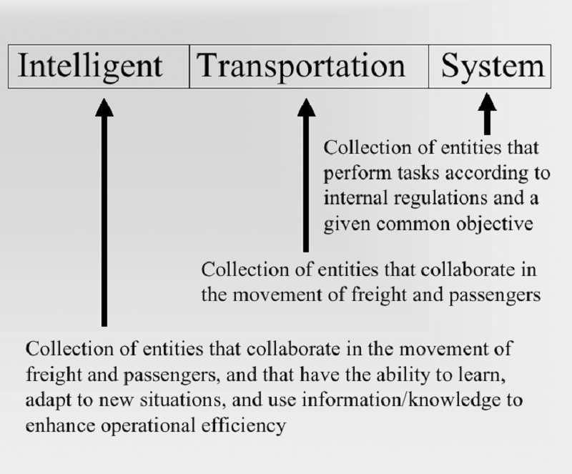

Figure ‎1‑1: Intelligent Transportation System. [1]

Evolution of ITS over decades and up to the latest technology has brought improvement in efficiency, safety, and sustainability in transportation. Below is a very brief history:

1. 1960s-1970s: Emergence of Traffic Control Systems Emerge:
   * The basic traffic control systems with the use of traffic signals and other very basic sensor technologies, it controls the traffic in the first two decades.
2. 1980s: Advanced Traffic Management Systems (ATMS):
   * The 1980s saw the emergence of ATMS, which were equipped with the first models of traffic surveillance cameras and were developed to include the installation of basic signs, followed by the utilization of more advanced ATMS with computerized control systems and the enhancement of traffic signal coordination.
3. 1990s: Advanced Traveler Information Systems (ATIS):
   * Internet development now makes it possible to deliver to a greater number of individuals. Come the 1990s. ITS extends its boundaries to ATIS; it provides real-time information to the traveling public regarding traffic conditions, other possible routes, and transit schedules.
4. Late 1990s-2000s: Convergence of Communication Technologies:
   * Late 1990s and early 2000s: the various communication technologies, including the use of the wireless networks, and the Global Positioning System (GPS); this allows for the development of the more sophisticated navigation and tracking systems.
5. 2000s: Intelligent Vehicle Technologies and Connected Vehicles:
   * The 2000s had significant activity in the areas of intelligent vehicle technologies and advanced driver assistance systems (ADAS). The concept of connected vehicles, which aims to provide safety through the vehicle-to-vehicle (V2V) and vehicle-to-infrastructure (V2I) connection, also developed.
6. 2010s: Autonomous Vehicles and Smart Cities:
   * The most found great research and development in the autonomous vehicles that have gathered a lot of experience due to significant developments in sensor technology, machine learning, and artificial intelligence in the 2010s. The concept of the Smart Cities will be driven to share the road space of ITS with the urban infrastructure to harness better, efficient, and sustainable transportation.
7. 2020s: The Connectivity and Sustainability:
   * It kept on developing powerfully into the current decade, coupled with connectivity, analytics in data, and sustainability. ITS inculcates the use of 5G networks, the Internet of Things (IoT), big data analytics in bringing a very strong enhancement capability in ITS to optimize transportation systems.

## PROBLEM STATEMENT

Congestion causes transportation inefficiency, which increases travel time, fuel consumption, and air pollution. The bad weather from time to time worsens road safety problems due to the occurrence of incidents. Another area of concern is the current weighing process for the trucks as it is ineffective, time-consuming, and raises issues of fairness. Most car tunnels experience fires that pose a high concern for safety and hence require effective and immediate mitigation. All this leads to the manual processing of many traffic violations, which is time-consuming and hence prone to errors; therefore, the need for an automated approach is needed to increase efficiency and accuracy.

## STANDARDS AND CONSTRAINTS

* As a relatively young discipline, there are no specific standards that can be deemed either unique to, or universally adopted by, Intelligent Transportation Systems (ITS). However, it so happens that in the development and implementation of ITS, the discipline usually refers to guidelines that are universally recognized and accepted; the guidance of the Institute of Electrical and Electronics Engineers (IEEE) is one such example. Others include ISO/TS 16845, SAE JJ2735 and IEC 61496.
* In the context of a small-scale graduation project within the scope of Intelligent Transportation Systems, some constraints provide complexity for the development process. For practical constraints, this is because the project could not be implemented on real vehicles, and restrictions for the use of highly sophisticated and expensive sensors are limited because of resource limitations. Besides, high computational power in computer vision tasks presents a big challenge. However, these constraints act as a spur for innovation and creativity in finding alternatives within the scope of limited resources, while the focus is shifted to achieve cost-effective and practical implementations.

## OBJECTIVE

* Studying the ITS main features.
* Establishing the system design and selecting suitable components.
* Circuit design, schematic, and implementation via discreet components and utilizing microcontroller as Raspberry PI.
* Computer vision and AI deployment.
* Design of suitable graphical user interface (GUI).
* Assembling the system prototype.
* ITS-EM testing for various operational scenarios.

Chapter Two

# METHODOLGY

We intend to implement various functions of the ITS, which include humidity, speed, weight sensing, temperature, and the signage process. All this will be orchestrated by a centralized controller, using platforms as Raspberry Pi and Arduino. The implementation will be in the deploying of different sensors and the orchestration of the operations between them to achieve full controllability and manageability of the system. The goal is to enhance and implement an ITS emulation on a modular basis, serving as a proof of concept (POC). This POC of the ITS will be utilized to investigate and illustrate different functionalities, such as RFID integration, car recognition, safety measures, toll counting, road management, and more.

## INDIVIDUAL SYSTEMS AND OUTPUT ACCTUATORS RESEARCH

### System 1: Intelligent Truck Weighing Management System

Weigh-in-motion (WIM) systems are an array of sensors used to measure various features of vehicles in motion. WIM systems are comprised of not only the electronics and sensors but also, just as importantly, flat, smooth, and straight roadways, as shown in Figure ‎2‑1 below. The WIM system is designed based on shortening weighing time, improving efficiency, and ensuring the weighing fairness. It is used for automatically collecting weights of trucks, monitoring truck weighing, inputting and reading of IC card data, automatically permitting truck’s leaving after weighing, and so on.

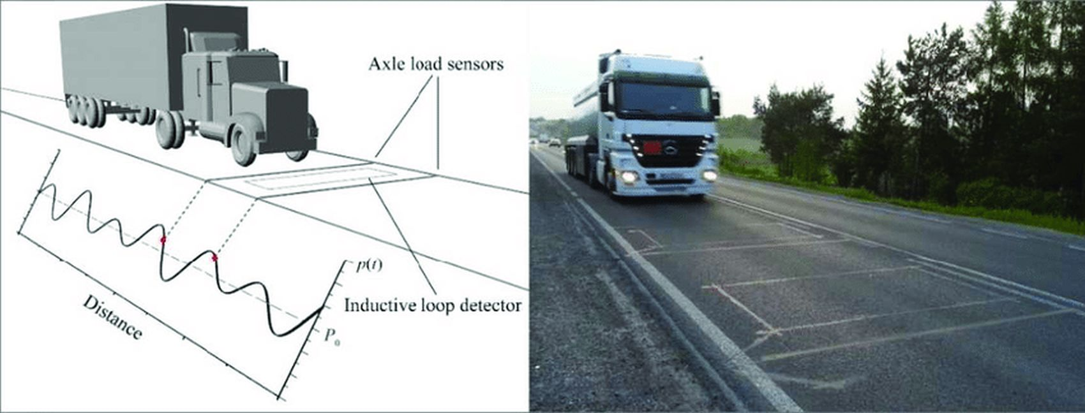

Figure ‎2‑1: Example of Weigh-in-Motion system. [2]

During the early stages of WIM system development, the changeable wheel load of a moving vehicle was thought to be the only source of substantial inaccuracy in weighing findings. A further in-depth research, however, revealed that there were additional elements interfering with the measurement [2], such as road roughness, pavement temperature, wheel load value, vehicle speed, and weather conditions, among others. These factors have an impact on all types of axle load sensors, regardless of sensor technology. We classified them based on the source of their occurrence (vehicle or WIM system) or the degree of influence (primary or secondary). Figure ‎2‑2 shows one such division.

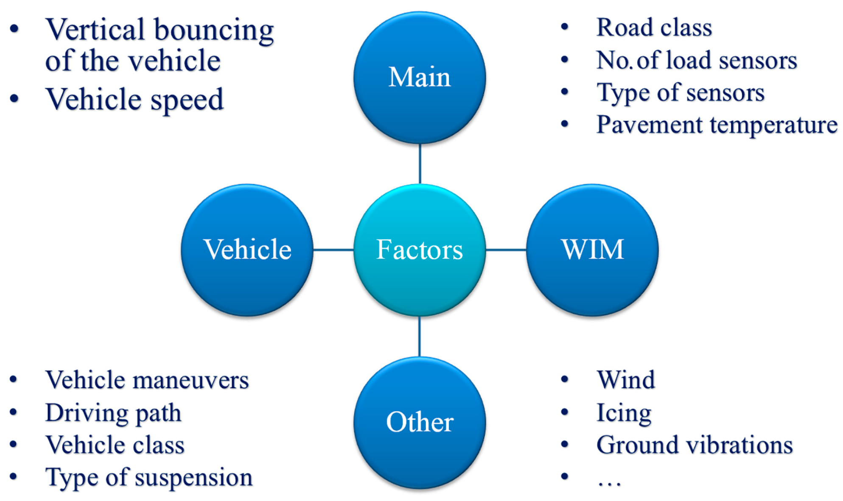

Figure ‎2‑2: Factors affecting the weighing accuracy. [2]

#### Literature Review

The literature survey uncovers the most important aspects of developing Weigh-in-Motion systems. First, the need to improve WIM system accuracy is emphasized because it is a prerequisite for certification by National Metrological Institutes. This certification allows WIM systems to enforce weight restrictions directly, offering great potential for reducing overloaded vehicles. In addition, a significant impact on pavement maintenance could be obtained by reducing overloading. It may enlarge pavement serviceability and lower the related costs. It has been indicated that the 15%-30% of heavy traffic constituted by overloaded vehicles may result in the contribution of up to 70% of pavement fatigue damage. Importantly, it has been shown that the doubling of pavement fatigue life can be achieved when the share of overloaded vehicles is reduced from 30% to 2% with increased enforcement. Therefore, its economic and social benefits could be reaped. WIM systems, in addition to their weighing functionality, offer valuable statistical information for traffic management, flow optimization, and infrastructure design for pavements and bridges. The literature review has also examined the temperature sensitivity of the axle load sensors. It has been found to vary between sensor types. Especially for the polymer and ceramic sensors, the variation in the measured load with the temperature of the pavement is significant; this is not the case for quartz sensors. In addition, different sensor types have been found to respond differently to a change in the vehicle speed. Polymer sensors are less sensitive to this parameter, whereas quartz sensors perform better at high speeds. The main negative effect was found for ceramic sensors, which exhibit the least sensitivity to vehicle speed variations [2].

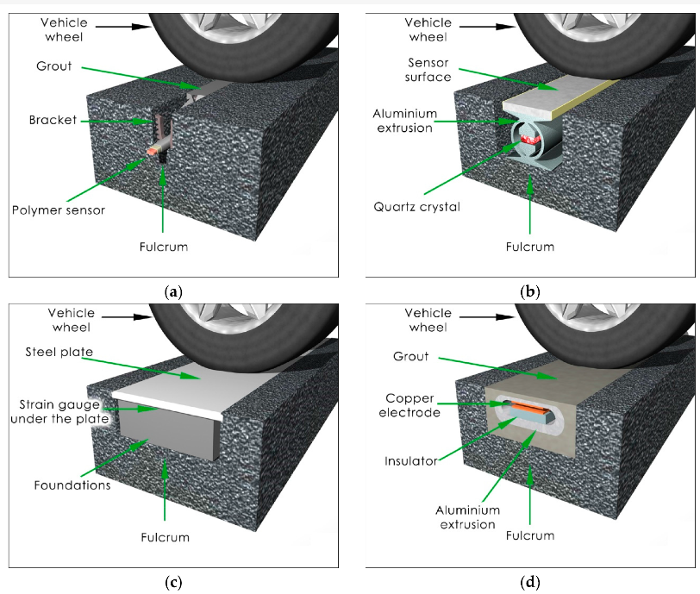

Figure ‎2‑3: (a) Polymer sensor installed below the pavement surface. (b) Quartz sensor installed on the level of the pavement surface. (c) Bending plate sensor installed on the level of the pavement surface. (d) Capacitive sensor installed on the level of the pavement surface. [2]

The installation of axle load sensors in WIM systems involves embedding them in the pavement perpendicular to the traffic flow. Presently, WIM systems utilize sensors employing four different technologies: piezoelectric (polymer or ceramic), quartz, bending plate, and capacitive. Although fiber-optic sensors, a promising technology, are not yet in use, literature contains information about their testing. Regarding installation methods, WIM sensors are categorized into two groups: those placed in a small cut in the pavement at a depth of 2 to 10 cm, depending on the sensor type (Figure ‎2‑3: (a)), where the sensor lacks direct contact with the vehicle wheel, and axle load is transmitted via the pavement and installation grout; this method is employed for polymer and piezo-ceramic sensors. The second group involves sensors installed in a cut in the pavement at the surface level (Figure ‎2‑3: (b-d)), allowing direct contact with the vehicle wheel. This method is applied for quartz, bending plate, and capacitive sensors [2].

In both mounting methods, the pavement serves as the fulcrum for the sensor. When the sensor is embedded below the road, the wheel load is transferred to the sensor via the pavement and the grout used to install the sensor. This is an unusual situation in which the pavement becomes part of the measuring system, and this component is not only a part of the road but also the weighing system. This implies that the properties of the pavement affect the overall properties of the WIM system. In order to compensate for these weighing errors, the authors propose to classify them into two groups: the sensor intrinsic error, due to changes in the electrical parameters of the sensor, because the sensor's temperature has changed, and the pavement/sensor complex external error, which includes the sensor intrinsic error along with the other errors due to the pavement that appear after installing the sensor. This classifies the pavement as the source of errors, which are affected by the temperature and the time the load from the vehicle wheel is transferred to the pavement/sensor complex. The main problem, which ensures an accurate vehicle weighing in motion, arises from the fact that the pavement/sensor complex has a great influence on the external error. Previous research highlighted three influential factors:

* Changes in pavement temperature.
* Duration of forces applied to the pavement/axle load sensor complex linked to the vehicle's speed.
* Stress on the tire-pavement contact area, which depends on wheel force values.

### System 2: Fire Suppression

The National Fire Protection Association, also known as the NFPA, are codes that regulate fire suppression systems. The NFPA develops codes, standards, and guidelines for the installation and maintenance of fire suppression systems. The fundamental issue with tunnel fires is the high fire dynamic combined with typically restricted evacuation options. As a result, it is critical to detect and combat fires as early as possible - with stationary equipment, even in the crucial minutes before the arrival of the fire department to avoid chain reaction.

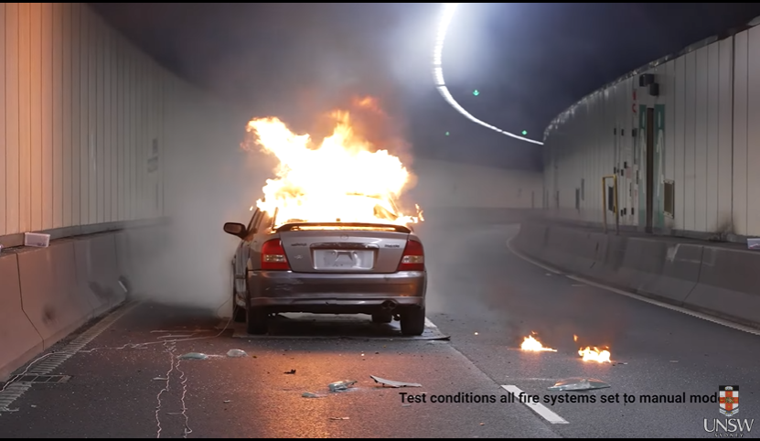

Figure ‎2‑4: Car caught on fire insde a tunnel. [3]

Figure ‎2‑4 shows that when a car is on fire in the tunnel, that is going to be a complex and critical situation. The confined space of the tunnel, on the one hand, accentuates all those typical dangers associated with a fire—severe heat, toxic fumes, and loss of visibility—which can take place very quickly because smoke and heat can accumulate. Lack of natural ventilation means that smoke and heat are not taken away, and this becomes a severe danger for the trapped and complicates the operations to put out the fire. Besides, the high temperature of a vehicle fire can also cause damage to the structure of the tunnel, which may result in a long-term closure for repair. Such actions disrupt traffic. But also can have severe economic consequences.

Moreover, in the event of tunnels that are part of critical infrastructure or great transit axes, the incident can bring serious effects on mobility and logistics. This is why it is so important to guarantee robust fire safety and quick reaction systems in tunnels.

Engineers at USNW Sydney have come up with a novel, low-cost Wi-Fi system that detects fires better. The system uses Wi-Fi signals and a machine learning algorithm to detect and monitor fires happening in real time. The system has a machine-learning algorithm developed for it, which provides training in different possible fire scenarios, differentiating between normal activities and the potential for a fire incident. By monitoring the Wi-Fi and analyzing patterns, the presence of a fire can be quickly detected; thus, occupants and emergency responders are warned effectively, as in Figure ‎2‑5. “Existing specialized fire detection cameras can cost around $10,000 to buy, whereas our transmitters and receivers are $100 or even less,” Prof. Seneviratne says. This makes it scalable to a very large range of applications, right from residential buildings to commercial and industrial buildings. The article emphasizes that this Wi-Fi-based fire detection system has shown promising results in early testing. More tests need to be performed, and its accuracy and reliability still need further improvement, including synchronization and integration with existing fire suppression and alarm systems [3].

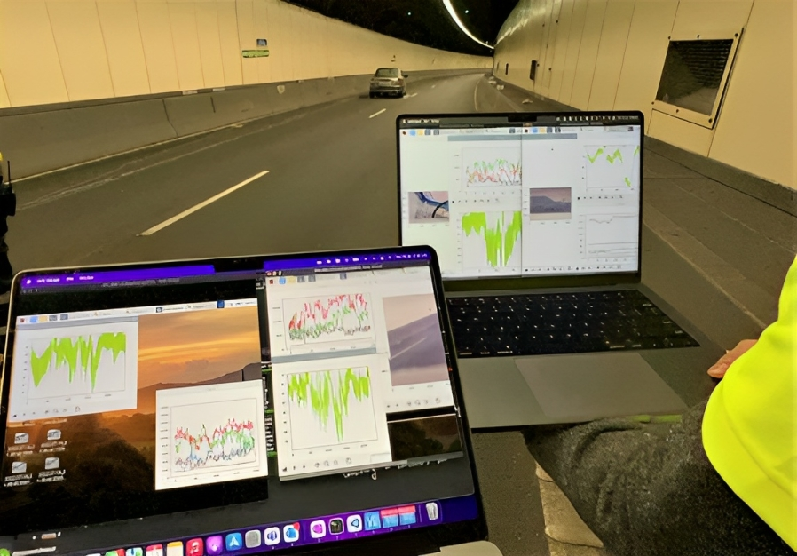

Figure ‎2‑5: Analysis of the received signal under normal and fire conditions. [3]

Designing tunnels with certain specific features and abilities for the treatment of risks associated with fires is of prime concern to the public and the resilience of the infrastructure. Tunnels exacerbate the risk involved with fire—increased temperature, poisonous smoke, and poor visibility. It is vital to include fundamental necessities such as advanced ventilation systems, surveillance cameras, effective illumination, and efficient water drain systems. Apart from just dispersion of heat and smoke, good ventilation also serves to locate and predict the exact source or location of fire for quick response by the emergency services. Cameras enhance real-time monitoring. This not only helps in early fire detection but also in the quick handling of the situation. The illumination systems keep the visibility optimal for safe evacuation and fire-fighting operations. Provision is also made for efficient water drainage to avoid piling up of water and wasting more time in a situation that may increase damage to the tunnel infrastructure. With the incorporation of these features in tunnel design, the authorities will be much more capable of detecting, responding, and mitigating fire from the tunnels, resulting in lives saved, economic disruptions minimized, and critical transportation routes kept available. Figure ‎2‑6 below is an example of a road tunnel with some of the addressed capabilities.

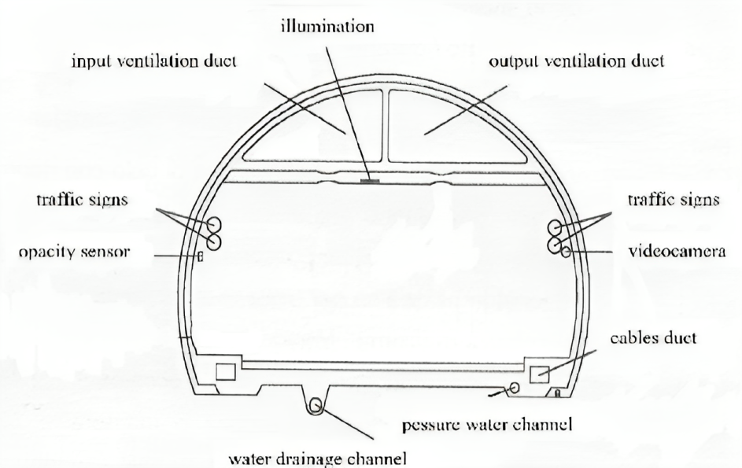

Figure ‎2‑6: Example of cross-section of an equipped road tunnel. [4]

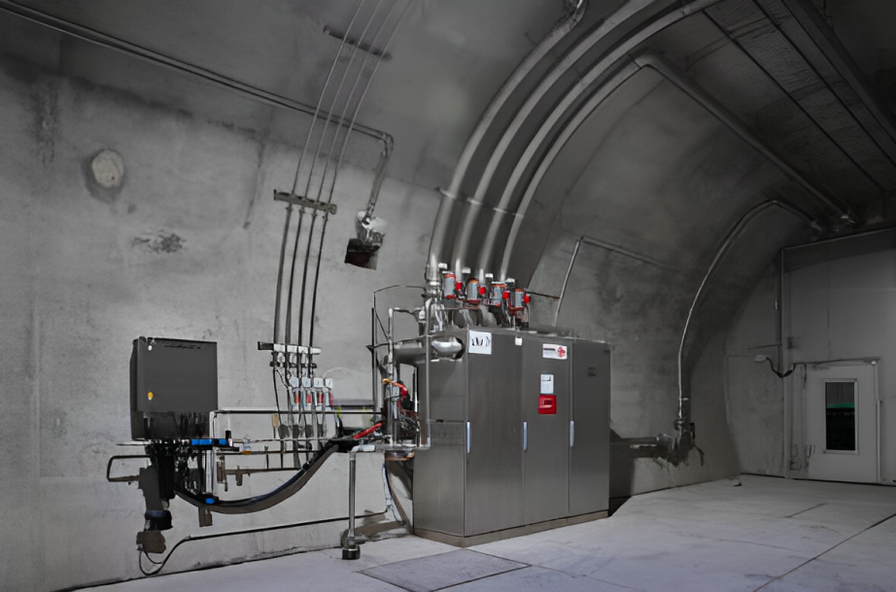

Figure ‎2‑7: Pre-engineered CAFS (Compressed Air Foam System) fire suppression unit for automatic tunnel fire detection and extinction. [5]

The installation of a pre-engineered Compressed Air Foam System (CAFS) displayed in Figure ‎2‑7 in tunnel environments is a breakthrough in the technology of fire suppression. This system is designed to detect a fire and then extinguish it automatically within a tunnel. When water, foam concentrate, and compressed air are mixed, CAFS generates fire-extinguishing foam; this kind of foam is more effective than water alone for cooling the fire and for covering the fuel surface, which retards re-ignition. This feature, combined with its automatic function, is an important feature in the event of a fire outbreak in a tunnel, a constrained and possibly dangerous environment. Once a fire has been detected, the system can immediately discharge foam to the affected area, thereby greatly suppressing the growth and spread of the fire. It is not only safer for tunnel users, but it also decreases the extent of structural damage. For a further detailed explanation of this system, refer to Figure ‎2‑8, which provides a comprehensive visual representation of the CAFS in a tunnel fire scenario. And Figure ‎2‑9 after the fire has been extinguished.

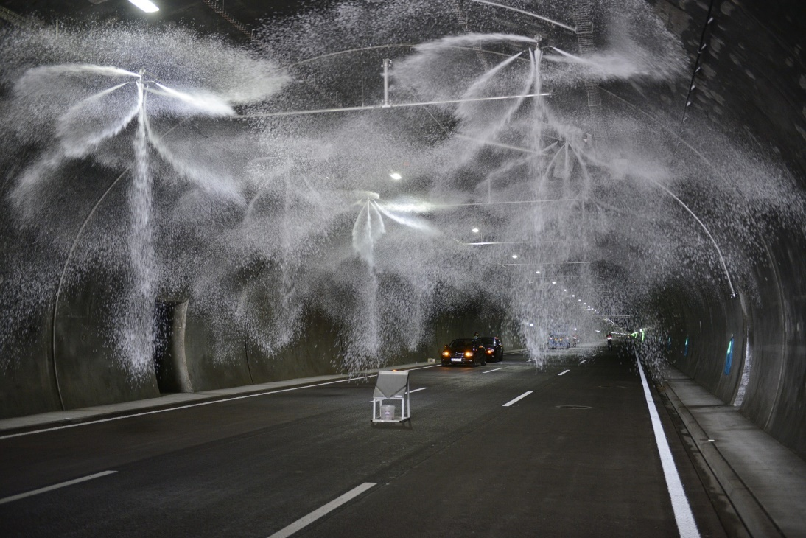

Figure ‎2‑8: ****Compressed air foam erupts from strategically placed nozzles, quickly suppressing a tunnel fire.**** [5]

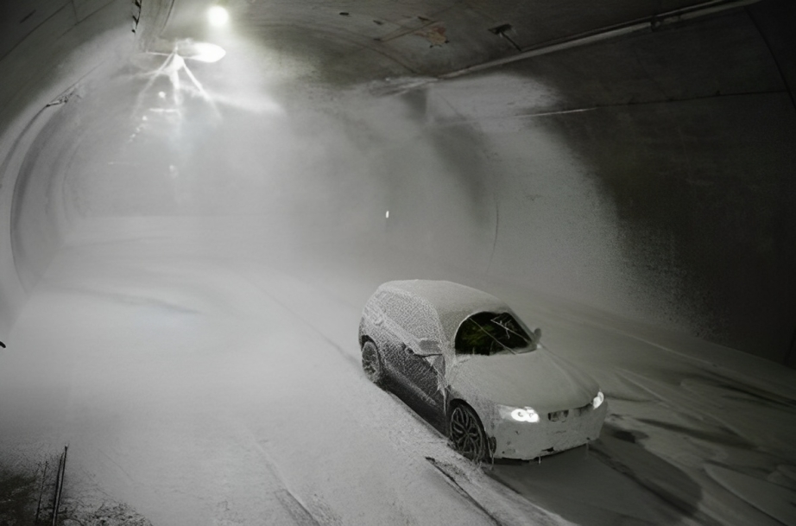

Figure ‎2‑9: Successfully extinguished vehicle. [5]

Figure ‎2‑10: ****Prominent signage installed at the tunnel entrance to alert incoming drivers of a potential hazardous situation within the tunnel.**** [3]

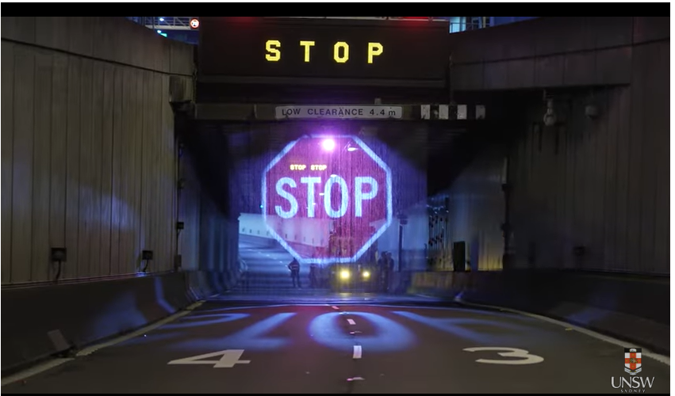

Signage message to stop incoming vehicles from entering tunnel

Hologram

Complementing the state-of-the-art fire suppression systems, such as the pre-engineered CAFS, the use of active signage around the tunnels is equally important during a fire incident. Dynamic signage outside a tunnel during a fire incident warns drivers of the hazardous condition inside the tunnel, effectively deterring them from proceeding into an unsafe environment, thereby saving lives. It also prevents the escalation of the fire or a chain collision, which may cause far greater damages and challenge emergency and firefighting operations. The positioning of the sign and its ability to display the warnings in real-time are highly critical in ensuring safety and traffic control during such emergencies. For a graphical illustration of how such signage systems work during a tunnel fire, refer to Figure ‎2‑10, which demonstrates the positioning and function of these critical warning systems.

### System 3: Road Weather Information

Road Weather Information System (RWIS) RWIS is a technology-driven system that provides real-time weather information and road condition data to drivers, transportation agencies, and other stakeholders. A network of sensors is strategically located along roads. The collection of data has been based on weather conditions, pavement temperature, visibility, precipitation, and other parameters. These may include a bank of sensors on the pavement, weather stations, cameras, and other meteorological instruments that monitor and send data continuously to a central server. Collected data are processed and delivered through a variety of means that include websites, mobile apps, and variable message signs. RWIS improves road safety, increases the efficiency of transportation, and aids in taking decisions on winter maintenance operations, route planning, and traveler advisories. RWIS can help make the right decisions by providing drivers with up-to-date and accurate weather and road condition information, thus encouraging proactive roadway management and contributing to a safer and more efficient transportation system. Figure ‎2‑11 shows an example of road weather monitoring system.

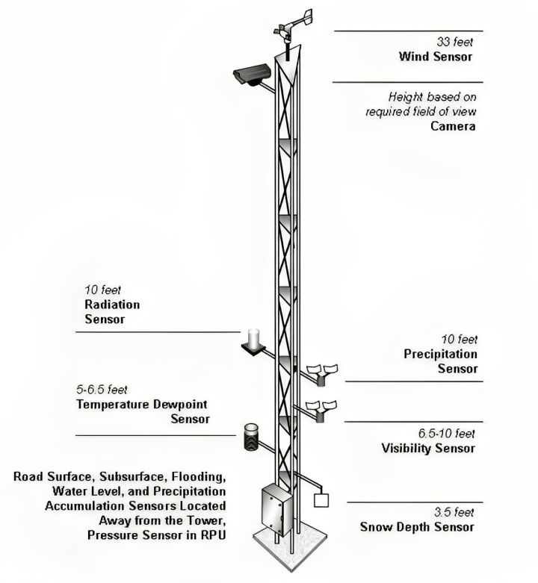

Figure ‎2‑11: Typical location of tower-based sensors for weather monitoring. [7]

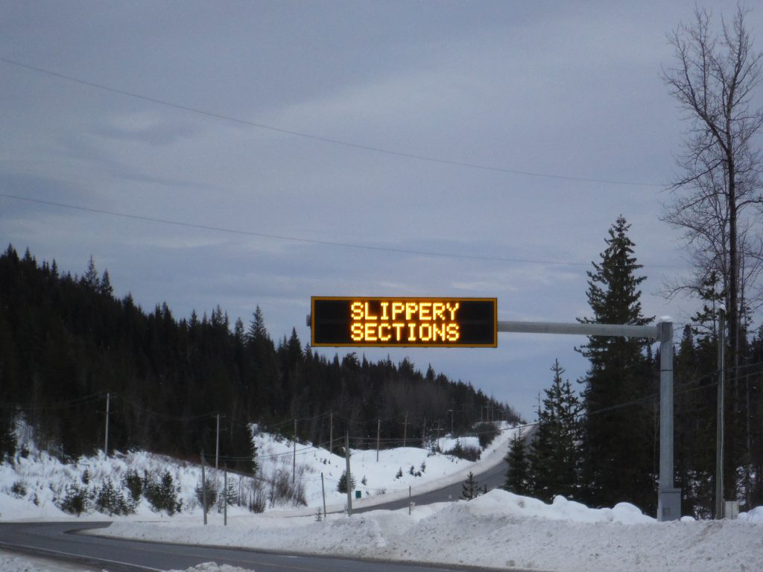

Figure ‎2‑12: Signage message to alert drivers of the road conditions.

A critical aspect of the system is the variable message signs, which are located so that they can display the current road conditions, current weather, and any warning information. These digital signs are directly connected to the RWIS-collected information so that they can clearly display information that is relevant to drivers. In this way, the RWIS can dynamically present important alerts and advisories to the motorists and hence will provide them with effective information for changing their travel route decisions and driving behavior. Such an immediate provision of information is, in fact, crucial for areas where changes in weather conditions happen suddenly or hazardous conditions are being created, and hence these would be reducing the chances of accidents and enhancing road safety in general. Figure ‎2‑12 illustrates an example of how a road weather monitoring system, integrated with these signage messages, operates to warn drivers and aid in proactive roadway management.

### System 4: Automatic Vehicle Identification and Toll Collection

The implementation of Automatic Vehicle Identification and Tolling (AVITC) Systems has been a significant step for traffic congestion management, more so in toll areas with high volumes. The actual build-up of traffic is triggered by conventional toll booths: a vehicle is forced to stop or slow down for the manual toll-transaction process. This operation decreases the flow and overall efficiency of transportation networks. In contrast, automated tolling systems reduce the tolling transaction process to identifying the vehicle using developed technology, for example, RFID or license plate recognition. After the vehicle identification process, the system computes the toll rate based on the vehicle type or miles driven, deducting the fee from the driver's linked bank, as shown in Figure ‎2‑13. In addition to shortening the time spent in the actual tolling process, system automation minimizes human error and, therefore, operational costs for labor-intensive manual tolling.

Moreover, AVITC may implement dynamic toll rates based on congestion, known as congestion pricing, to manage road use and encourage off-peak travel or alternative routes. This information is used by urban planners and policymakers to improve transportation infrastructure design and management. The system also contributes to an eco-friendly, sustainable approach to road usage, reducing idle times and gas emissions, thus improving traffic flow and urban mobility.

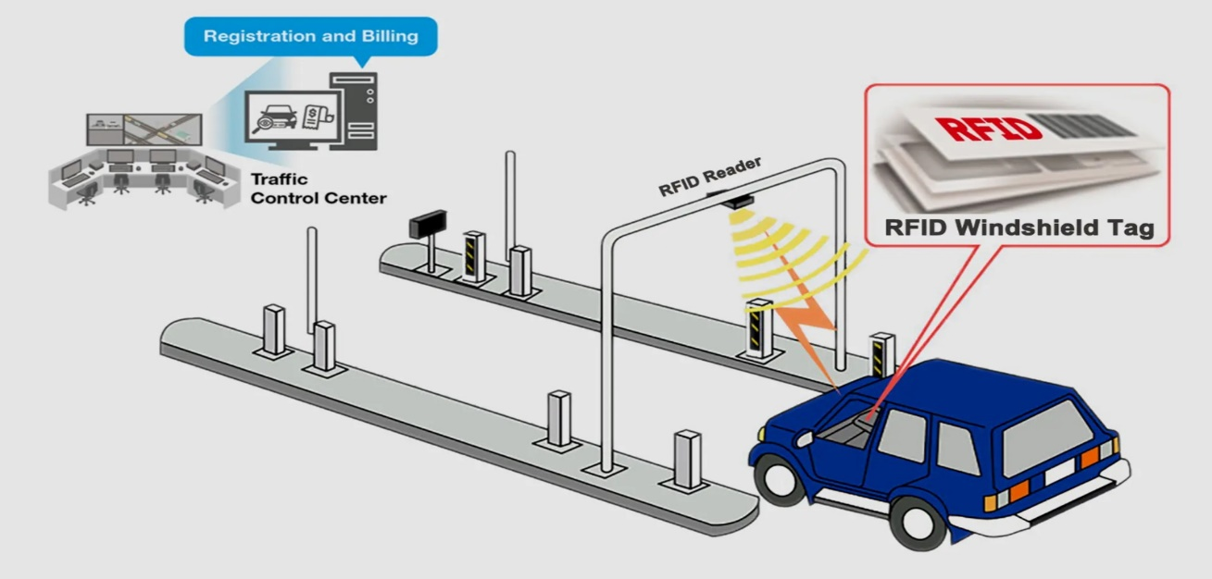

Figure ‎2‑13: Automatic number plate recognition system.

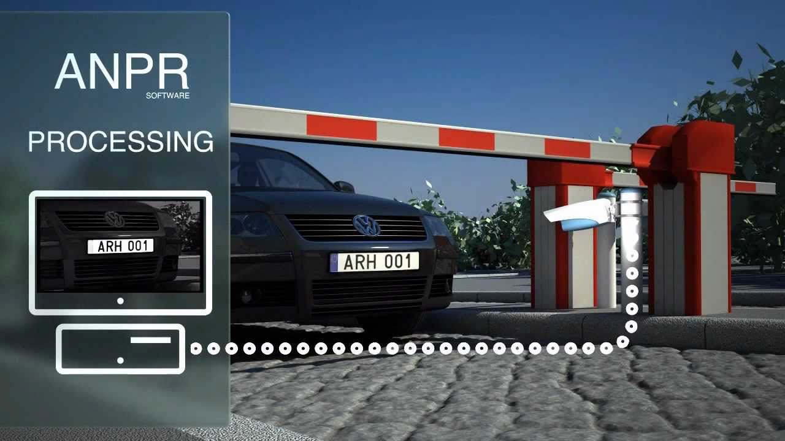

Figure ‎2‑14: Automatic number plate recognition system. [9]

The Automatic Number Plate Recognition (ANPR) system is an advanced system using an optical character recognition program to identify the registration numbers of vehicles. It is used in various applications like traffic, controlling traffic access to tollbooths, and controlling access to secure areas, as in Figure ‎2‑14. The system can work in real-time and perform checks and identification operations on the vehicles. This feature can be helpful for policing agencies in traffic management and monitoring, finding stolen or unregistered vehicles, and enforcing traffic discipline, as in Figure ‎2‑15. Additionally, ANPR systems are integral in intelligent transportation systems, contributing to smoother traffic flow and enhanced road safety.

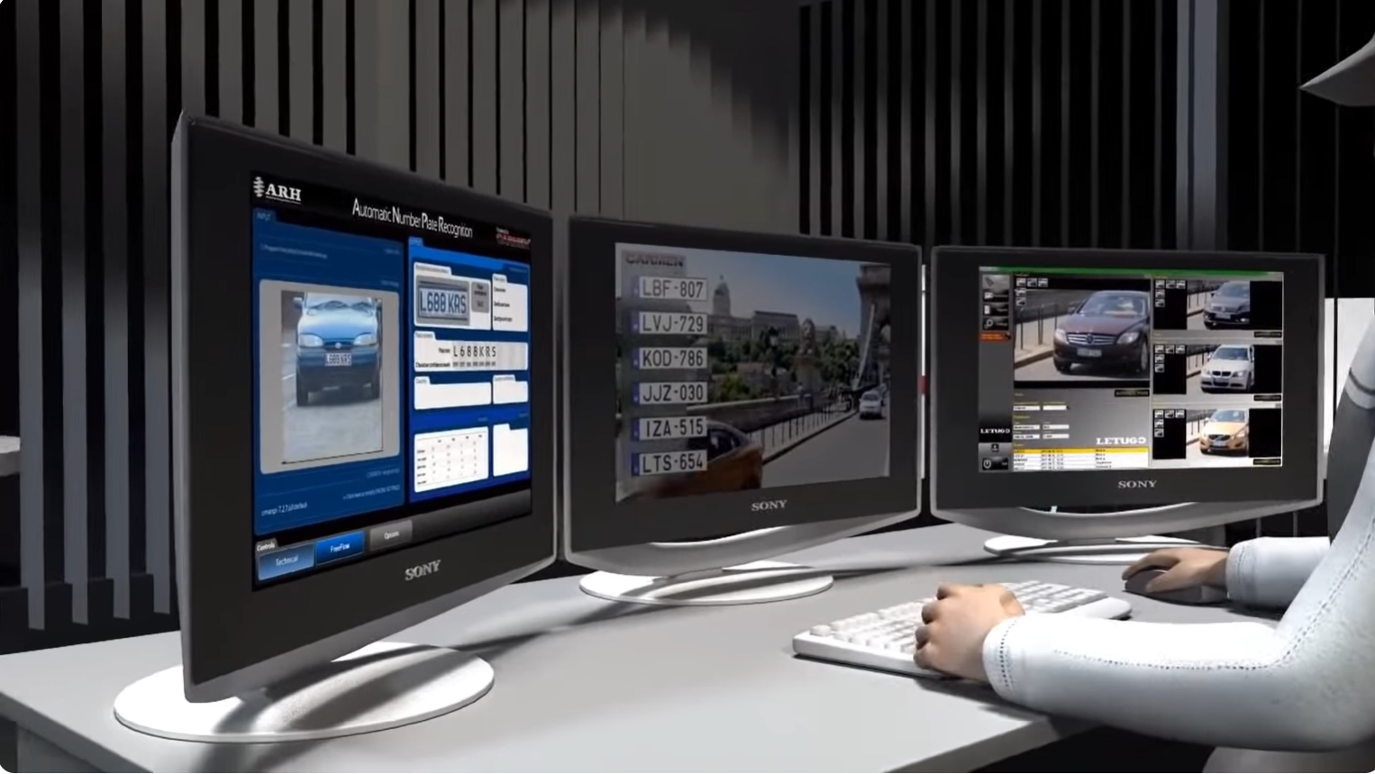

Figure ‎2‑15: Real-time monitoring of passing vehicles. [9]

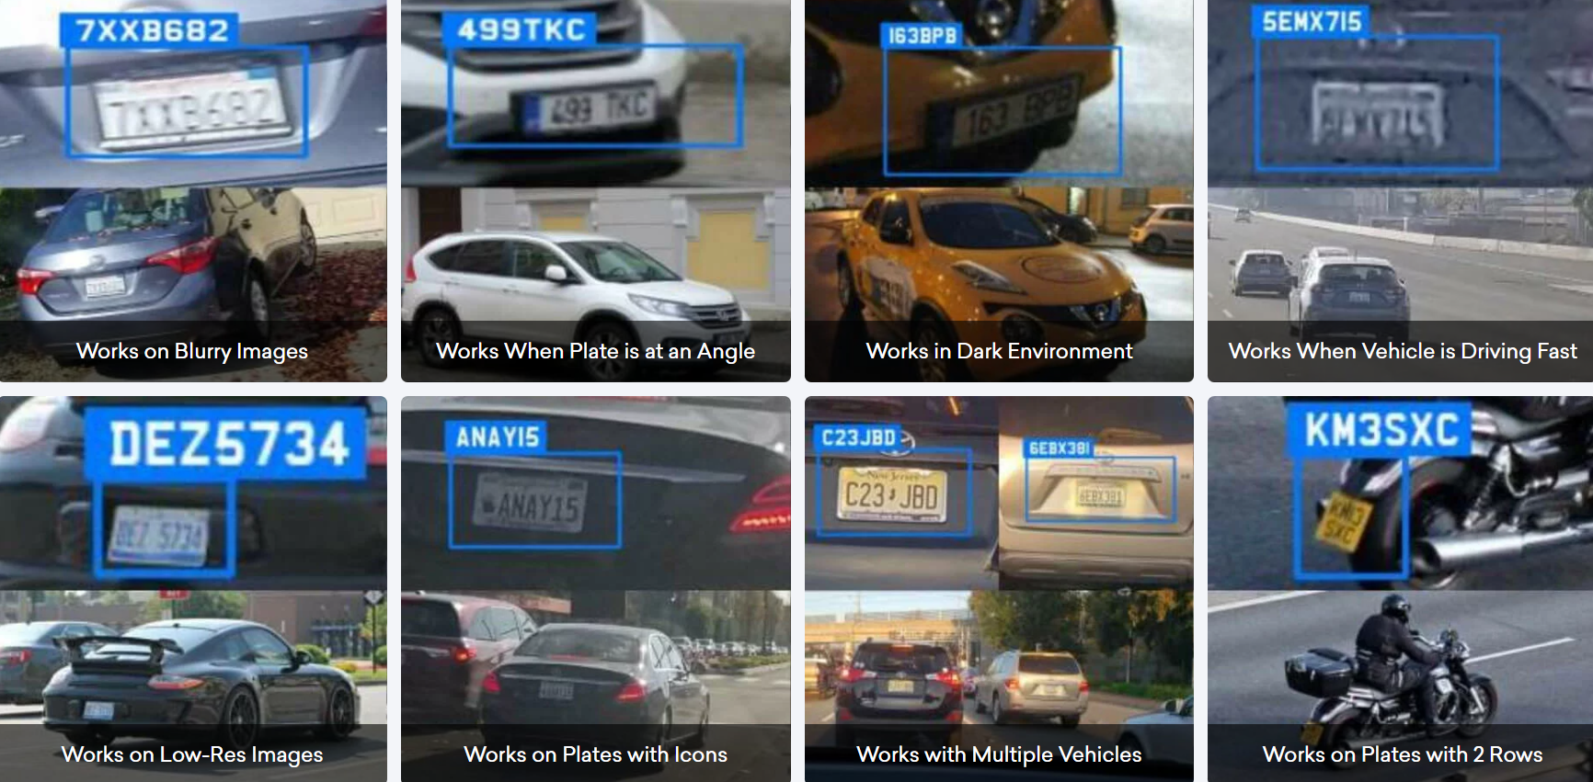

Figure ‎2‑16: Automatic number plate recognition under different conditions. [10]

There can be no ideal environmental conditions, taking into consideration weather, time of the day, regional variations in the number plates, and variation in vehicle speeds. Number plates may be bent, crumpled, and partially obstructed, while the challenge still stands for the operators to place high-quality cameras at an ideal angle in exactly the right location. Still, the number plate data has to be accurately captured. Automatic Number Plate Recognition (ANPR) technology has been uniquely built to meet all these challenges through the employment of high-speed cameras and advanced software that can capture and analyze images of vehicle plates, ensuring definitively accurate data capture, as shown in Figure ‎2‑16. This technology is not only used for the security of communities around the world by government, police, and security services but can also be employed by a wide variety of businesses, including toll plazas, gated communities, weigh systems, areas where the visibility is poor due to snow, and even in drone operations. A good example of the advanced nature of ANPR software is the fact that it is trustworthy to be used in car wash businesses, where it easily cuts through dirt and grime to ensure that the license plates are captured precisely.

**Table ‎2‑1: Vehicle passed away from toll booth in 1 year.** [11]

|  |  |  |
| --- | --- | --- |
| **Vehicle** | **Days** | **Toll Booth** |
| 100 | 1 | 1 |
| 36,000 | 30 $×$ 12 | 1 |
| 3,600,000 | 30 $×$ 12 | 100 |

Suppose in, if there are 100 manual toll-taxes system and every day 100 vehicles cross through each system, then No. of vehicles that pass through one system yearly = 100 x 30 x 12 = 36,000. No. of vehicles that pass through 100 systems yearly =100 x 36,000 = 36,00,000. And each car waits on average everyday 1 min at the toll booth. Assuming cost of 1-liter of fuel = 0.88 USD then total cost of fuel consumed by 3,600,000 vehicles = 0.88 x 3,600,000 = 3,168,000 USD.

The above is the money wastage under the consideration that the vehicle stops for 60 seconds at the toll booth, and 100 vehicles pass through the toll plaza each day and there are 100 toll plazas. These figures are all in minimum.

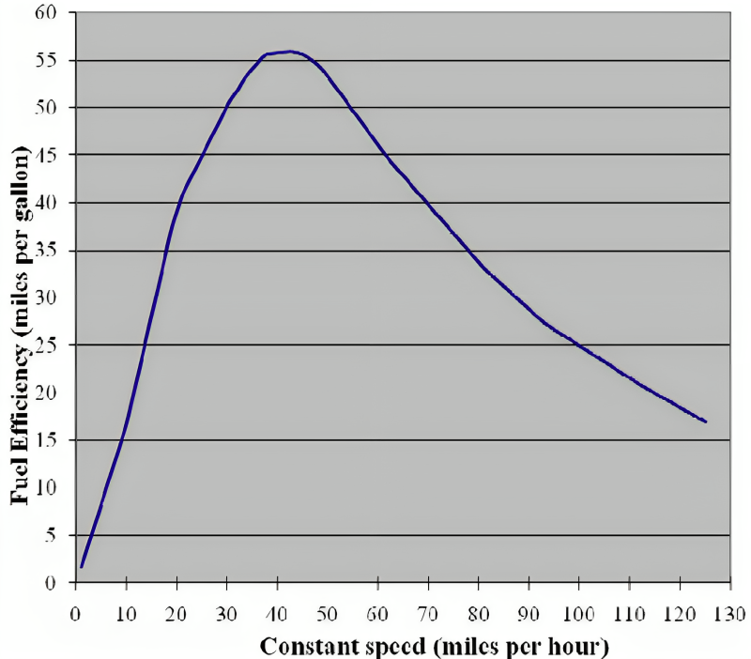

Figure ‎2‑17: Fuel consumption vs. speed. [12]

The data presented in Figure ‎2‑17 shows fuel consumption vs. vehicle speed. From the graph, it can be observed that fuel consumption increases when there is low speed, as in congestion with a longer waiting time. [12]

The CO2 calculation carried out assumes a petrol engine burning standard unleaded fuel with oxygen at stoichiometric (ideal) ratios. One liter of standard unleaded fuel burnt completely with oxygen yields 2.36kg of carbon dioxide. Using this ratio, CO2 emissions for an average passenger car were calculated for each speed (in 1mph intervals) from the average vehicle fuel consumption data. These values were then multiplied by the percentages of vehicles travelling at each speed on the three roads to be analyzed in order to determine the average CO2 produced per mile for all vehicles travelling on the road for that month (assuming that a constant speed is maintained over the mile covered). [12]

Both in terms of the fuel saved and in CO2 emissions reduced. With a 50-mph limit, the possible reduction in fuel consumption and emission should reach up to 30%, as shown in Table ‎2‑2 below. [12]

**Table ‎2‑2: Fuel consumption, CO2 emissions and savings.** [12]

|  |  |  |  |
| --- | --- | --- | --- |
|  | **Unenforced 70mph limit** | **Enforced 70mph limit** | **Enforced 50mph limit** |
| **Annual fuel consumption (Gallons per mile)** | 699,459 | 620,268 | 493,156 |
| **Annual fuel saving (Gallons per mile)** | 0 | 79,190 | 206,303 |
| **CO2 Emissions (kg per vehicle per mile)** | 0.280 | 0.248 | 0.197 |
| **Annual CO2 Emissions (Metric tons per mile)** | 7,505 | 6,655 | 5,292 |
| **Annual CO2 Reduction (Metric tons per mile)** | 0 | 850 | 2,214 |
| **Percentage Saving (Fuel & CO2)** | 0% | 11.3% | 29.5% |

With increased variation in traffic speeds, as visible in the unenforced national speed limit speed profile, more acceleration and braking takes place, as faster drivers brake on approaching slower drivers then accelerate again. These actions lead to an increase in fuel consumption and emissions. In SPECS average speed enforcement areas, speeds are typically closer to the speed limit with far less speed variation across the site or between vehicles. This smoother driving incurs less fuel consumption and lower CO2 emissions. In areas where there is peak period congestion, the effects of SPECS average speed enforcement are also present, with the delay in the onset of the traffic flow breakdown. This was shown by SPECS enforcement in roadworks reducing peak period congestion. A reduction in congestion will also have a positive effect in reducing fuel consumption and CO2 emissions. [12]

In other words, solving traffic congestion is related to reduced fuel demand and better environmental sustainability. Vehicles in traffic are believed to consume more fuel through idling or moving at very slow speeds, which leads to higher greenhouse gas emissions, which are dominated by carbon dioxide (CO2). A major aspect of curbing congestion is to reduce idling caused by traffic and help vehicles drive more smoothly to consume less fuel. Improved fuel efficiency is also noticed as a resulting trend when there is smoother traffic, which increases vehicle speeds; thus, reduction in traffic congestion also cuts down cold starts. In the case of cold starts, engines operate at sub-optimal conditions before reaching the required temperature, so there is a further increase in fuel efficiency and positive environmental impact.

### System 5: Lighting Control

Street lighting consumes a significant share of energy in any city or town across the globe. Strategic control of street lighting can help in saving a lot of energy and, therefore, ensure sustainable development. Modern street lighting systems are therefore integrated with intelligent control systems, which reduce energy consumption while, at the same time, ensuring public safety. Advanced lighting controls will enable the system to adjust the ratio of operation for these lights—for instance, the reduction of intensity and switching off of lights during low traffic. Advanced lighting controls include occupancy sensors and daylight harvesting controls, which help to optimize energy. Occupancy sensors dim or switch off lighting when spaces are unoccupied, whereas daylight harvesting controls dim electric lighting according to natural lighting.

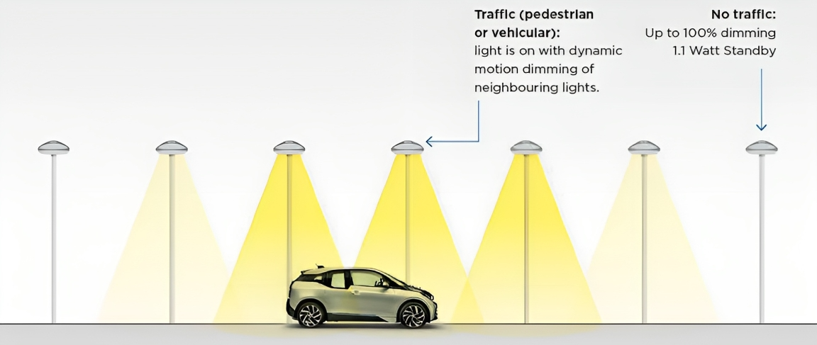

Figure ‎2‑18: Street lights control by targeted dimming of LED lights. [16]

Compared to normal LED street lighting you increase energy efficiency up to 90% with the intelligent lighting system. This extends the lifetime of the luminaires and reduces maintenance costs. The system can always be adapted to new conditions, so that a perfect illumination of the road is always guaranteed, as shown in Figure ‎2‑18. Since the illumination of a street section is only increased as required, the light pollution can be considerably reduced [13].

Figure ‎2‑19 shows the general architecture of the Smart Street pilot site is located at the ENEA Casaccia R.C. (Rome): the system is a public street lighting line managed in an automatic (programmable) and manual ways. Thanks to the sensors that the system is equipped with, it is possible to program the switching of lights, according to the ephemeris tables (local sunrise and sunset), based on a pre-set and fixed timetable. The system is able to respond dynamically, due to the presence of smart cameras, to the traffic flow rate. The system is composed of streetlights; every unit has a ‘‘lamp assembly” composed by an IP Node, a LED driver, and a LED matrix lamp. Since each lamp has a unique IP address, it is possible to monitor the individual status and adjust the brightness by operating on the driver that has a specific interface. Several smart cameras provide all the traffic data information, as they are able to record not only the passage of a vehicle or a pedestrian, but also detect its type and speed. All the status information and electric power absorption data are then sent to a hub that takes care to send it to a remote computer system which, moreover, stores the critical data of all the street lamps at 15 min intervals; thanks to a software developed ad hoc, it is possible to run the reverse path to the controls in order to pilot the LED driver. It is therefore possible to receive the telemetry data of each single lamp and consequently send appropriate remote controls that can adjust the brightness from 100% up to the off state. [17]

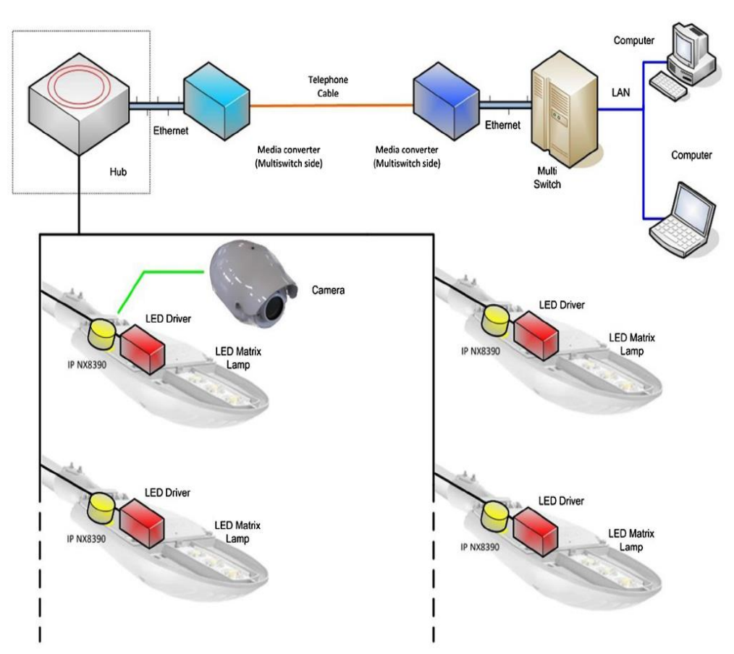

**Figure ‎2‑19: Smart street pilot site system general architecture.** [17]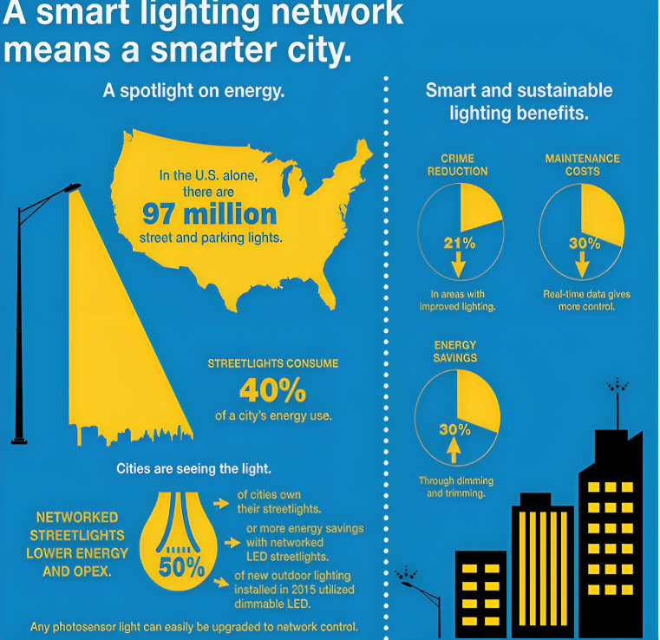

Figure ‎2‑20: Smart and sustainable lighting benefits. [17]

Smart and sustainable lighting brings a host of benefits to urban environments, as shown in Figure ‎2‑20. This will be achieved through the application of advanced technologies with LED fixtures, sensors, and intelligent controls, among others. Such a system will present great energy savings, minimal environmental impact, and enhanced overall efficiency with adaptive lighting, which enables the implementation of real-time conditions to optimize energy consumption. It will, therefore, open the gates for safety in terms of energy savings, better visibility, and a reduction in light pollution in the smart lighting installations, which shall further encourage more sustainable and livable urban spaces. With the concept of smart and sustainable lighting emerging into the modern genre of urban planning, these will have a good environment with long-term benefits that include the reduction in cost and better quality of life.

Chapter Three

# EXPERMIENT AND RESULTS

During the experimental phase, individual systems and output actuators were tested on a small scale to determine their efficacy and reliability. The experiments were carried out in several controlled tests, each developed to evaluate given functionality and response time of the systems at different conditions. Data obtained from the tests were very essential in understanding the performance capabilities and limitations of individual components. Output actuators were also monitored for their precision and speed in executing the system's commands. The data thus obtained from these experiments provided insight into the overall system integration, pinpointing areas in which performance can be leveraged. The success of these small-scale tests was very important in that one was able to scale up the systems so that when used in broader applications, they would be able to perform in efficient and effective ways in real situations.

## SYSTEM 1: INTELLIGENT TRUCK WEIGHING MANAGEMENT

### Load Cell and HX711 Amplifier

**Description:**

A load cell is a device that uses piezoelectric effect to convert a force acting on it to an electrical signal measurable by instrumentation; in simple terms, it converts a force acting on it into an electrical signal. The electrical signal varies linearly with the applied force.

#### Load Cell Circuit Diagram

A strain gauge load cell is a sensor made of piezoelectric materials, constructed from metal, designed to measure force or strain on an object. The resistance of the strain gauges varies when an outside force is applied to a body; in this case, the result is a deformation in the form of the metal. This deformation leads to a change in the electrical resistance of the gauge.

The strain gauge resistance is proportional to the load applied, that will enable us to calculate the weight of objects. Usually, load cells have four strain gauges hooked up in a Wheatstone bridge that allow us to get accurate resistance measurements, as shown below in Figure ‎3‑1.

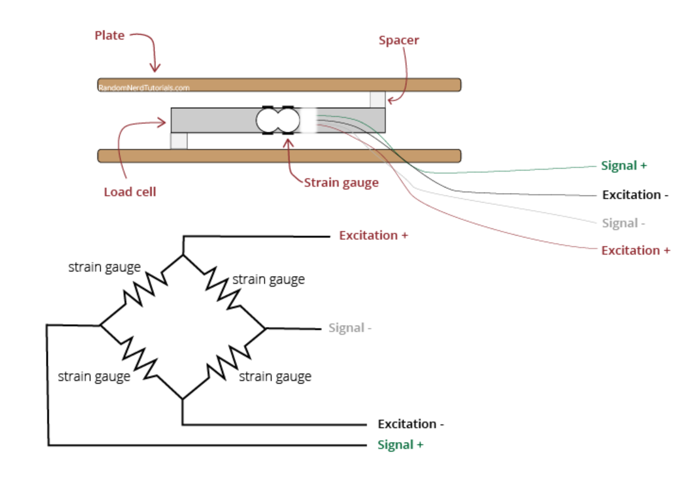

Figure ‎3‑1: Load Cell Circuit Diagram. [20]

The system accuracy for weight measurement relies heavily on the inclusion of load cell weight sensors. It is one way of converting mechanical force to electrical signals, which makes it possible to measure weight accurately and with a lot of reliability. Load cells have found application in a wide range of industries, ranging from industrial scales to medical devices, and therefore provide a versatile solution to any and all weight measurement needs. The specification and features of the load cell weight sensors used within our system are elaborated in detail within Table ‎3‑1.

**Table ‎3‑1: Comparison between load cell weight sensor and bathroom scale weight sensor**

| **Sensor** | **Load Cell Weight Sensor** | **Bathroom Scale Weight Sensor** |
| --- | --- | --- |
| Measurement  Type | Force/Weight | Force/Weight |
| Accuracy | Highly accurate (±0.1% or better) | Low accuracy (±5% or more) |
| Linearity | High | Moderate |
| Hysteresis | Low | Moderate |
| Measurement  Range | Wide (kg to tons) | Narrow (person weight only) |
| Temperature  Effect | Minimal | Significant |
| Humidity Effect | Minimal | Significant |
| Applications | Industrial weighing, shipping, precision measurement | Home scales, fitness tracking |
| Construction | Uses strain gauges to measure  compression | Uses strain gauges to measure  compression |
| Output | Analog voltage or digital from module | Analog only |
| Durability | Rugged and withstands  vibration/overloading | Not durable, can break under  stress |
| Cost | Moderate-high depending on capacity and accuracy | Low |

**Table ‎3‑2: 20 KG load cell weight sensor specifications.** [21]

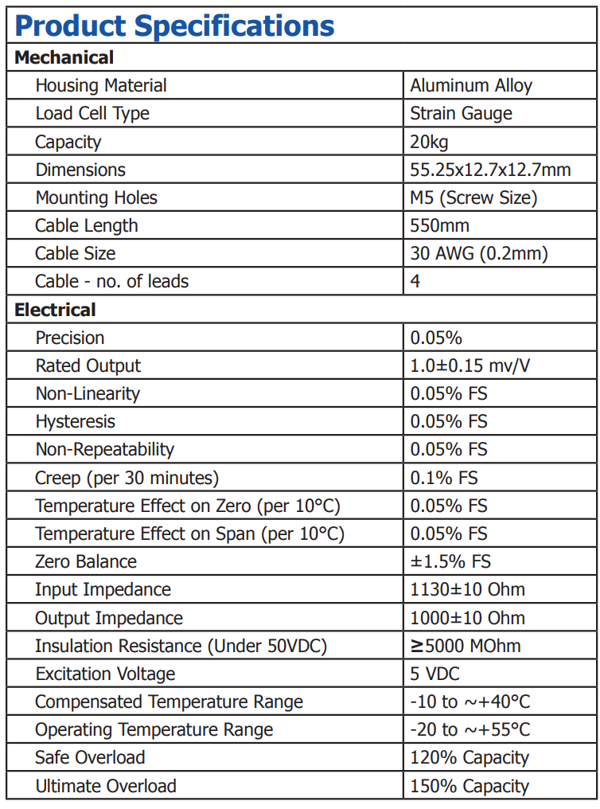

#### ****Load Cell Weight Sensor Wiring****

A load cell is an essential part of weight measuring systems used in scales, industrial machinery, and testing apparatus. This device operates by converting mechanical force into an electrical signal. Normally, a load cell has four wires: two for providing the excitation voltage (commonly red and black) and two for measuring the output signal (commonly green and white). The red wire should be connected to positive excitation voltage and the black wire to negative. The green wire is usually the positive signal, and the white wire is the negative signal. Some load cells additionally include a shield wire to be connected to the ground to reduce electrical noise. Proper calibration after wiring is the key to correct weight measurements, as shown in Figure ‎3‑2.

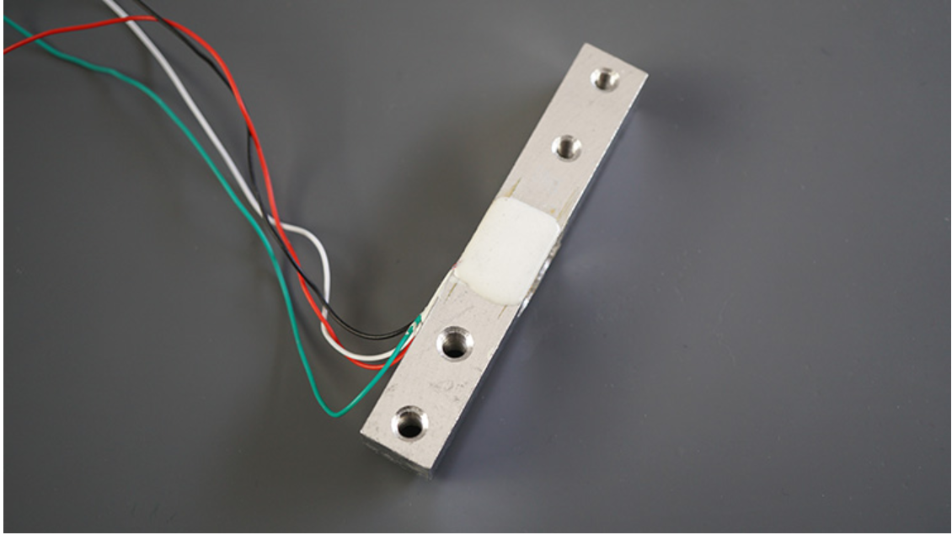

Figure ‎3‑2: 20 KG load cell weight sensor. [20]

The wires coming from the load cell usually have the following colors:

* Red: VCC (E+)
* Black: GND (E-)
* White: Output – (A-)
* Green: Output + (A+)

#### Working principle of load cell weight sensor

In a load cell, strain gauges acting as variable resistors are attached to a metal bar that bends under an applied load. When no load is applied, the resistances in all the strain gauges remain equal and balanced. This results in no voltage difference across the Wheatstone bridge output, as illustrated in Figure ‎3‑3.

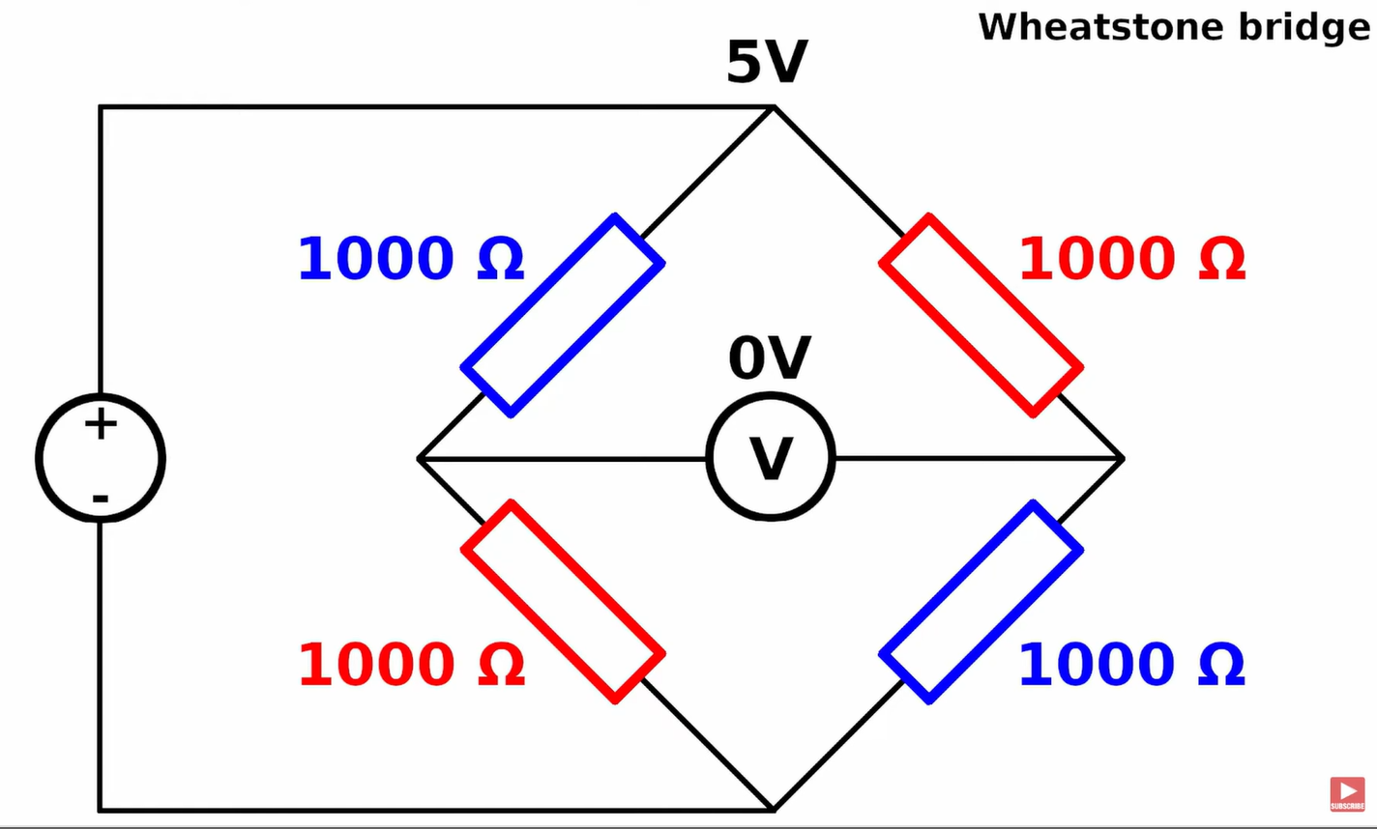

Figure ‎3‑3: Voltage difference of load cell when no weight applied. [20]

But on application of a load, it brings into a slight bending of the metal bar. This bending causes the gauges located at the top surface of the bar to be compressed in nature and leads to a slight increase in resistance. Gauges located on the bottom surface of the bar are stretched, resulting in the decrease of their resistance.

These imbalances in the resistances across the Wheatstone bridge legs result in a voltage difference at the output. This voltage output, which is proportional to the level of bending/load applied, will give an indication of the applied force/weight, as illustrated in Figure ‎3‑4.

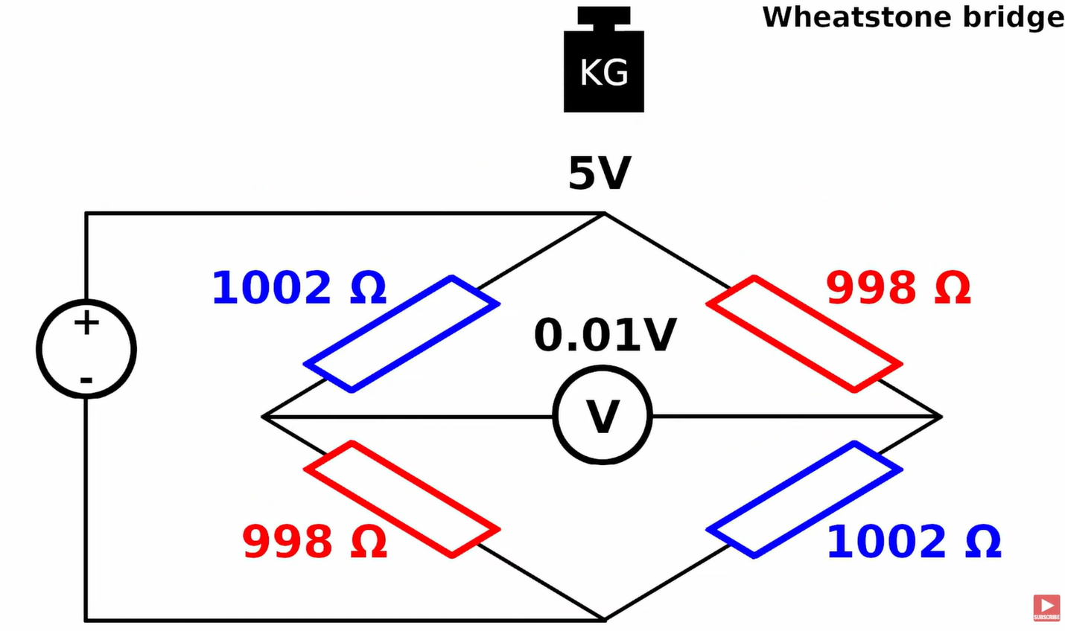

Figure ‎3‑4: Voltage difference of Wheatstone bridge when weight applied. [20]

#### Connecting the Load Cell to the HX711 Module and Arduino

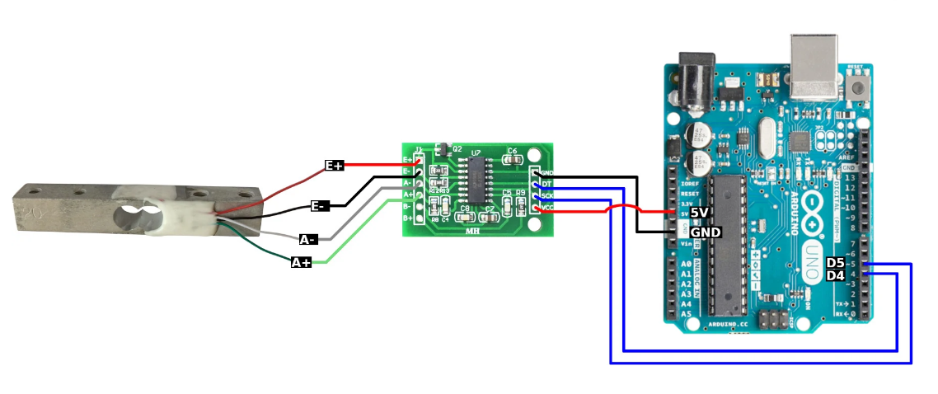

Figure ‎3‑5: Connections of load cell to the HX711 module and Arduino. [20]

A load cell connected directly to a microcontroller without an amplifier, such as the HX711, presents a number of problems. The load cell generates very small electric signals, of the order of millivolts, which are difficult for microcontrollers to measure and process with precision. These weak signals are subject to noise and interference, which will provide inaccurate results in weight measurements.

Load cells typically also have internal strain gauges that need an excitation voltage, normally 5V. Since most microcontrollers are not capable of supplying this excitation voltage, an external amplifier has to be used, such as the HX711, to provide the required voltage.

We need to create a strain between the opposing ends of the load cell. The easiest way to do that is to attach it between two boards. The bottom board holds scale in place, and the top board is the weighing plate. Making sure we put some spacers between the board and the load cell, so there is room for deformation, as in Figure ‎3‑6.

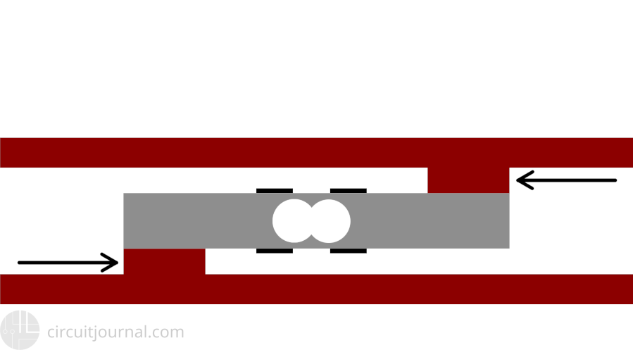

Figure ‎3‑6: No force applied. [23]

When you apply force to the load cell, two of the strain gauges will compress (red) while the other two will stretch (blue) shown in Figure ‎3‑7.

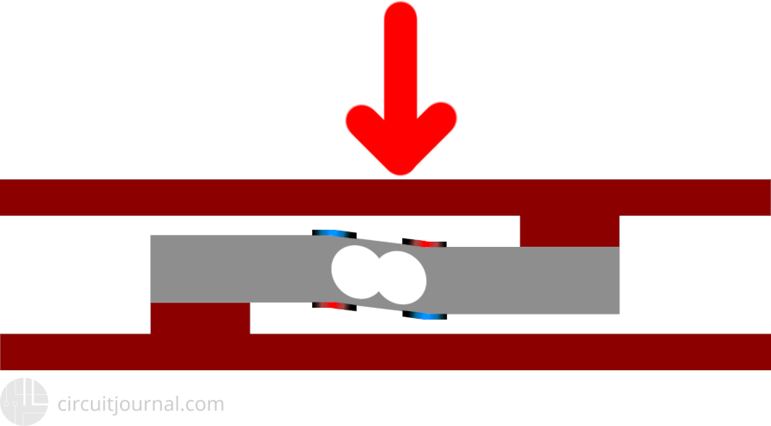

Figure ‎3‑7: Force applied. [23]

#### Load Cell with HX711 Amplifier: Proteus Circuit Diagram

Now that we have completely understood how load cell with HX711 amplifier works, we can connect all the required wires to Arduino and write the code to get weight measurement for the vehicle weighing system. The following figures show the circuit diagram for interfacing the load cell with Arduino using Proteus 8 Professional, as in Figure ‎3‑8.

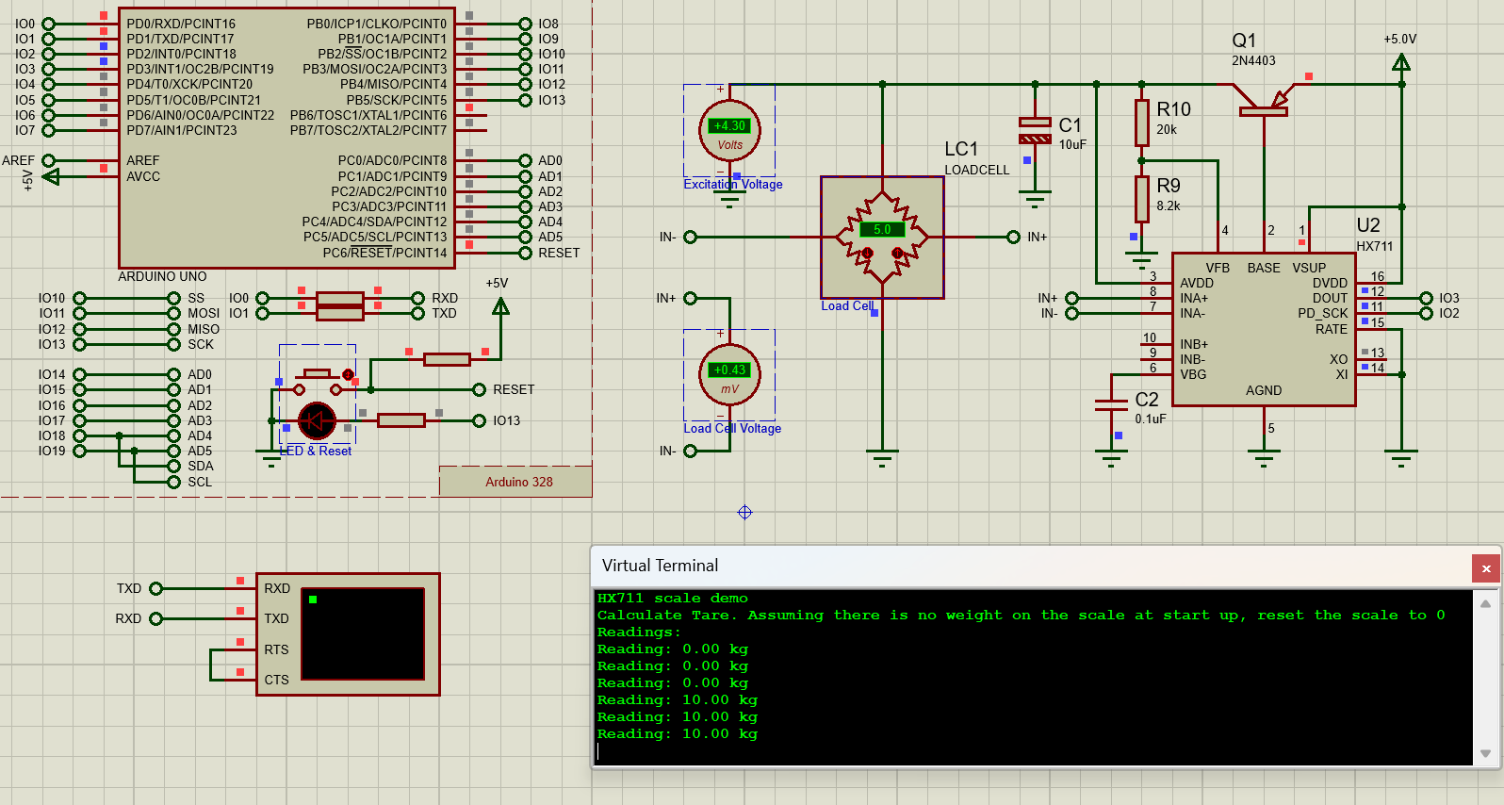

Figure ‎3‑8: Sample project of load cell with HX711 amplifier on Proteus using Arduino.

#### Hardware Implementation

The hardware implementation of a weighing system beneath the road surface in a tolling system for trucks is important for the sake of ensuring fairness and speeding up the toll collection process, as illustrated in Figure ‎3‑9. For a tolling system, the presence of the load cell beneath the road surface collects data of real-time weight of the truck. Such data can be fed seamlessly to an automatic system that calculates applicable toll fees based on the load. As shown in the figure, the load cell placed beneath the road surface ensures accurate weight measurements with no influence on the flow of traffic. An automated system using load cell data allows fair and consistent applications of toll fees, without any chance of human error or bias. This technology allows for the overall efficiency of toll collection, which will lead to ease and expedited traffic while maintaining fairness in the fee calculation process, as shown in Figure ‎3‑10 and Figure ‎3‑11.

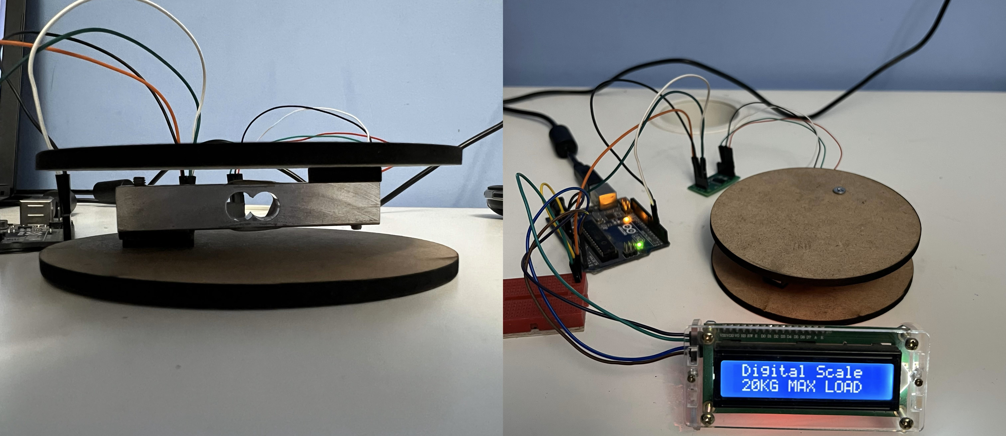

Figure ‎3‑9: Intelligent truck weighing management system.

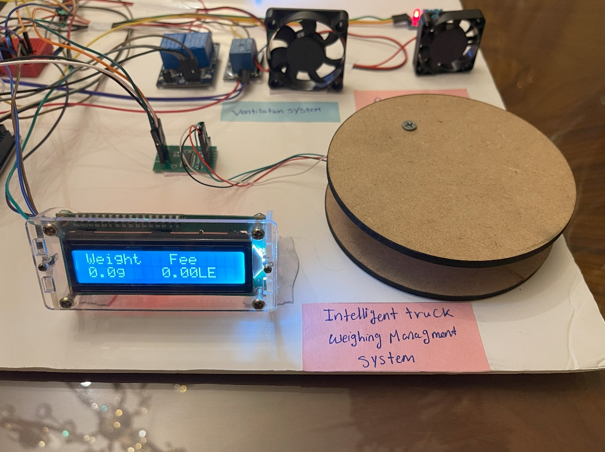

Figure ‎3‑10: No load.

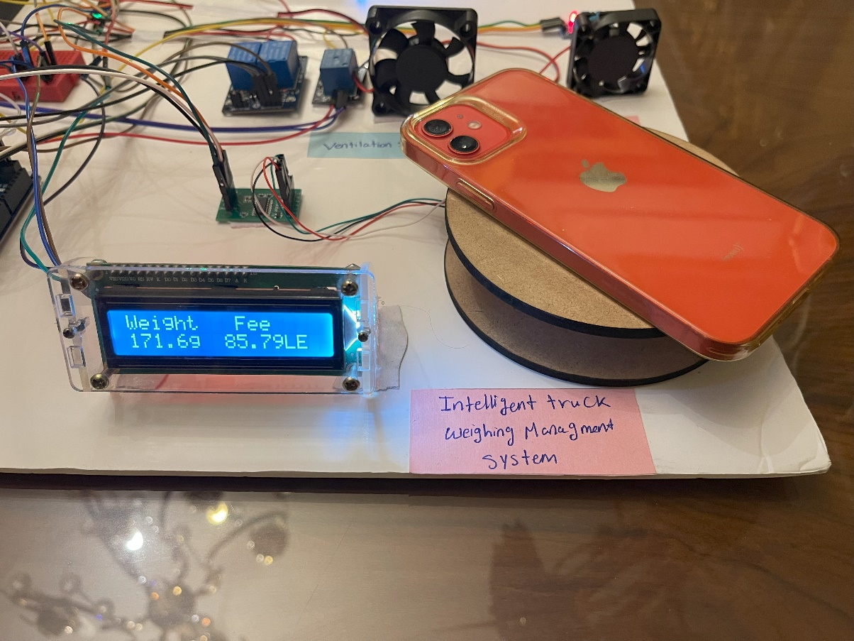

Figure ‎3‑11: Calculated fee for the applied load.

## SYSTEM 2: FIRE SUPPRESSION

### Flame Sensor Module LM393

**Description:**  
A flame sensor is a type of detection device used to detect and respond to the presence or occurrence of a fire or flame. It normally responds and is more sensitive than a heat or smoke sensor because of its detection mechanisms used to locate a flame. These sensors are used in safety equipment to maintain offices, homes, or stores safe from fire accidents.

#### Flame Sensor Module Circuit Diagram

The schematic diagram for the flame sensor module is given below. As mentioned earlier, the board has a very low component count. The main components are the IR photodiode and the comparator circuit, as shown in Figure ‎3‑12.

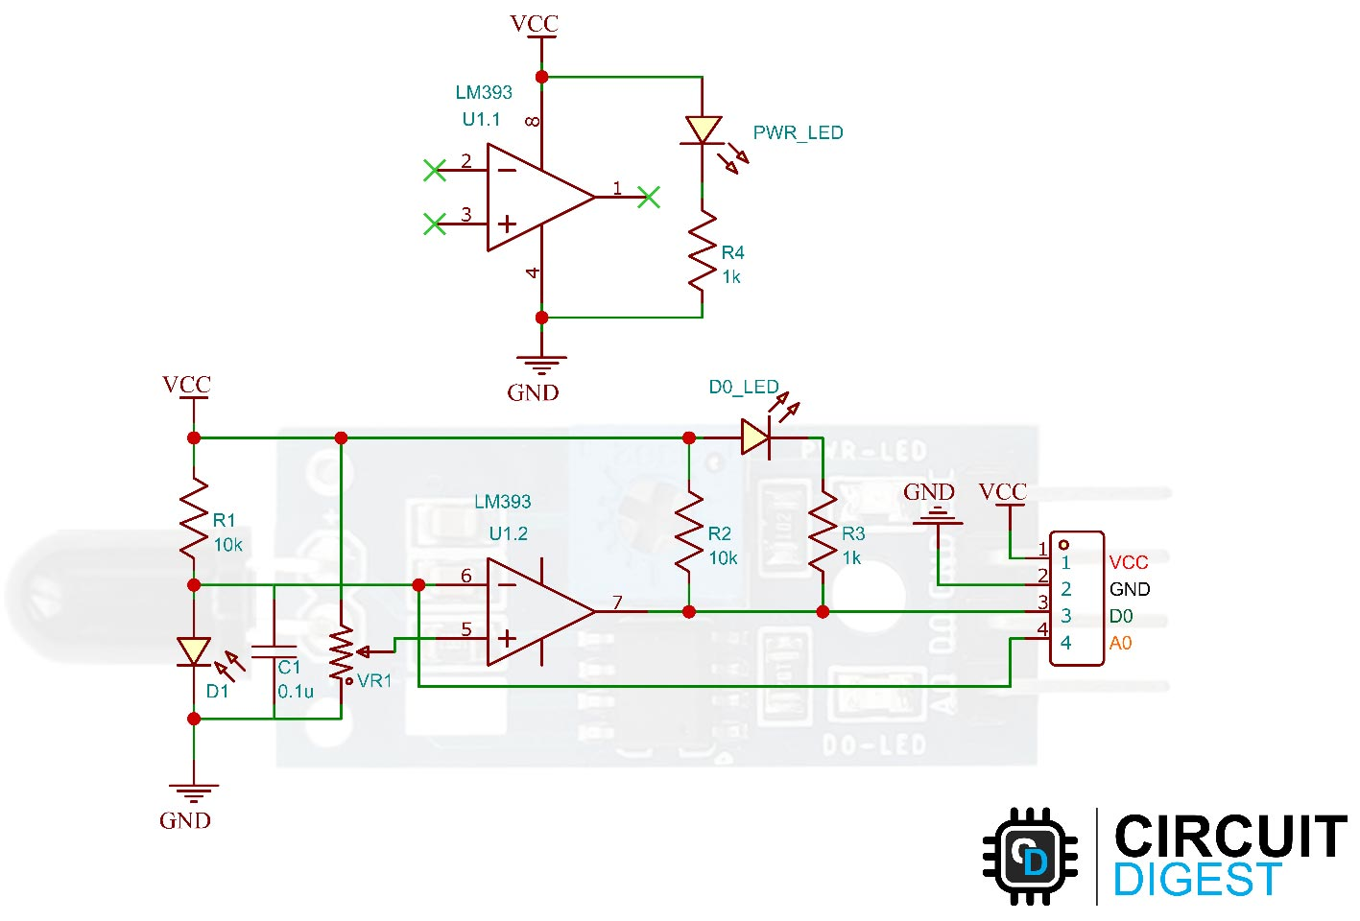

Figure ‎3‑12: Flame Sensor Module Circuit Diagram. [26]

#### Why Flame Sensor Module LM393?

The choice of the flame sensor module LM393 for the fire suppression system shall be based on the considerations of different aspects. The sensor specifications shall meet the fire suppression system requirements to make it adequate and effective to detect flames. Moreover, the LM393 module is fairly low-cost, with a price justifiable for its function. The wide availability of this product in the market will facilitate easy integration with the system. Functionality is one of the most important factors, and the LM393 module is able to detect flames accurately and reliably, with the performance described in Table ‎3‑3 and Table ‎3‑4 below.

**Table ‎3‑3: Selection criteria of flame sensor module LM393.**

| **Sensor** | **Reason for Selection/Rejection** |
| --- | --- |
| TMP35 and  LM35 | Rejected as these only function with electronic devices using transfer  equations to calculate the voltage. Unable to directly detect heat. |
| MLX90614  Infrared  Thermometer | Potential for direct heat measurement but library support lacking on  Proteus 8 Professional. |
| **Flame Sensor with LM393** | **Selected as it enables direct heat/flame detection.**  **Libraries available to simulate on Proteus 8 Professional, allowing**  **testing before procurement.** |

**Table ‎3‑4: Flame sensor module specifications.**

| **Specification** | **Description** |
| --- | --- |
| Operating Voltage | 3.3V to 5V |
| Operating Current | 15 mA |
| Comparator Chip | LM393 |
| Sensor Type | YG1006 Phototransistor |
| Sensitivity | Adjustable by potentiometer |
| Output Type | Digital o/p or Digital & Analog output |
| Red LED | For power |
| Green LED | For output |
| Spectrum Range | 760 nm to 1100 nm |
| Detection Angle | 0 to 60 degrees |
| Operating Temperature | -25℃ to 85℃ |
| Range | Accurate up to about 1m |

#### ****Flame Sensor Module Parts****

The flame sensor module has only very few components, which include an IR photodiode, an LM393 comparator IC, and some complimentary passive components. The power LED will light up when the module is powered and the D0 LED will turn off, when a flame is detected. The sensitivity can be adjusted with the trimmer resistor onboard, as in Figure ‎3‑13.

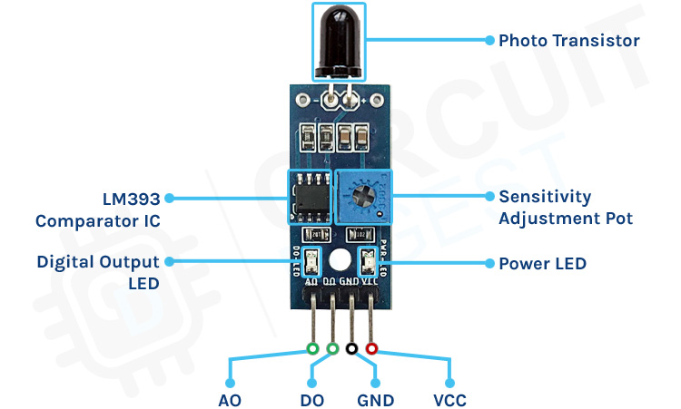

Figure ‎3‑13: Pinsfunctions. [26]

* VCC: 5V Power supply
* GND: Ground
* DO: Digital Output
* AO: Analog Output

#### ****How Does the Flame Sensor Module Works?****

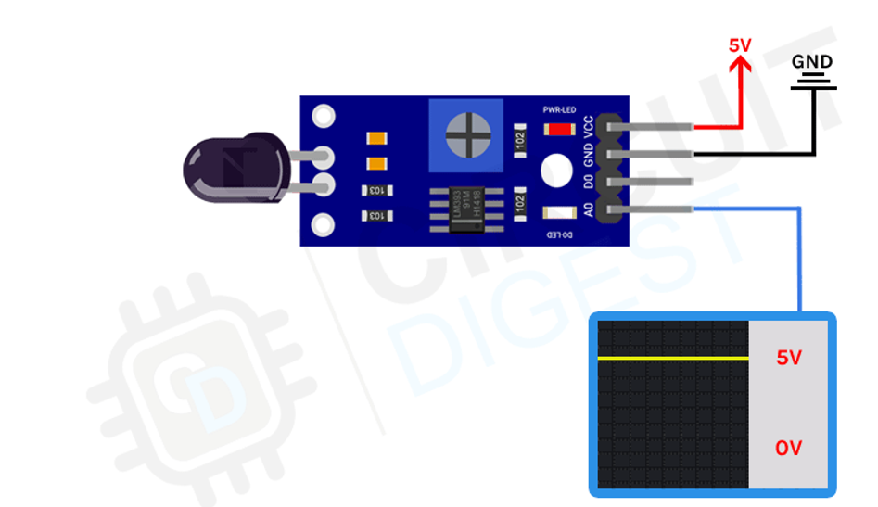

Figure ‎3‑14: Flame sensor module output when no fire in range. [26]

The working of the flame sensor module is simple. The theory behind it is that a hot body will emit infrared radiation. And for a flame or fire, this radiation will be high. We will detect this IR radiation using an infrared photodiode. The conductivity of the photodiode will vary depending on the IR radiation it detects. We use an LM393 to compare this radiation and when a threshold value is reached the digital output is changed, as shown in Figure ‎3‑14 scenario which shows the state when no fire is detected, and Figure ‎3‑15 depicts the condition when a fire is detected.

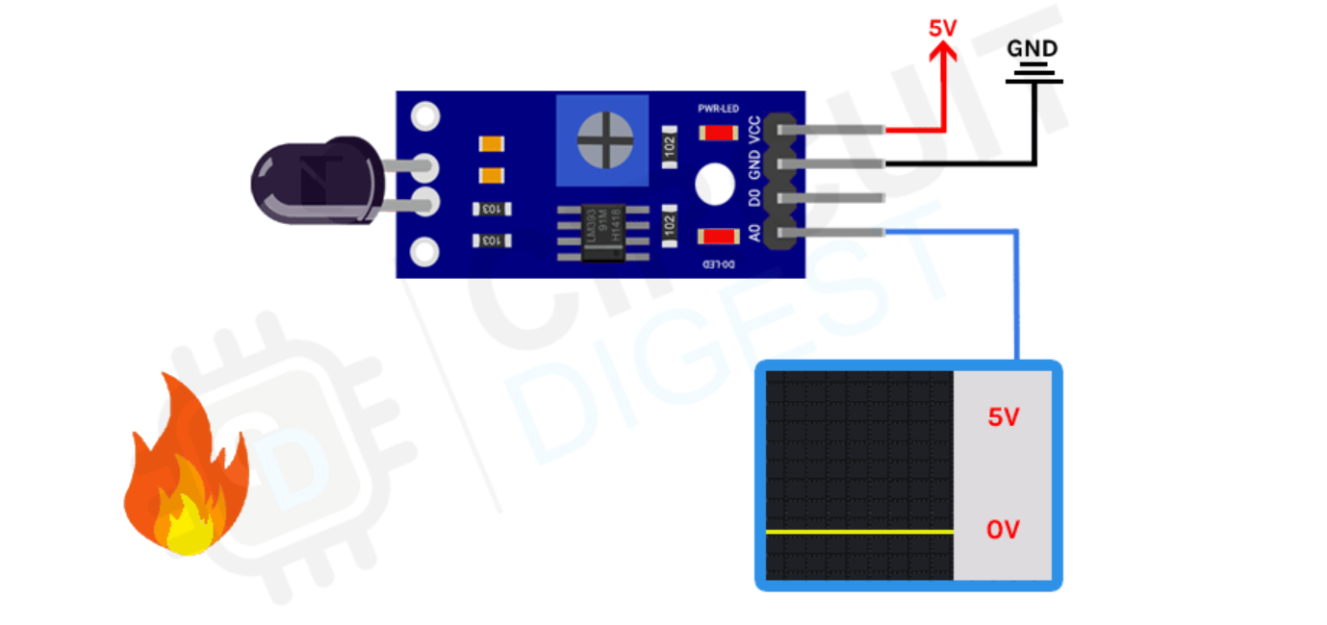

Figure ‎3‑15: Flame sensor module output when fire in range. [26]

#### ****Flame Sensor Interfacing with Arduino: Proteus Circuit Diagram****

Now that we have completely understood how a Flame Sensor works, the following figures show the circuit diagram for interfacing the flame sensor module with Arduino Mega using Proteus, as in Figure ‎3‑16 when fire condition is false and Figure ‎3‑17 when fire condition true.

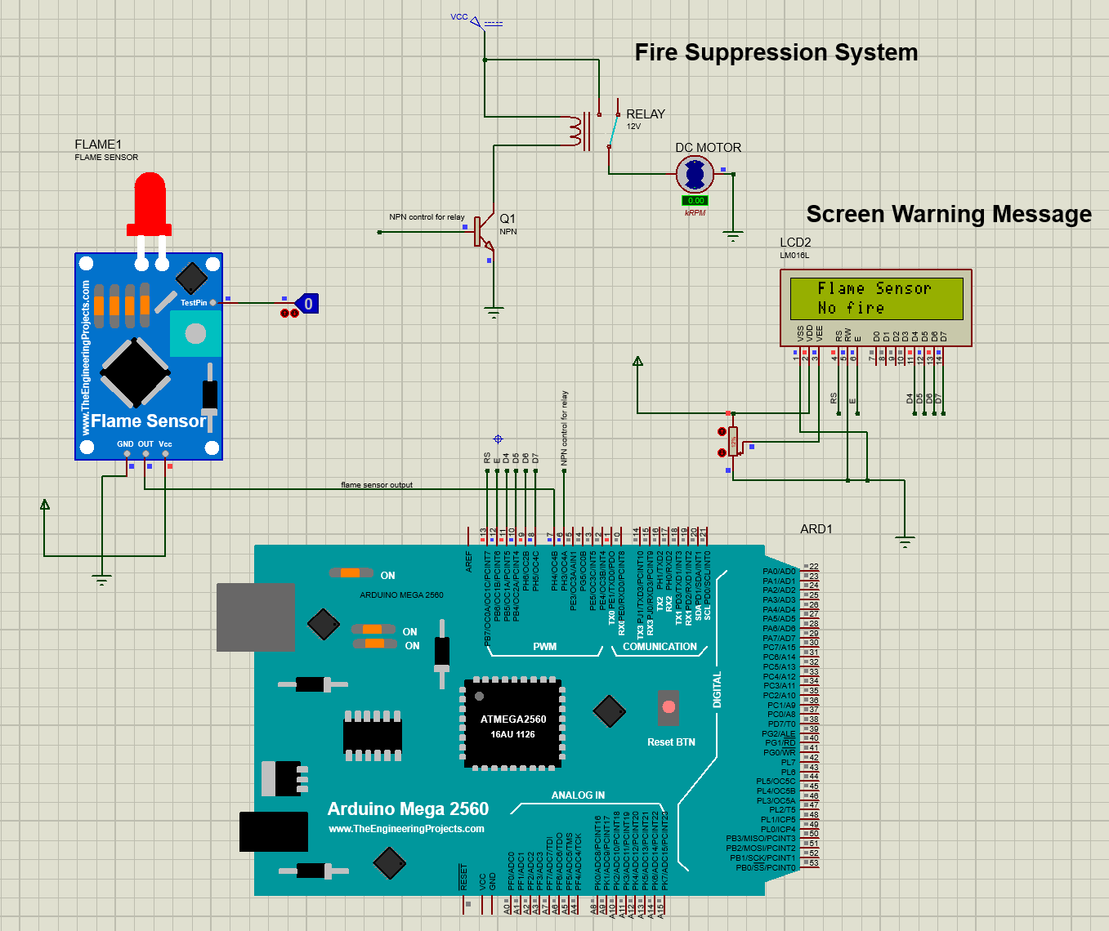

Figure ‎3‑16: Interfacing flame sensor on proteus with test pin is low.

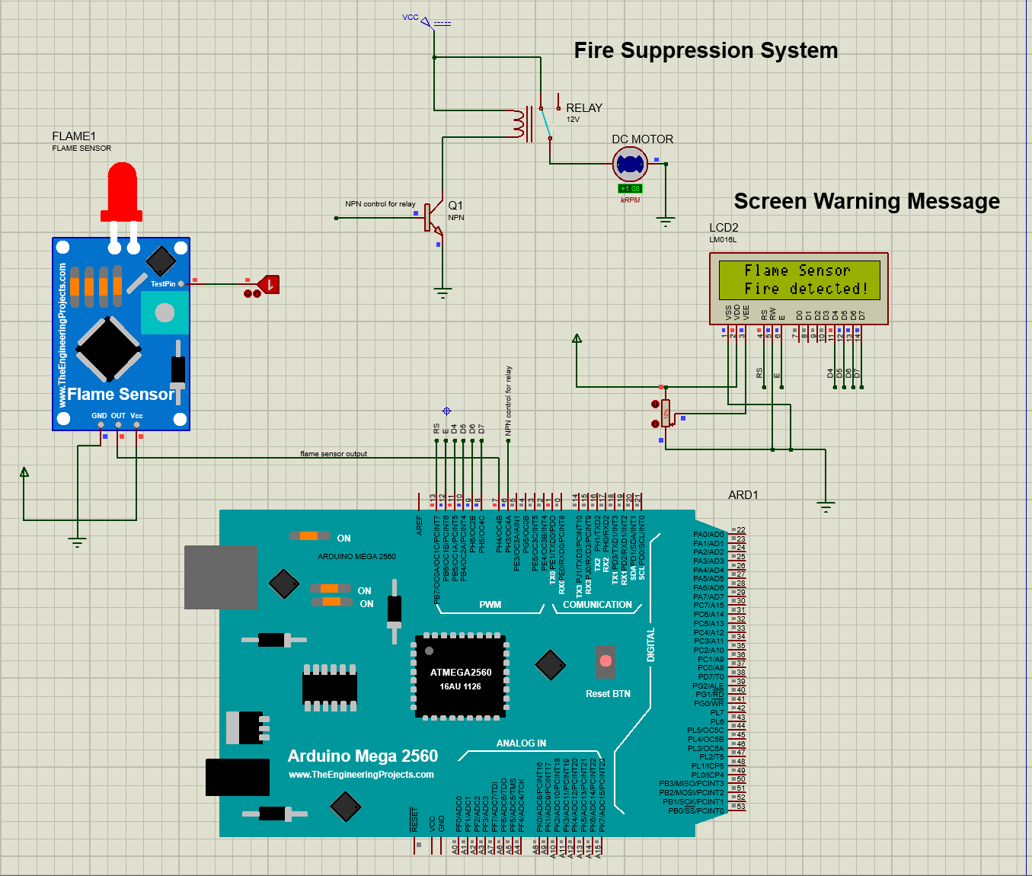

Figure ‎3‑17: Interfacing flame sensor on proteus with test pin is high.

**Advantages:**

* High-speed response
* Resistant to fake alarms
* Long detection distance, environmental adaptability is good & high reliability

**Applications:**

* A flame-sensor is mainly used to detect & react to the occurrence of a flame/fire
* Flame sensors are used in fire alarms, fire detection, drying systems, firefighting robot, industrial heating, hydrogen stations, domestic heating systems, industrial gas turbines, gas-powered cooking devices, etc.
* These are used in MDF factories, pharmaceuticals, fume cupboards, coal handling, spray booths, nuclear industry, fabrication of metal, clothing dryers, aircraft hangars, gas fueled cookers, domestic heating systems, heating & drying systems in industries, generators & storage tanks.

#### Hardware Implementation

The hardware realization of a fire suppression system inside a tunnel incorporates flame sensors to detect fire incidents at the earliest possible instance. When the flame sensor recognizes that a fire exists, it will activate the water pumps to deliver an immediate response to the appearance of flames and douse it to prevent further spread. At the same time, the system sends warning signals to the external LCD displays located outside the tunnel, warning incoming vehicles to prepare to stop, as in Figure ‎3‑18. This is a significant safety measure to prevent possible chain reactions and save incoming traffic. When there is no fire present, the system is on standby and continues to monitor the tunnel environment, as shown in Figure ‎3‑19. This pro-active hardware setup focuses on the responsiveness of the system to emergencies and its strict monitoring stance in regular operational periods contributing largely to the safety of the tunnel and fire prevention.

Water pump

Fire applied

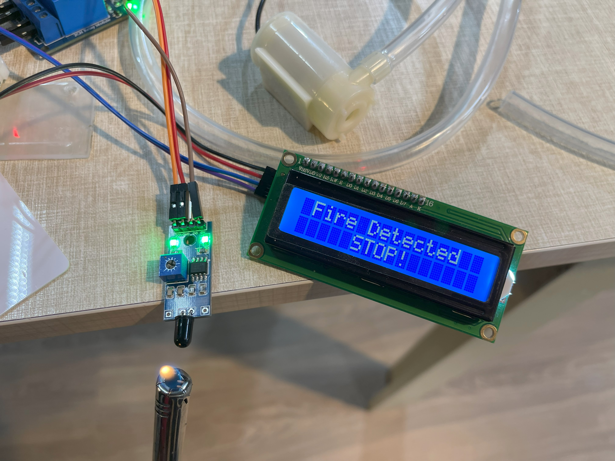

Figure ‎3‑18: When fire is detected, warning message is displayed, and the water pump activates.

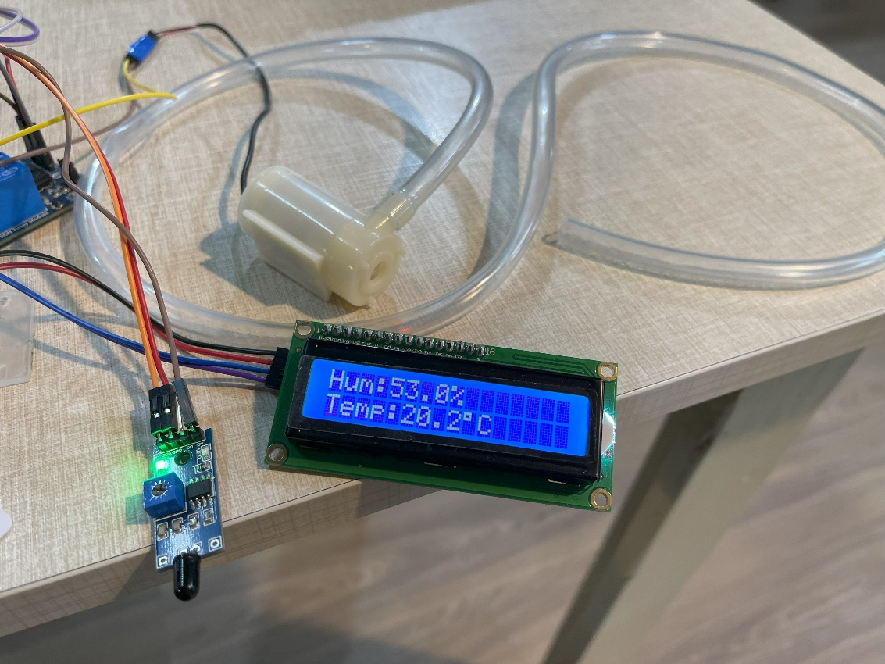

Figure ‎3‑19: Fire suppression system remains idle when there is no fire detected.

## SYSTEM 3: ROAD WEATHER INFORMATION

### Humidity and Temperature Module DHT22

**Description:**

A temperature and humidity sensor is defined as a device that can be used to determine the ambient temperature and humidity of the surroundings, converting the same to electrical signals. These signals are, therefore easily interpretable and measurable. Temperature and humidity transmitters are readily available in the market and measure the air's temperature and relative humidity. This is done by converting the measurement data of a signal which is electrical or of some different standard. This data is, therefore transmitted to the appropriate instrument or software system that will reflect the environmental monitoring requirements of the user. This kind of technology is necessary for maintaining optimum conditions within which precise and reliable environmental control is performed.

#### DHT22 Sensor Module Circuit Diagram

The DHT22 sensor module circuit diagram portrays the connections of the temperature and humidity connections for accurate readings; see Figure ‎3‑20 for details.

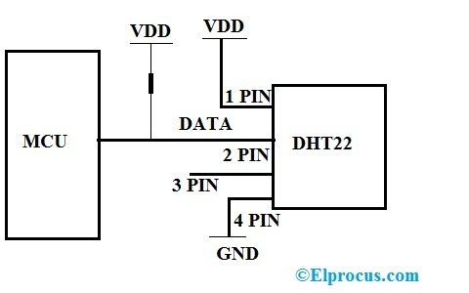

Figure ‎3‑20:DHT22 Sensor Module Circuit Diagram.

1) VCC is Connected to the Supply of the Arduino

2) Data is the pin connected to the Arduino

3) NC not connected

4) GND is Connected to the ground

#### Why DHT22 Sensor Module?

The selection of the DHT22 sensor as the sensor to be adapted to the environmental monitoring system is based on a highly prolific evaluation of a few yet very important aspects. The first and the most important are its technical specifications that make it highly feasible for the measurement of both temperature and humidity with accuracy and reliability, important parameters that must be met by the system. The second would be its cost-effectiveness, therefore maintaining quite a fine balance between performance and affordability. Finally, the sensor is readily available in the market, thus ensuring availability and timelessness. It is also to be importantly noted that DHT22 is a very precise sensor and with long-term stability performance, two factors that are good for constant environmental monitoring. The sensor's reliability and the fulfilling of the system requirements are evident from the data presented in Table ‎3‑5 and Table ‎3‑6 below.

**Table ‎3‑5: Selection criteria for DHT22 sensor module.**

| **Sensor** | **Reason for Selection/Rejection** |
| --- | --- |
| Adafruit AHT20 | Is not available at the market. |
| AM2301B | There is only one I2C address so it's not a good option when you need multiple humidity sensors. |
| DHT22 | **Libraries available to simulate on Proteus, allowing testing before procurement.** |

**Table ‎3‑6: DHT22 sensor specifications.**

| **Specification** | **Value** |
| --- | --- |
| Temperature Range | -40°C to +80°C |
| Supply Voltage | 3.3V to 6V DC |
| Humidity Range | 0-100% |
| Sensing Element | Polymer Capacitor |
| Accuracy | ±0.5°C (typical)  Humidity +-2%RH (Max +-5%RH); |
| Package | TO-92 |
| Sensor Type | Digital |
| Self-Heating | 0.1°C (typical) |

#### ****DHT22 Sensor Module Parts****

The sensor will come as a 4-pin package out of which only three pin will be used, as shown in the Figure ‎3‑21 below.

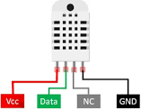

Figure ‎3‑21: Pins functions.

VCC: 5V Power supply

GND: Ground

Data: Digital Output

NC: Not Connected

#### ****How does DHT22 Module Works?****

**First Part is Humidity Sensing Component:**

For humidity measurement, it uses the humidity measurement component, which has two electrodes with moisture holding substrate between them. As humidity changes, the conductivity of substrate changes or resistance between electrodes changes, as shown in Figure ‎3‑22. This changes in resistance are measured, then processed by IC which make it ready to be read by microcontroller.

**Second Part is Temperature Sensing Component:**

To gauge temperature, the sensor employs a Negative Temperature Coefficient (NTC) temperature sensor, commonly known as a Thermistor. A thermistor is a device that acts as a variable resistor; it changes resistance with temperature. These sensors are usually built through sintering, which allows a lot of resistance to be changed with very little temperature change by semiconductive materials, such as ceramics and polymers. The change in resistance occurs with a corresponding change in ambient temperature, and the change is used to measure the environmental temperature most accurately.

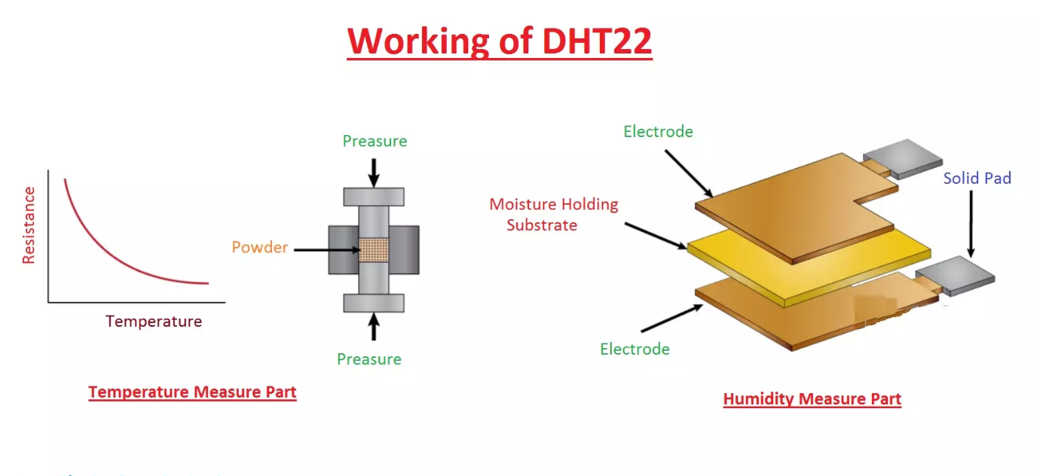

Figure ‎3‑22: DHT22 sensor parts. [30]

#### ****DHT22 Interfacing with Arduino: Proteus Circuit Diagram****

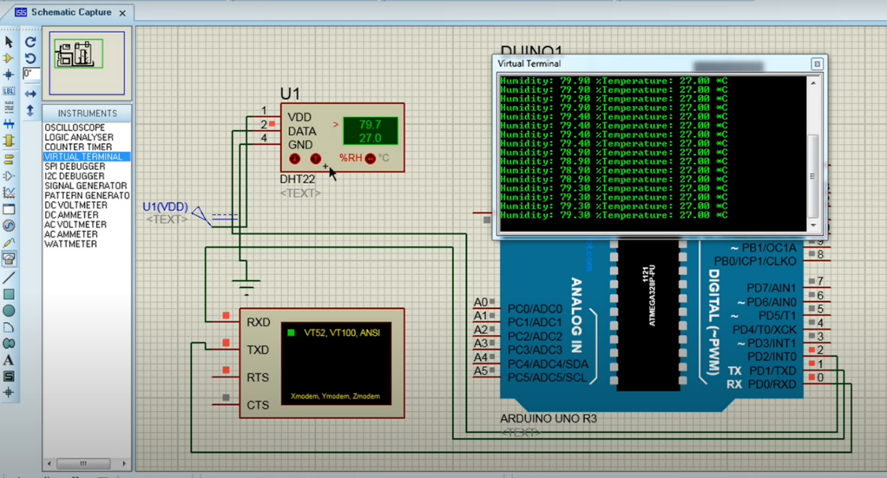

Figure ‎3‑23:Interfacing DHT22 sesnsor on Proteus.

Now that we have a thorough grasp of how the DHT22 sensor works, the above figure shows how to connect the DHT22 sensor module to an Arduino Mega using Proteus. The setup emphasizing the function of the DHT22 sensor in accurate temperature and humidity measurement. This diagram is a useful resource that provides information on how the DHT22 sensor may be easily included into the Arduino Mega configuration for efficient environmental monitoring. As shown in Figure ‎3‑23 DHT22 sensor reads the RH (relative humidity) and temperature in real time.

**Advantages:**

* + High temperature and humidity measurement accuracy
  + Ultra-low power consumption
  + 20-meter signal transmission distance
  + Factory calibrated, easy to use

**Applications:**

* DHT22 is applied in HVAC.
* Testing and Inspection equipment use DHT22 for measuring temperature and humidity values.
* This sensor is used in home appliances and consumer products for measuring temperature and humidity values.
* In medical units to detect the humidity values in isolation units of patients, DHT22 is used.

#### Hardware Implementation

The hardware implementation of the DHT sensor for measuring ambient temperature and humidity effectively gives a significant contribution to controlling environmental management systems, especially in restricted areas like tunnels. The DHT sensor, with an integrated temperature and humidity sensor, can provide in real time the environmental states in the tunnel. This information could be used as an important input to an intelligent ventilation system. After integrating the data of the DHT sensor, the heat and humidity could be fully evaluated, so as to make a decision on whether to open assisting fans. It can adjust the speed of fans according to the changing temperature and humidity levels, and reach the required speed under different ventilation modes. This effectively mitigates the negative effects and can deploy other fans effectively, which makes the environment inside the tunnel more comfortable and safer. This hardware implementation shows the practical implementation of DHT sensors in making responsive and adaptive system implementations for climate control in restricted areas, where the modulation of the fan speed provides an additional layer of precision and efficiency. As presented Figure ‎3‑24 and Figure ‎3‑25.

Assisting fan inactive

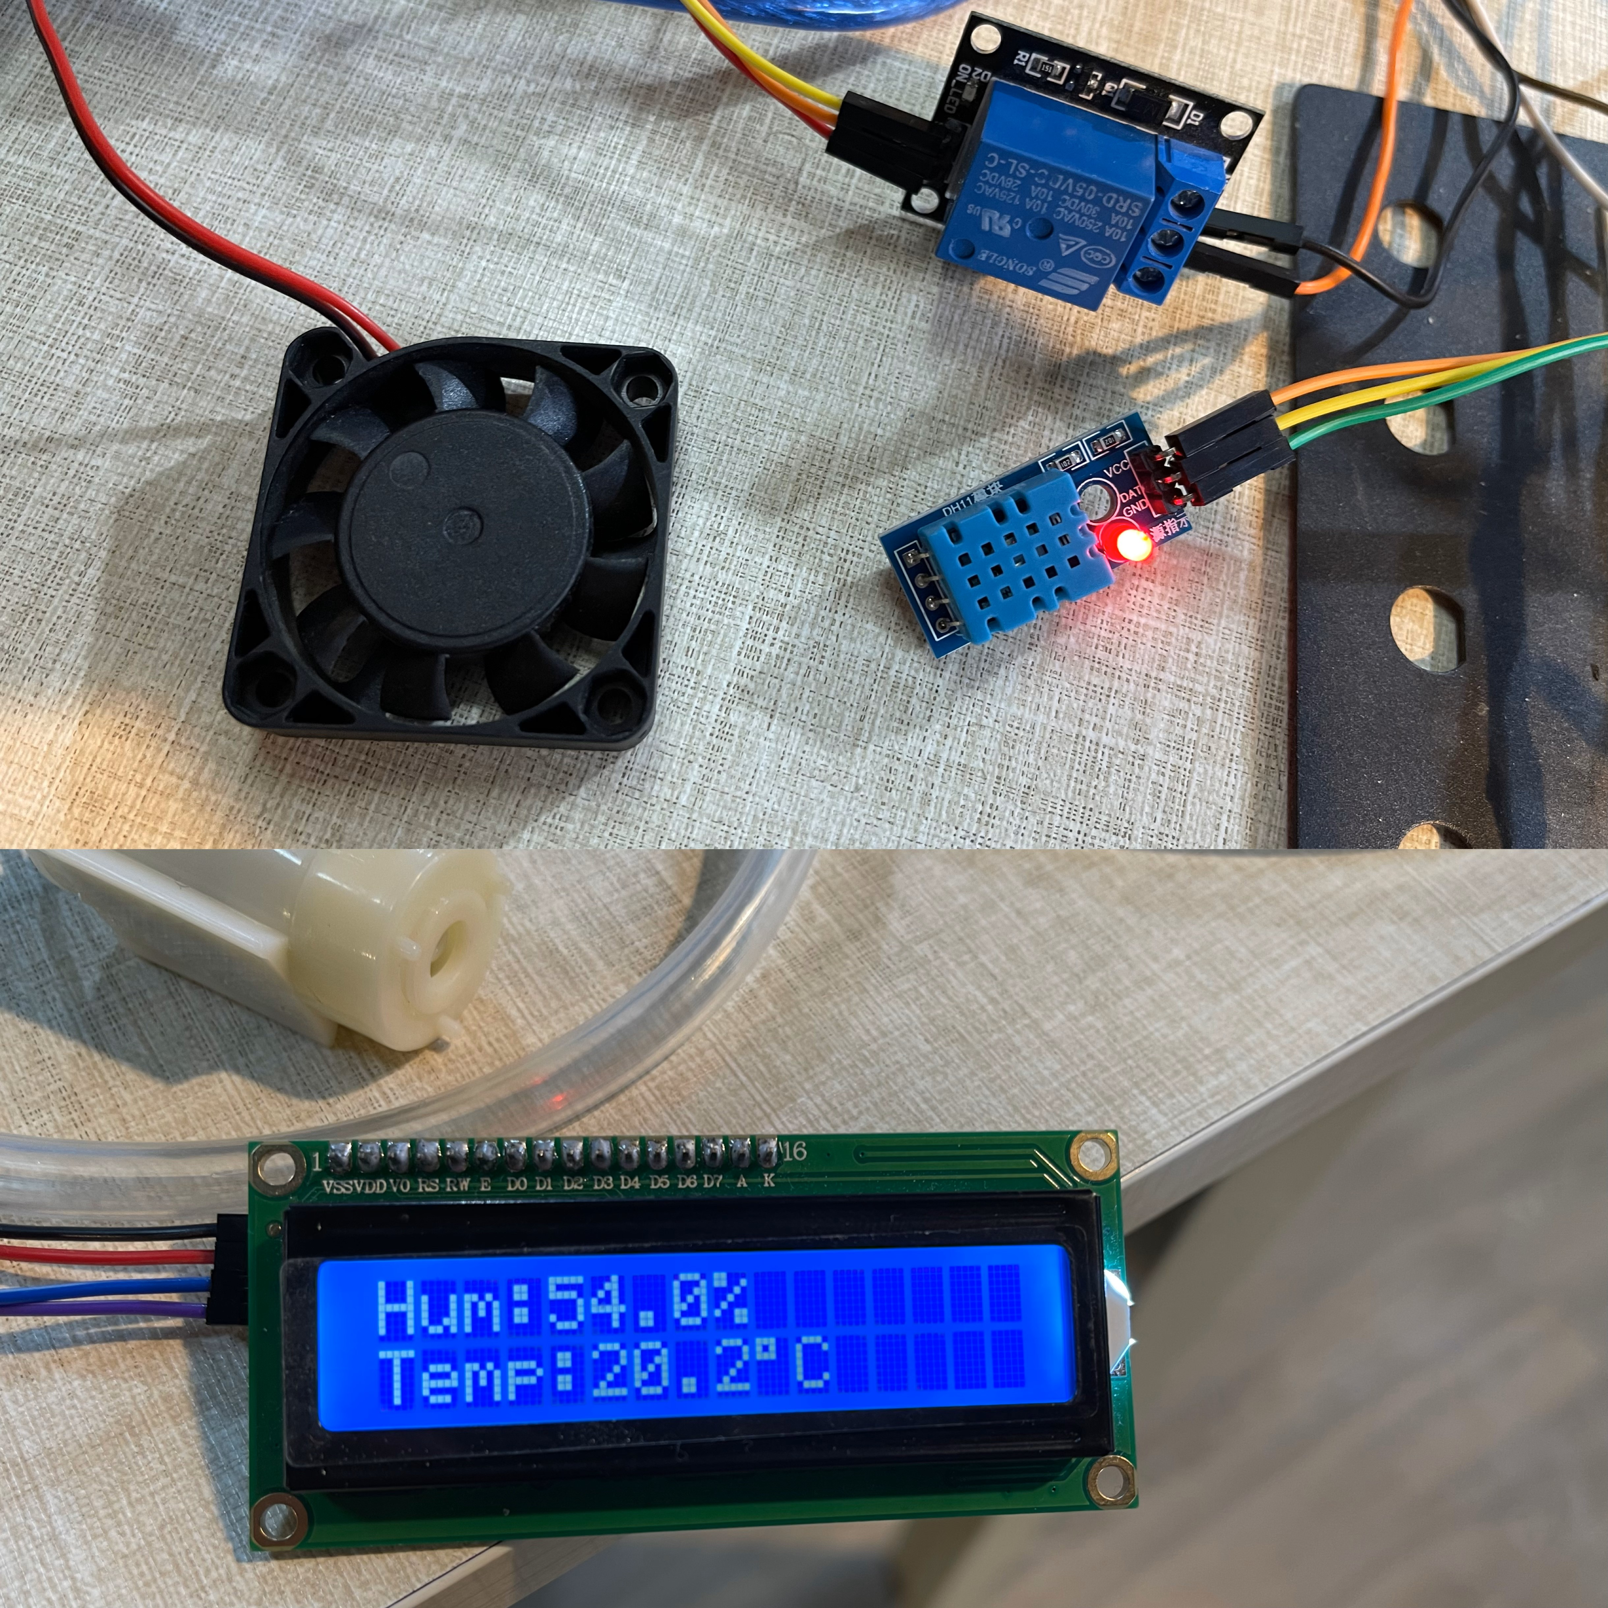

Figure ‎3‑24: Assisting fan inactive when temperature below 23 degree.

Assisting fan activated

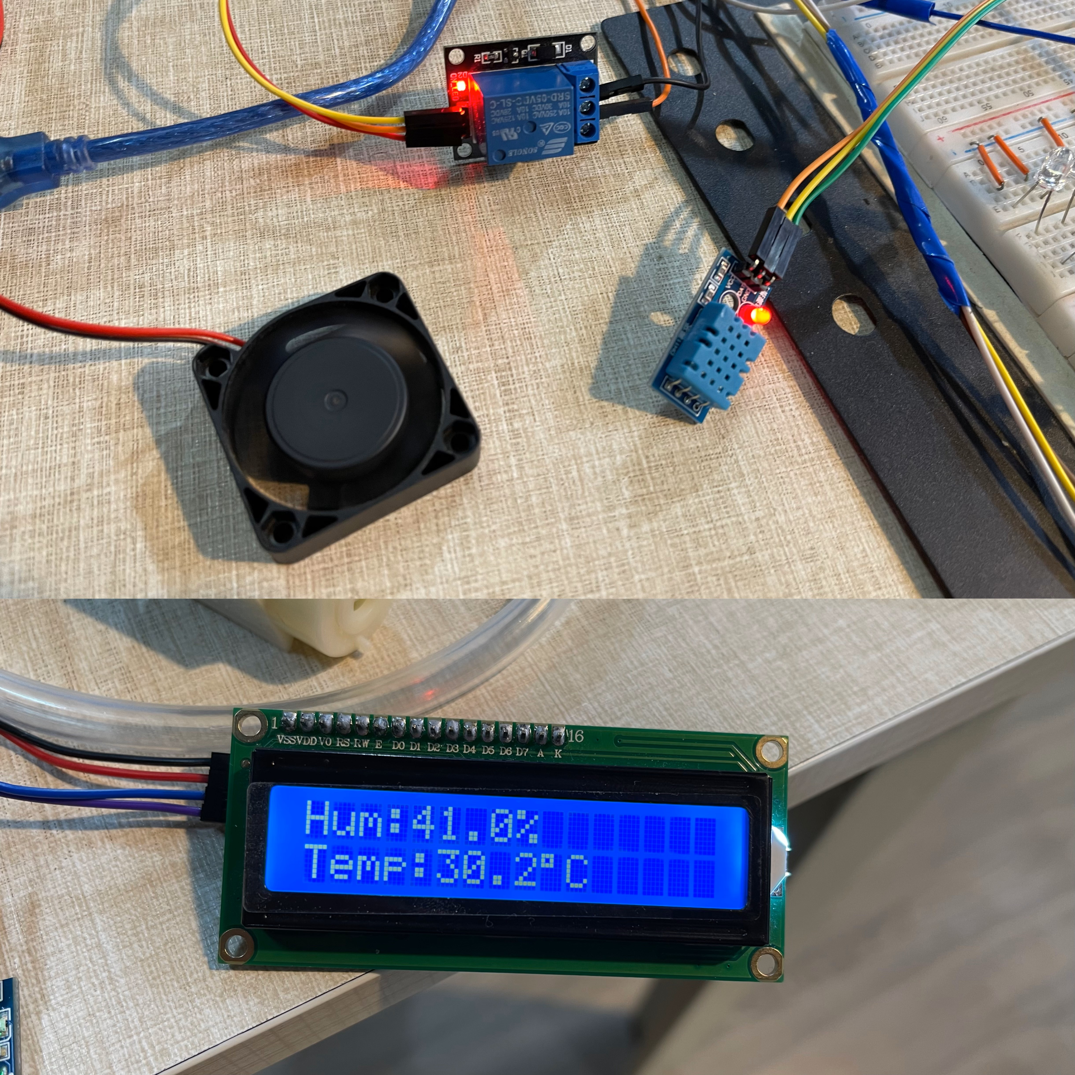

Figure ‎3‑25: Assisting fan active when temperature above 23 degrees.

## SYSTEM 4: AUTOMATIC VEHICLE IDENTIFICATION AND TOLL COLLECTION

### Radio Frequency Identification

**Description:**

A Radio Frequency Identification (RFID) system has two main components: the tag attached to the object to be identified and the reader that reads the tag. The reader comprises a radio frequency module together with an antenna, which produces a high frequency electromagnetic field. The tag is normally a passive device; a passive device means it does not have a battery. It has a microchip for storage and processing of the tag information and an antenna to receive and transmit a signal.

#### RFID Working Principle

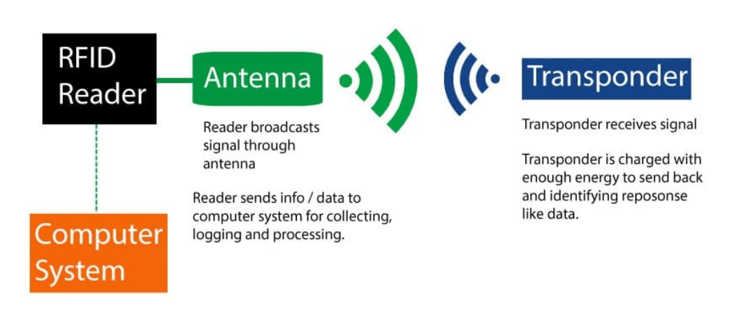

Figure ‎3‑26: RFID working principle.

When the tag is brought close to the reader, the reader generates an electromagnetic field. This causes electrons to move through the tag’s antenna and subsequently powers the chip. The chip then responds by sending its stored information back to the reader in the form of another radio signal. This is called a backscatter. The reader detects and interprets this backscatter and sends the data to a computer or microcontroller, as shown in Figure ‎3‑26.

#### Hardware overview

The RC522 RFID module based on the [MFRC522 IC from NXP](https://www.nxp.com/products/identification-and-security/nfc/nfc-reader-ics/standard-performance-mifare-and-ntag-frontend:MFRC52202HN1) is one of the cheapest RFID options you can get online for less than four dollars. It usually comes with an RFID card tag and a key fob tag with 1KB of memory. And the best part is that it can write a tag that means you can store any message in it. For most of our RFID based Arduino projects, the RC522 RFID reader/writer module is a great choice. It is low power, low cost, very rugged, easy to interface and extremely popular among hobbyists.

#### How to choose the right RFID Technology?

Selecting appropriate RFID technology must be achieved based on the variety of technologies and the specific application for which each is used. The most common, and read, form of RFID technology is the passive, wherein the reader sends out energy that converts to the radio signal that powers the tag; allowing for it to be inexpensive, and appropriate for low range. The active technology is the one that carries energy and has a longer range, enabling the tracking of high-value assets over longer distances. The semipassive is a combination of both. The battery is used to create a stronger signal but does not contribute to the higher cost of the active tag. The features of passive and active RFID shall be discussed in detail in the following, helping you to decide on the RFID technology most suitable to your requirement.

##### Active RFID Tags

**Description:**

The active RFID tags contain in one unit a transmitter, a transponder, and a battery. A battery is used to power the transmitter, and thus, the tag can send data to a RFID reader. Tags with beacons send signals continuously, while transponders send signals when activated by a reader's signal.

**Advantages:**

* Much longer read ranges
* High data memory
* Rugged and weather-resistant housings are available.

**Disadvantages:**

* Higher cost
* Relatively short battery life (usually 3 to 5 years)
* Large size
* Potential to generate noise to work environments

Note: Despite drawbacks, active RFID systems can provide very good Return On Investment (ROI), across a very wide range of operating conditions, and are very commonly used in critical or high-value tracking.

##### Passive RFID Tags

**Description:**

Passive RFID tags receive power from the tag reader through a process called coupling, which provides the power electromagnetically. Readable up to about 20 feet away or closer, the passive tag has practical use in smaller-scale and large-scale RFID-based inventory and asset management systems.

**Advantages:**

* Sold in a greater variety of shapes, sizes, and materials
* Cost per tag much less
* Embeddable formats well suited to a great variety of products or packaging
* May be more durable in use, due to the lack of a battery

**Disadvantages:**

* Read range shorter than with active tags
* Powered from the reader

Note: Passive tags are widely used in item-level tracking, supply chain management, and many access control applications.

##### Semi-Passive RFID Tags

**Description:**

Semi-passive RFID tags are similar in size and ease of manufacturing to a passive tag but include a small, environmentally friendly battery in a similar configuration to an active tag. This battery will boost data transmission to increase the read range and allow for wider data transmission.

**Advantages:**

* Sensor and memory function support to track the condition of the product
* Readable from a medium distance (longer than passive tags)
* Cheaper than active tags

**Disadvantages:**

* Restricted by battery life

Note: Semi-passive tags are a good compromise, with a few more features than passive tags at a lower price than active tags.

#### Working principle

The RC522 RFID reader module creates an electromagnetic field at 13.56 MHz and communicates with the RFID tag. It's an ISO 14443A standard tag. The reader can interface with a microcontroller using a 4-pin SPI at a maximum data rate of 10 Mbps. It also supports communication over I2C and UART protocols. The RC522 RFID module can be programmed to generate an interrupt, allowing the module to alert us when a tag approaches it, instead of constantly asking the module “Is there a card nearby?”. The module’s operating voltage ranges from 2.5 to 3.3V, but the good news is that the logic pins are 5-volt tolerant, so we can easily connect it to an Arduino or any 5V logic microcontroller without using a logic level converter below in Table ‎3‑7 are RC522 specifications.

**Table ‎3‑7: RC522 RFID specifications.**

|  |  |
| --- | --- |
| Frequency Range | 13.56 MHz ISM Band |
| Host Interface | SPI / I2C / UART |
| Operating Supply Voltage | 2.5 V to 3.3 V |
| Max. Operating Current | 13-26mA |
| Min. Current(Power down) | 10µA |
| Logic Inputs | 5V Tolerant |
| Read Range | 5 cm |

#### RC522 RFID Module Pinout

The RC522 module has a total of 8 pins that connect it to the outside world. The connections are as follows in the following Figure ‎3‑27:

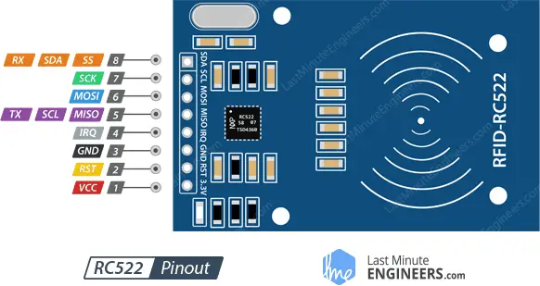

Figure ‎3‑27: RC522 RFID Module Pinout.

1. VCC: Supplies power to the module. This can be anywhere from 2.5 to 3.3 volts. You can connect it to the 3.3V power output pin.
2. RST: Is an input for reset and power-down. When this pin goes low, the module enters power-down mode, in which the oscillator is turned off, and the input pins are disconnected from the outside world. The module is reset on the rising edge of the signal.
3. GND: Is the ground pin.
4. IRQ: Is an interrupt pin that alerts the microcontroller when an RFID tag is in the vicinity.
5. MISO, SCL, TX: Pin acts as master-in-slave-out when SPI interface is enabled, as serial clock when I2C interface is enabled, and as serial data output when the UART interface is enabled.
6. MOSI (Master Out Slave In): Is the SPI input to the RC522 module.
7. SCK (Serial Clock): Receives the clock pulses provided by the SPI bus master.
8. RX, SS, SDA: Pin acts as a signal input when the SPI interface is enabled, serial data when the I2C interface is enabled, and as a serial data input when the UART interface is enabled. This pin is marked by encasing pin in a square so it can be used as a reference.

#### RFID Sensor Interfacing with Arduino: Proteus Circuit Diagram

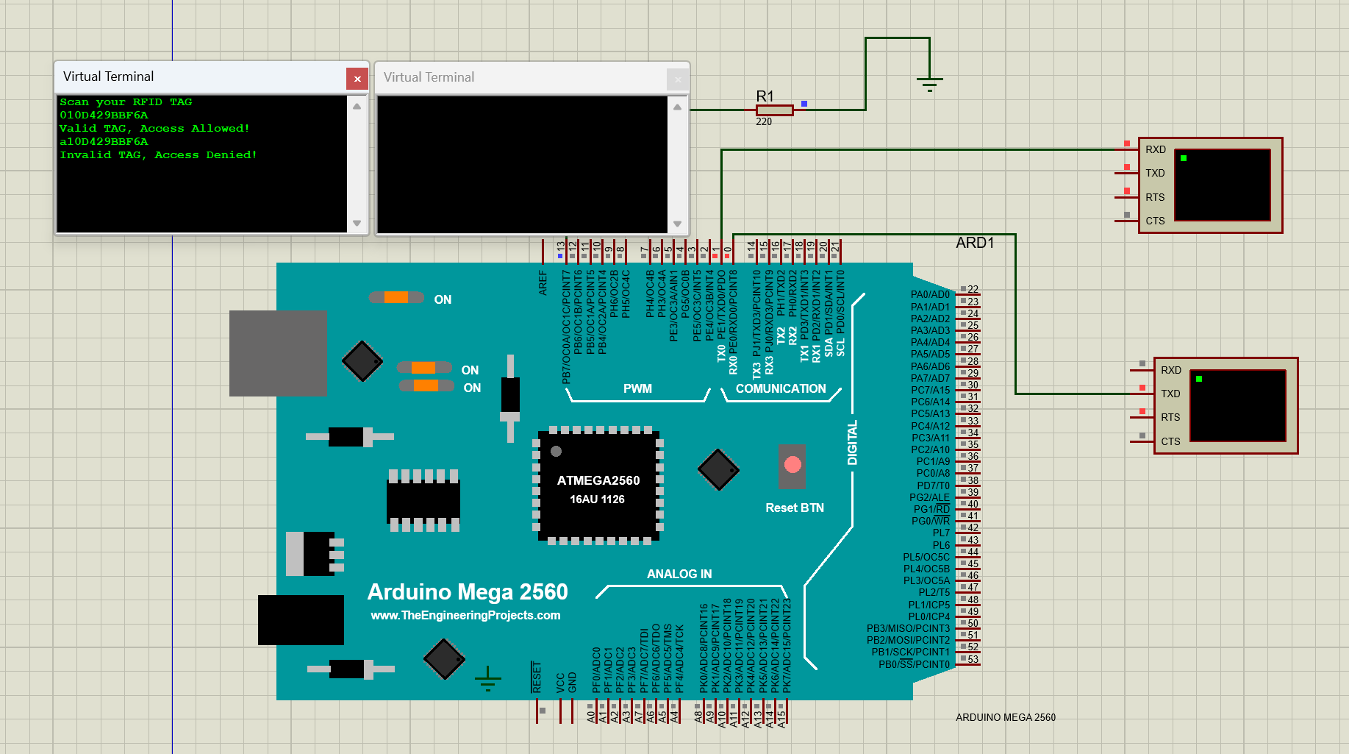

Figure ‎3‑28: Interfacing RFID on Proteus.

In the demonstration, a single RFID system setup is employed to effectively differentiate between authorized and unauthorized access. As illustrated in Figure ‎3‑28, the system's response to two distinct tag IDs is observed.

When the RFID reader scans an authorized tag ID as "010D429BBF6A", then a valid and authorized tag ID is identified. The reader will give a signal and, at the same time, it will give a movement to open the servo connected with the access gate, while the LED is indicated as on. At this point, it will display "Valid TAG, Access Allowed!", just like that allowed entry or access within its programmed behavior.

On the other hand, when any other non-stored tag ID is presented, the system detects this as an invalid tag. It does not send any signal to the servo, which will maintain the closed position, and the LED will not light up. This inaction serves as a warning: "Invalid TAG, Access Denied!", effectively preventing unauthorized access.

**Applications:**

* Automatic billing systems.
* Attendance systems.
* Verification/Identification system.
* Access control systems.
* tracking applications
* supply chain,
* IT hardware
* document controls
* medical facilities
* wristband
* badge access controls.

#### Hardware Implementation

The use of RFID technology in toll collection boosts the throughput and speeds of the traffic flow at the toll gate by many times. In this system, the vehicle has an RFID tag installed in it. The RFID tag has an ID, as shown in Figure ‎3‑29. As the vehicle gets closer to the toll gate, it is scanned by the RFID reader to retrieve its ID. The ID then goes through a pre-installed database to check out if the specific vehicle is registered or has pre-paid the toll to access a particular highway. If the vehicle ID is present in the database of the system, the gate of the toll opens, allowing the vehicle to pass through. The system has a built-in application that closes the toll gate a few seconds after the vehicle has passed to give a secure and non-collision time of passage, as shown in Figure ‎3‑30. On the contrary, if the ID of the vehicle is not recognized or is not in the database in good standing, the gate will be closed. Again, the toll gate will not open, as is the case in Figure ‎3‑31. This RFID-based system for toll collection not only keeps toll congestion under control but also keeps the time spent in the queue down, especially for the regular traveler. The fees will be withdrawn automatically from vehicles balance as soon they pass the toll point, as shown in Figure ‎3‑32.

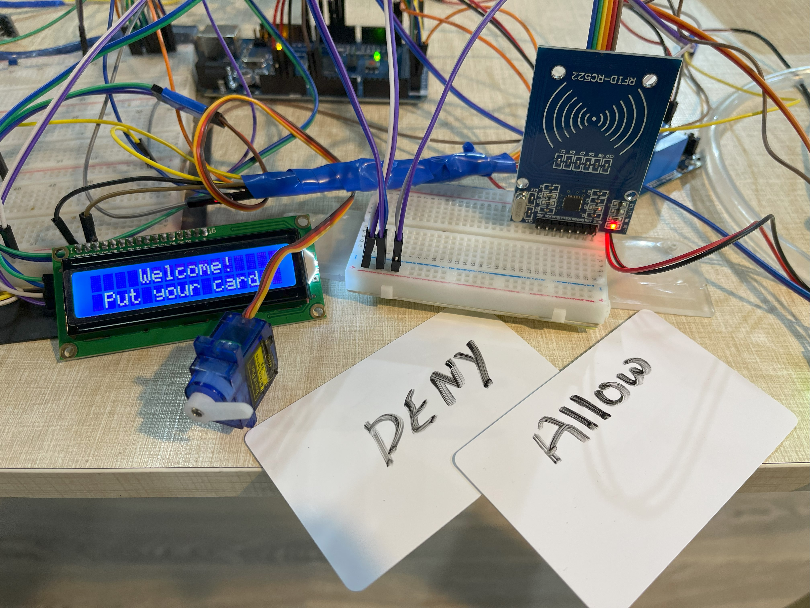

Figure ‎3‑29: Automatic tolling and vehicle identification hardware.

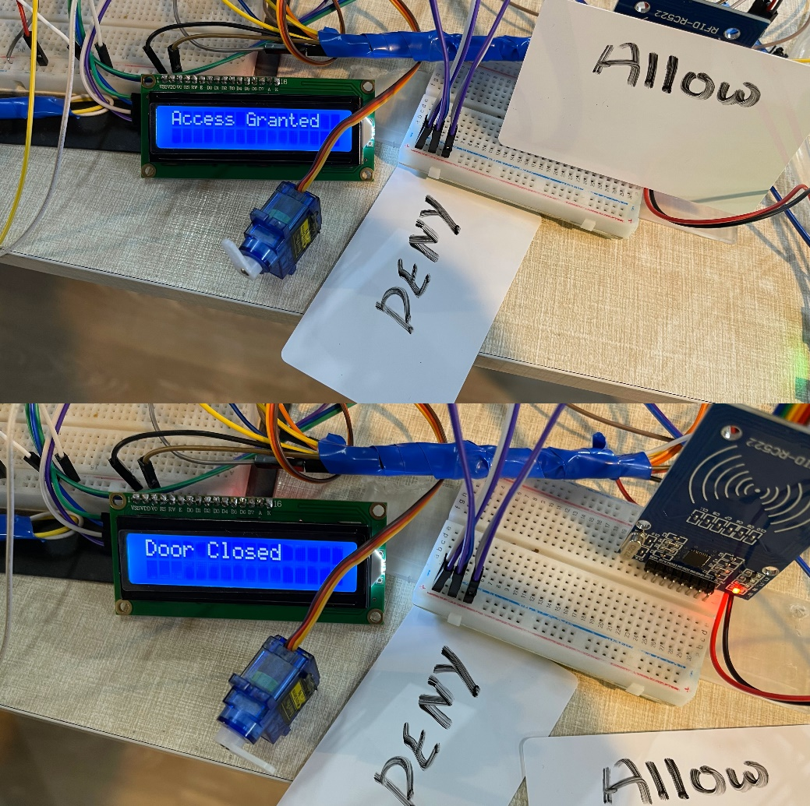

Door opened

(a)

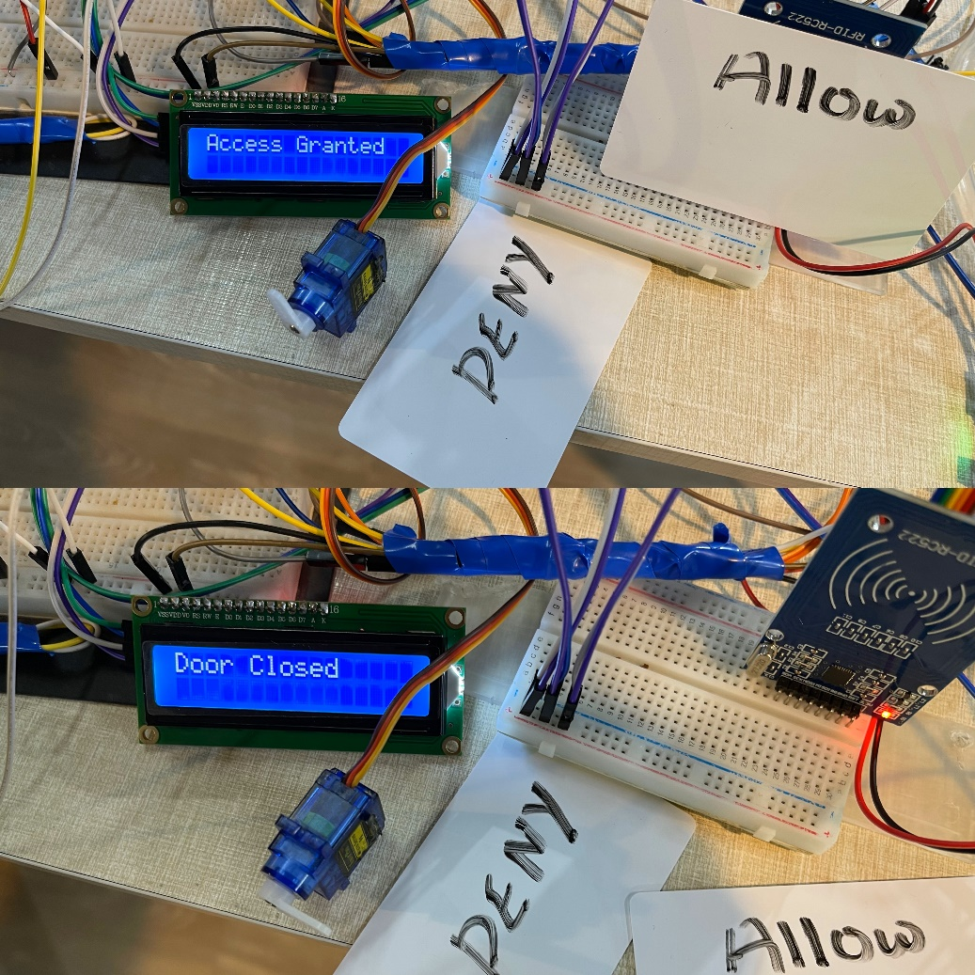

Door closed

(b)

Figure ‎3‑30: (a) Access granted for valid ID. (b) Door closed after a few seconds of passage.

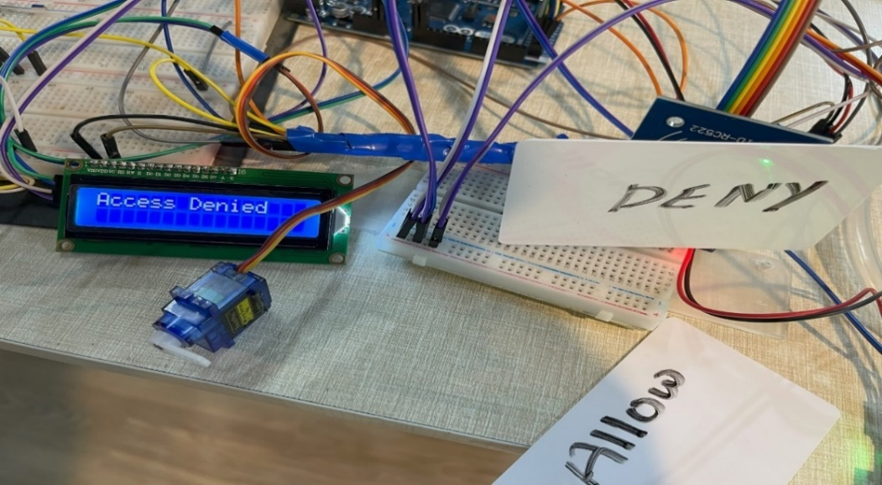

Figure ‎3‑31: Access denied for invalid ID.

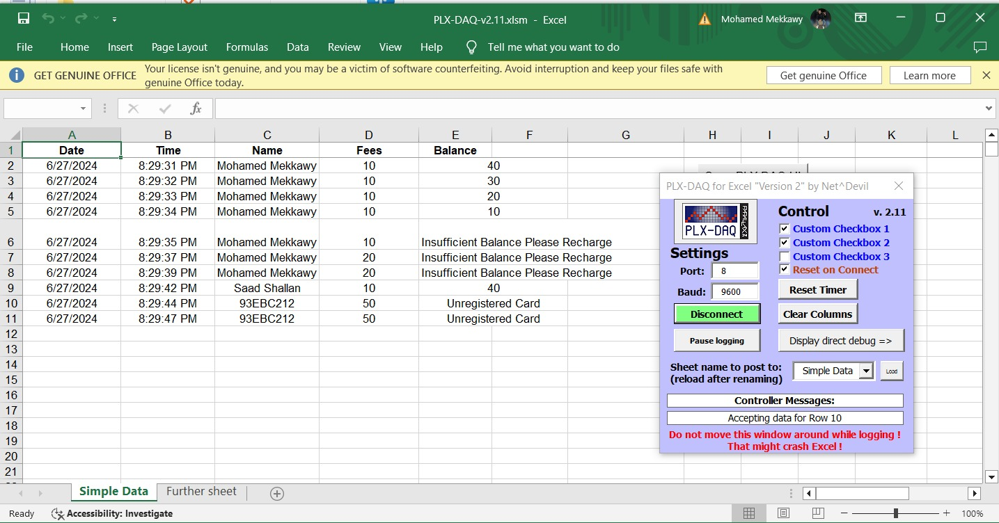

Figure ‎3‑32: Automatic fee withdraw from vehicles balance.

## SYSTEM 5: LIGHTING CONTROL

### Light sensor TSL2561

**Description:**

A light sensor is a photoelectric device or photo sensor and, in its most common form, is a passive device designed to convert light energy into electrical signal output through the photovoltaic effect. This is the process by which light that impinges upon the device releases energy that will be absorbed and, in its most basic form, creates an electron. The light intensity sensors are of different types, including a phototransistor, a photoresistor, and a photodiode.

On One of the practical applications of these sensors is for the realization of the presence or absence of light, which gives insights into the difference between day and night. For instance, during the day, light from the surroundings is absorbed by the sensor, which creates an electrical signal and signifies that the place is well lit. However, during the night or in the darkness, this input of light is reduced, and this yields a different signal that suggests the place is dark. These features make light sensors one of the most critical sensing elements, specifically in automatic lighting control, since the level of surrounding light is detected to assess the need for artificial lights.

#### Light Sensor TSL2561 Circuit Diagram

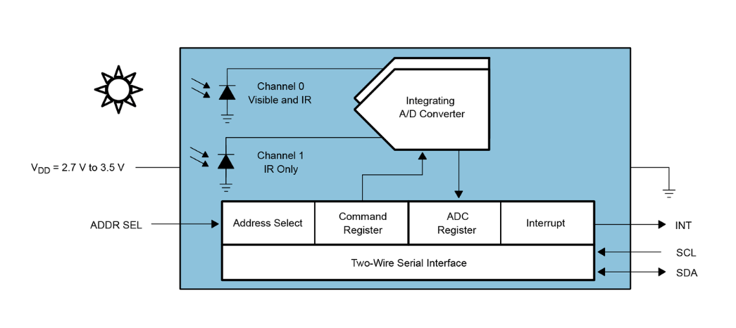

Figure ‎3‑33: Light Sensor TSL2561 Circuit Diagram. [32]

The Light Sensor TSL2561 Circuit Diagram in Figure ‎3‑33 provides a clear explanation of the connections and components required for the successful realization of the TSL2561 light sensor module, as depicted in Figure ‎3‑34. This circuit diagram will be helpful to infer the wiring and operation of the sensor; it will define different pins such as VCC for a power supply, GND for grounding, SDA for serial data communication, SCL for serial clock synchronization, and INT for generating interrupt signals according to a threshold value provided for light intensity. This circuit diagram shall be quite useful for any individual who intends to use TSL2561 in various applications to achieve intelligent lighting systems or highly sophisticated monitoring devices.

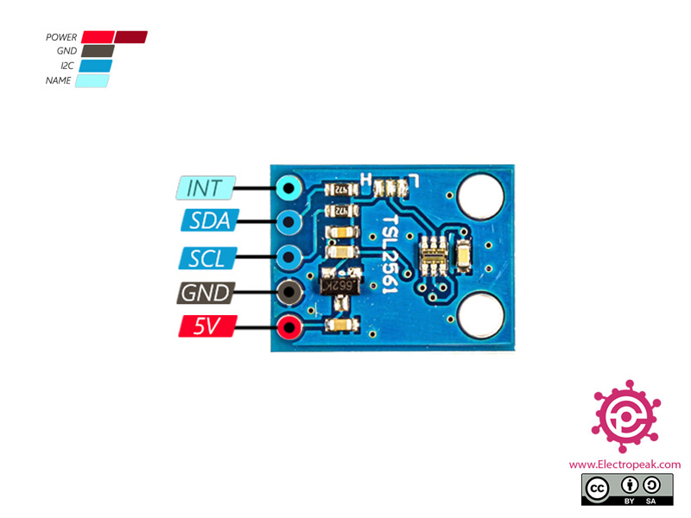

Figure ‎3‑34: TSL2561 module pinout.

#### Why TSL2561 Module?

The choice of the best light sensor will depend on what exactly the application demands. To determine which features are most important, one must consider the important criteria and perform a comparison between sensors against this set of criteria. Other than the technical specifications, cost, package type, availability, and ease of use are all key criteria to be able to make a fair judgment in selection. For an in-depth comparison between various sensors and specific specifications of TSL2561 used, refer Table ‎3‑8.

**Lux Performance:**

1. BH1750: It measures illuminance in the lux range, from 0.1 to 400,000 lux.
2. LTR-329ALS: It measures illuminance in lux from 0.5 to 50,000 lux.
3. TSL2572: Outputs measure of illuminance in lux, ranging from 0.1 to 130,000 lux.
4. TSL2561: It measures illuminance in lux, ranging from 0.01 to 40,000 lux in high sensitivity mode.

**Voltage and Current:**

1. BH1750: It works at 1.8 to 3.3 V, and in the standby mode, the current is 0.7 μA.
2. LTR-329ALS: It operates at 2.7 to 5.5 V, and in the standby mode, it consumes 1.6 μA.
3. TSL2572: It operates at 2.7 to 3.6 V, and in the standby mode, it consumes 1.2 μA.
4. TSL2561: It operates at 2.7 to 3.6 V, and in the standby mode in high sensitivity mode, the current is 1.5 μA.

**Additional Features:**

1. BH1750: Small in volume and low in power consumption with high accuracy, for simple applications.
2. LTR-329ALS: High accuracy, large dynamic range, flicker rejection, and interrupt functionality.
3. TSL2572: Visible and IR sensitive; proximity for approach and gesture detection.
4. TSL2561: High accuracy and resolution, high sensitivity mode, and programmable.

**Summary:**

1. For high accuracy and wide dynamic range, it may be best with the LTR-329ALS.
2. In the case of lower power consumption and simple applications: the first option should be the BH1750.
3. TSL2572 is suitable for visible and IR detection for proximity and gesture sensing.
4. TSL2561 is the most sensitive, powerful, and with good low-light capabilities.

**Table ‎3‑8: TSL256 light sensor module specifications**

|  |  |
| --- | --- |
| Supply voltage | 2.7V to 3.6V |
| Interface | I2C |
| Measuring range | 0.1 – 40,000+ Lux |
| Spectral response | 320nm – 1050nm |
| Peak sensitivity | 560nm |
| Dynamic range | 16-bit |
| Integration time | 13.7ms to 400ms |
| Current consumption | 0.5mA (typical) |
| Operating temperature range | -30°C to +80°C |

TSL2561 light sensor has a feature advantage in that it is highly sensitive under low light conditions. The sensor is at its best for collecting precise data in places with the slightest light, making it ideal in cases where sensitivity is key. Digital (I2C) interface. So, can select one of three addresses and have up to three sensors on one board each with a different I2C address.

#### Hardware Implementation

The hardware implementation of a light sensor module in street lighting systems introduces an approach to energy efficiency and urban lighting management. Integrated into the streetlight infrastructure, the light sensor module will detect the ambient light conditions in real time. When the daylight is sufficient, signaling the daytime, the sensor turns on the automatic deactivation of street lights to save energy and reduce unnecessary illumination, as shown in Figure ‎3‑35. Conversely, when it gets dark and the ambient light starts to decrease, the sensor turns the street lights on so that all pedestrians and drivers can feel safe and see clearly, as in Figure ‎3‑36. This system does not only save energy but also brings environmental protection into urban lighting control.

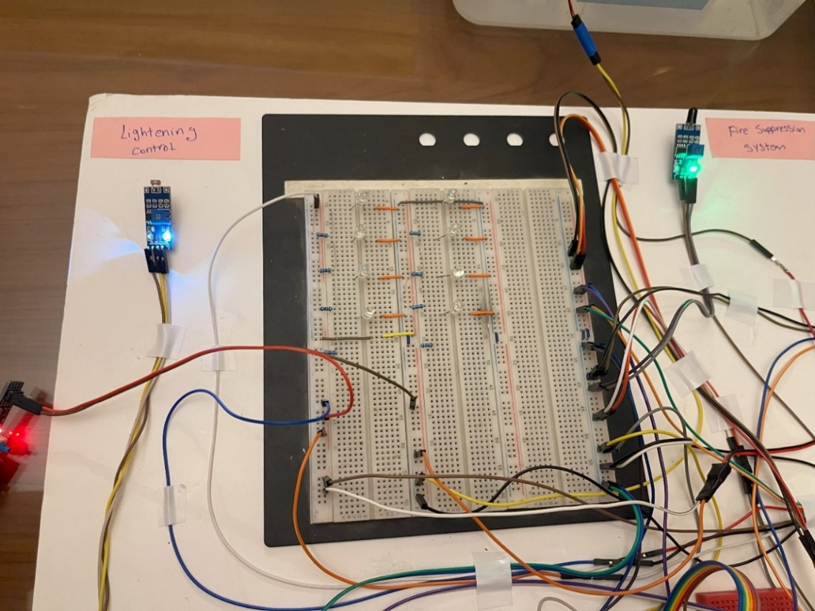

Figure ‎3‑35: Lights automatically turn off when ambient light levels are sufficient.

Ambient light is blocked

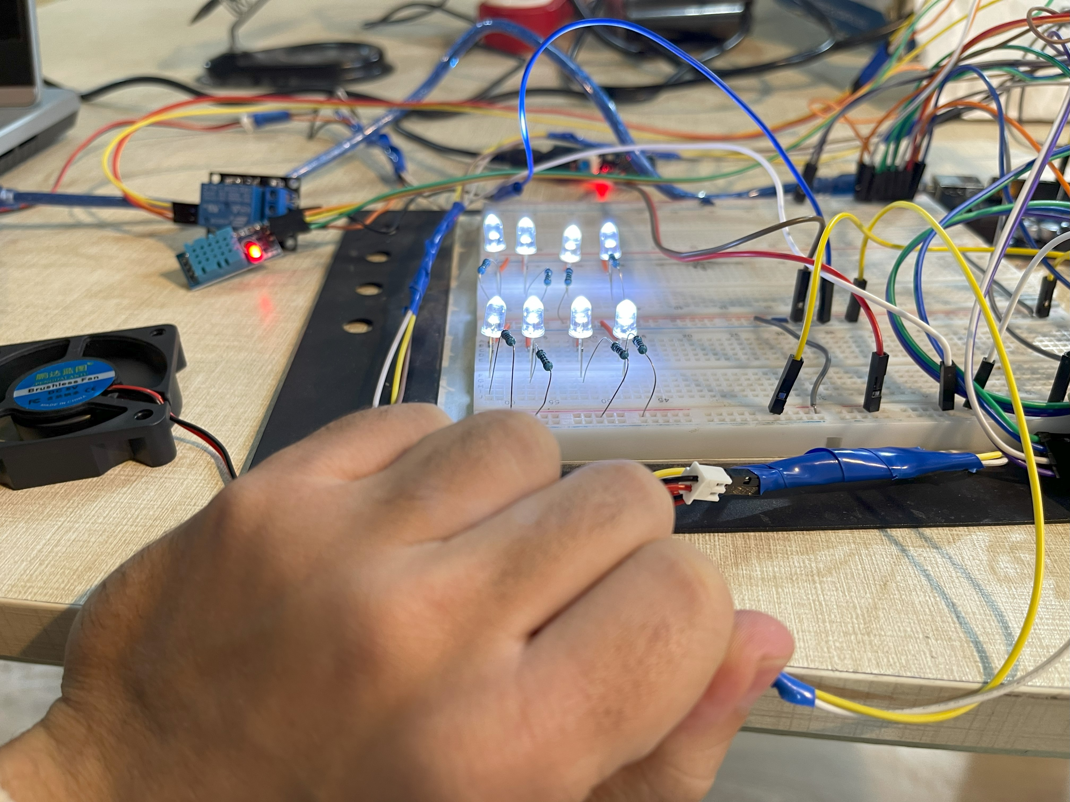

Figure ‎3‑36: Lights automatically turn on when ambient light levels become insufficient.

For improving the circuit to work not only on the conditions of ambient light levels but also on the occupancy state of the road for power consumption efficiency: the road is divided into small patches, each consisting of an ultrasonic sensor to detect occupancy. When there is no occupancy in a patch, the operation percentage of lighting goes down from 100% to about 40% for energy saving. This improves it into a more dynamic and adaptive lighting system; it optimizes energy usage while assuring adequate lighting levels for safety and visibility.

For that purpose, the light system circuit was designed using 2N2222 transistors to be connected to the pulse width modulation (PWM) pins, along with a 74HC595 shift register to expand the number of controllable outputs. Occupancy detected by ultrasonic sensors will send signals to the microcontroller for adjusting the PWM pins, which will in turn alter the current flow through the BJTs, hence the light intensity. The 2N2222 transistors are used for regulating power to the lights. Whenever a patch is occupied, the PWM signal is on for providing full power lighting. Whenever the patch is not occupied, the PWM on-time reduces the power, thereby dimming the light to 40% operation. This setup saves energy while maintaining necessary illumination for safety purposes, as shown in Figure ‎3‑37. The system dynamically changes the lighting intensity in real time, taking into account the data from the occupied or unoccupied status of rooms from the ultrasonic sensors, achieving big savings in energy consumption with proper visibility.

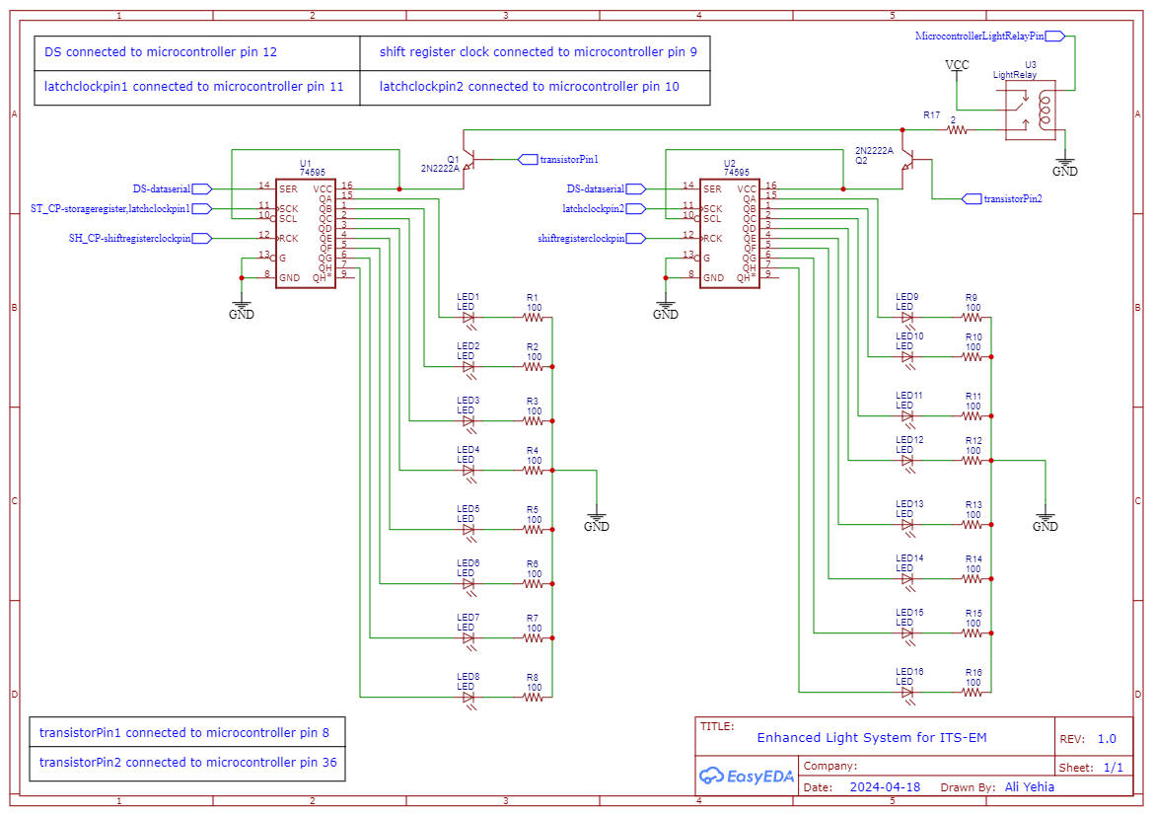

Figure ‎3‑37: Enhanced circuit diagram of light system.

The following two figures illustrate the hardware implementation of the adaptive lighting system and demonstrate how it operates in response to road occupancy, as in Figure ‎3‑38 and Figure ‎3‑39.

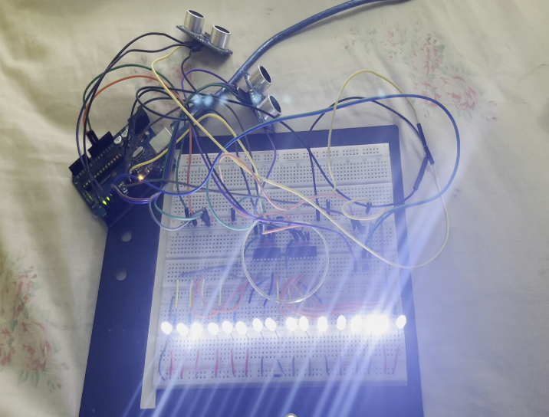

Figure ‎3‑38: Dynamic and adaptive lighting system hardware implementation.

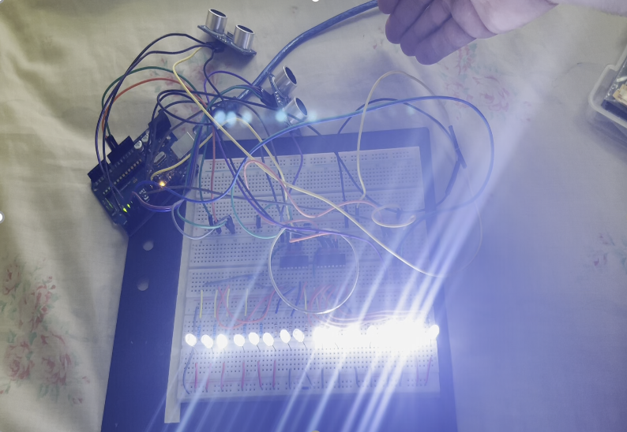

Patch 2 sensor detected an object

Patch 2 light intensity raised to 100%

Figure ‎3‑39: light intensity increase upon object detection.

Chapter Four

# COMPUTER VISION AND ARTIFICIAL INTELLIGENCE

Computer vision forms a large part of the evolution of ITS with improvements in traffic management, safety, and efficiency. Based on AI and high-performance image processing methods, computer vision enables real-time monitoring and analysis of vehicular movement and road and traffic conditions. The technology will also help in automatic vehicle detection and classification, detecting traffic violation, and optimize traffic flow by reducing congestion and improving road safety. Computer vision can be integrated into ITS for data-based decision-making, allowing the emergence of smarter, responsive transportation networks, which are adaptive to dynamic urban traffic.

In our modular base, we had deployed an AI and computer vision model for detecting microcontroller cars, which needed a custom-made model for precise classification and detection. For this, we trained YOLOv8 model on a dataset of ours that contains images of cars. The initial dataset has 194 photos, but after using augmentation techniques, we could expand the dataset to 1336. For precise labeling, as shown in Figure ‎4‑1, we used the LabelImg tool to draw the region of interest (ROI) for all the images.

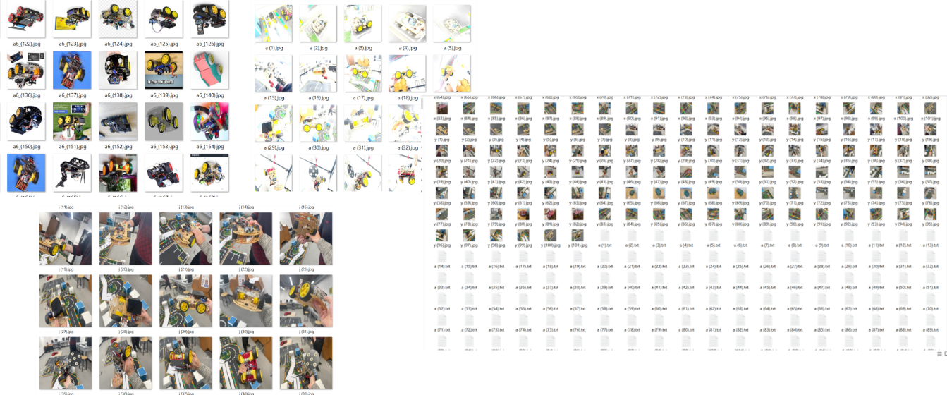

Figure ‎4‑1: Dataset expanding using segmentation techniques.

Results in the form of precision, P = 0.976, recall, R = 0.977, mean average precision, mAP = 0.992, and F1 Score = 0.894 are very impressive. Figure ‎4‑2 depicts the deployed setup of the model where the cars are accurately identified and labeled along with their confidence scores, further marking the efficacy of the model.

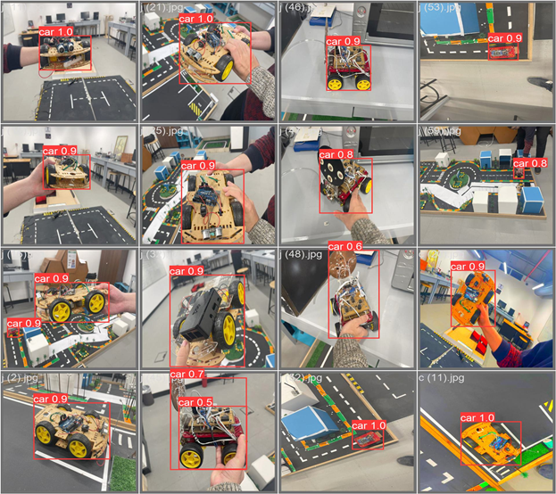

Figure ‎4‑2: Model’s accuracy for identifying cars after training.

Figure ‎4‑3 exemplifies the flow analysis used in the AI model to monitor the traffic in our model setup. The system will count how many cars are moving in each direction on the road sections, incoming (in) and outgoing (out). In addition, the algorithm detects the flow direction of the cars to detect the cars moving against traffic. In the case that such violation happens, the system captures the car's license number, date, time, and type of violation and stores this information in a file for violations. This feature not only monitors the movement of vehicles but also provides safety and law compliance in the modular road setup, as is shown here where the cars are being traced and deviances are recorded.

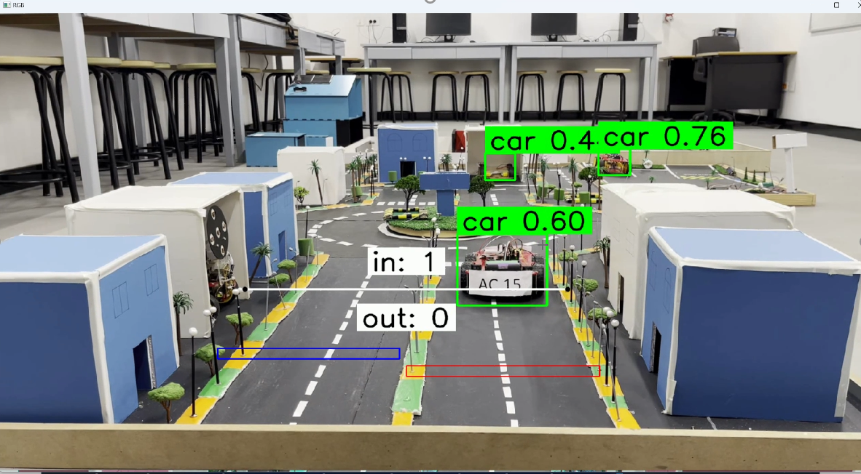

Sections to detect direction of moving

Figure ‎4‑3: Traffic management system model.

In case of violation to extract the license plate number for cars violating traffic by passing in the opposite direction, our algorithm first processes the input video of the road to classify and detect vehicles. If a car passes in the wrong direction—such as moving from bottom to top in an outgoing road section or from top to bottom in an incoming road section—the algorithm identifies this violation. The model then confirms that the detected object is, in fact, a car before trying to locate the license plate in that frame. As license plates could be blurred or noisy, the algorithm enhances the image quality of the plate. Lastly, the license plate information is extracted accurately using OCR, as shown in Figure ‎4‑4, and we may document the violation.

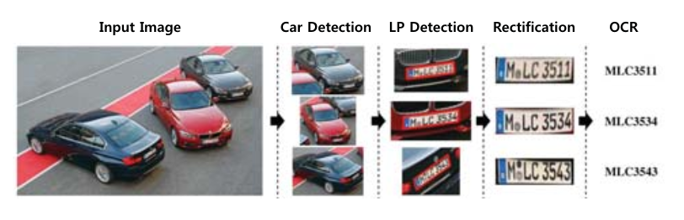

Figure ‎4‑4: License plate extraction for violating cars.

The following figures depict the operation of the traffic violation detection system. These figures demonstrate the use of the algorithm in detecting vehicles moving in the wrong direction; their license plates are detected, image quality is improved, and optical character recognition is applied to extract and record the license plate numbers of offending cars by creating automatically an excel file with all violations records, as in Figure ‎4‑5 and Figure ‎4‑6.

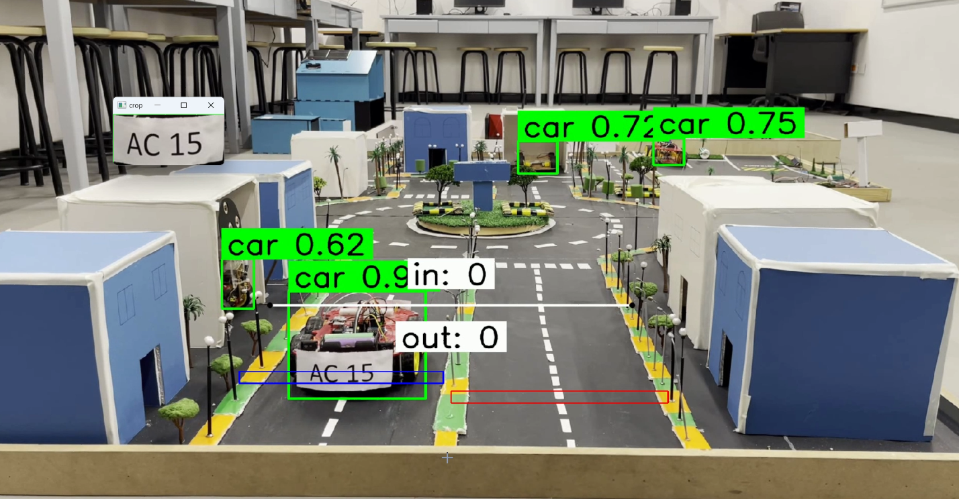

Car moving in the wrong direction of the road

Figure ‎4‑5: Car moving in the opposite direction.



Figure ‎4‑6: Violation information records.

Chapter Five

# GRAPHICAL USER INTERFACE

A Graphical User Interface (GUI) is a user-friendly, window-based interface excerpted with drop-down menus and icons that make it possible for people to interact with electronic devices graphically. This is in comparison to a textual interface that uses typed command labels or text navigation. The GUI revolutionized user–computer interaction, as it provided a platform where acts are executed by direct manipulation of graphical elements. GUI design and usability affect a lot in user experience, accessibility, and even the efficiency by which tasks are performed. As part of today's computing, they apply to a variety of devices and applications, making digital interactions more intuitive and elegant. The GUIs are still one of the most relevant and active fields of research in computer science, targeted at much more user engagement and easiness of complexity in digital interactions.

We have developed a mobile application that allows monitoring for each of our ITS components. Each meter and gauge in the app indicates a specific system condition, as shown in Figure ‎5‑1. These include temperature, humidity, and weight or mass on the WIM system:

* **Temperature Meter:** gives the reading in degrees Celsius for temperature.
* **Humidity Meter:** it gives the relative humidity of the system in percent.
* **Weight Meter:** gives the weight/mass on the WIM system in grams.
* **Light Meter:** It shows the light intensity of the ITS system in percentage relative to the maximum possible intensity.
* **Flame Meter:** This will detect fire presence of our fire suppression system. This is a Boolean variable, meaning just "detected" or "not detected."

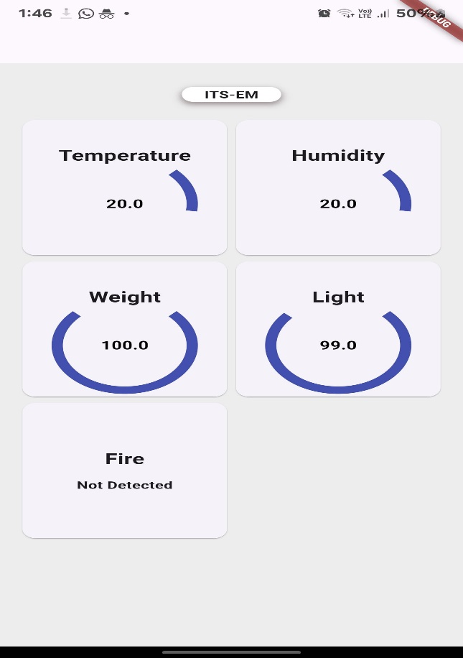

Figure ‎5‑1: Monitoring application for ITS systems.

Also, the welcome page of the user-based domain, as illustrated in Figure ‎5‑2, allows users to view and forecast traffic conditions. Created using Animate v.6.0. Pressing the "Start" button brings up the main page, as illustrated in Figure ‎5‑3.

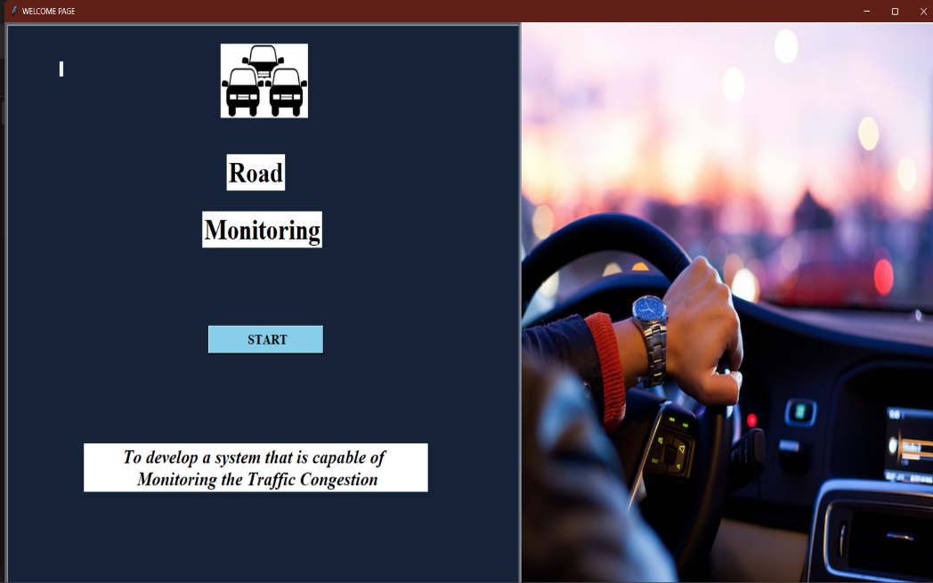

Figure ‎5‑2: Welcome page for user.

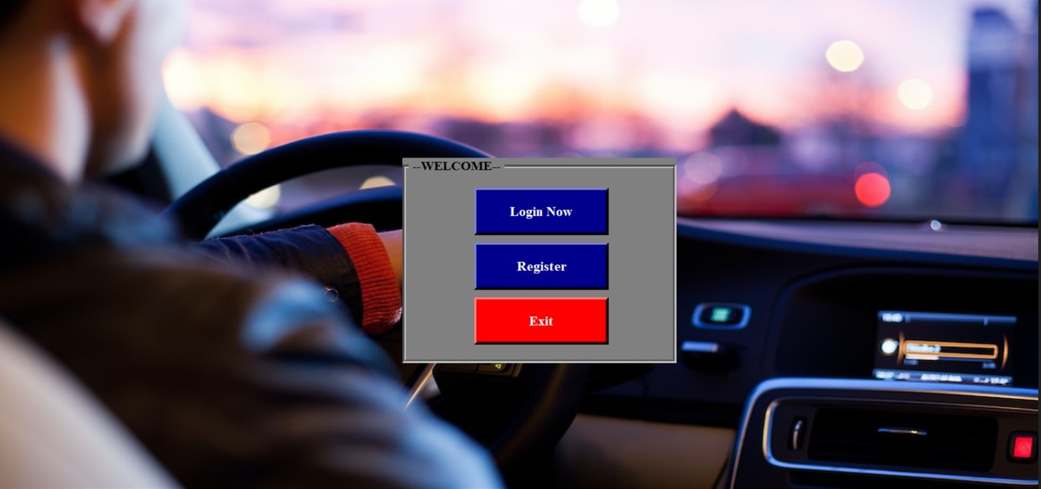

Figure ‎5‑3: Main page.

If we don't have records of the user, or if it's their first time accessing the GUI, they will need to complete the registration form, as shown in Figure ‎5‑4. This form will collect the user's information and credentials.



Figure ‎5‑4: Register page.

Chapter Six

# EMULATION MODULE

In our prototype, we have incorporated various hardware implementations that reflect the vision in infrastructure management. The first figure shows the setting up of the initial prototype where individual components were tested and integrated, as shown in Figure ‎6‑1.

The final emulation module in is an expansion of the prototype, where all the systems are linked together more efficently. This setup is an improvement on the prototype because it provides real-time data monitoring and acquisition through the GUI. The emulation module offers exact weight measurements, real-time responses in case of a fire breakout, climate-responsive ventilation, effortless Toll collection, intelligent street lighting. This final configuration has provided a resilient, interconnected infrastructure model to solve some very complex challenges in transportation, safety, and urban management, as shown in Figure ‎6‑2 and Figure ‎6‑3.

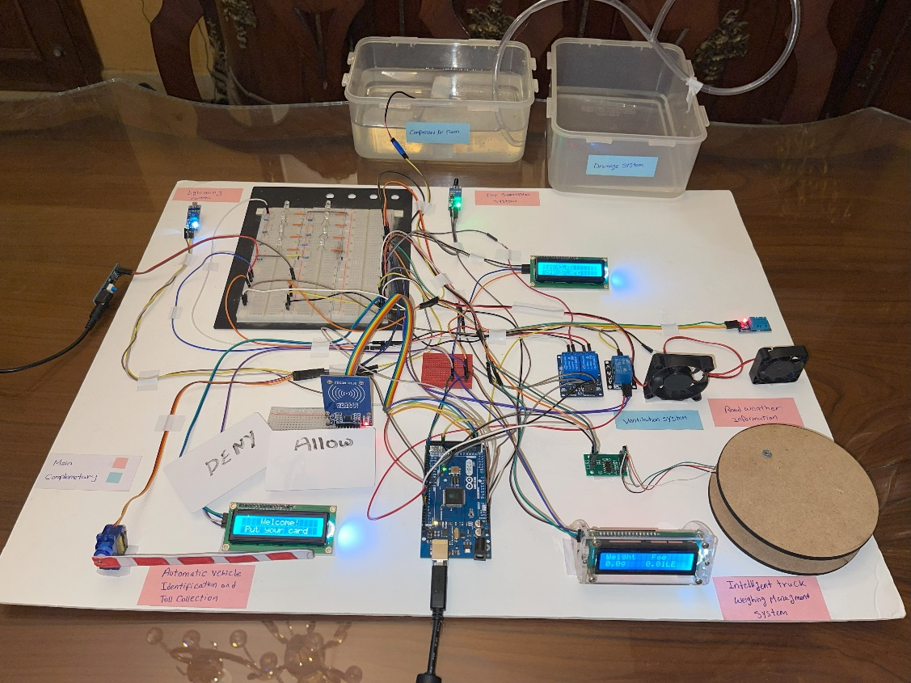

Figure ‎6‑1: Integrated systems prototype.

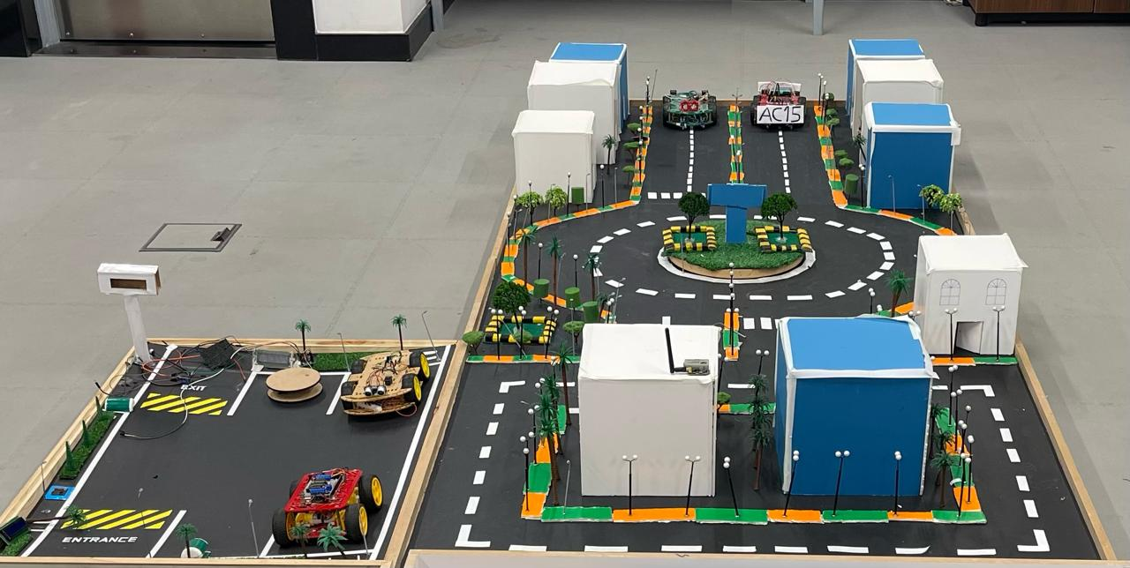

Figure ‎6‑2: Emulation module initial phase.

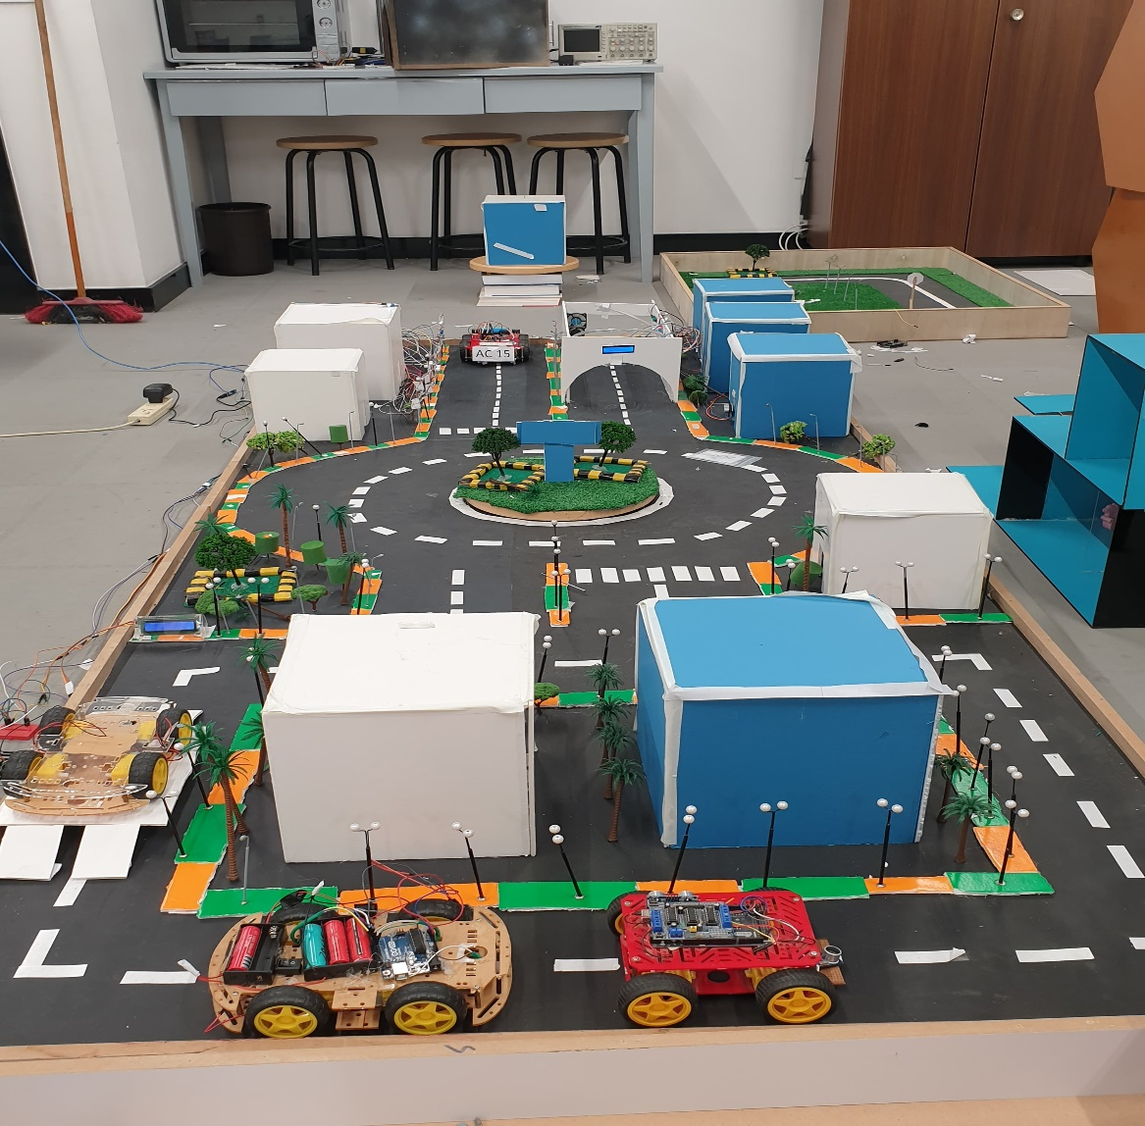

Figure ‎6‑3: Emulation module final phase.

Chapter Seven

# EVALUATION OF THE PROJECT

* **Cost:**

This translates to roughly 11134.5 EGP for the ITS-EM systems' hardware components and that of the Raspberry Pi in implementing AI and computer vision. The cost of the equipment is relatively modest considering the main components that would be used for the implementation.

* **Environmental Impact:**

The project is feasible in environmental sustainability. The project reduces fuel consumption and emissions by consolidating a well-improved management system for traffic flow. Reduction of transportation challenges like congestion leads to low levels of air pollution.

* **Manufacturability:**

The ITS-EM project was designed considering manufacturing capabilities and requirements for elements and platforms that are already available in the market like Raspberry Pi and Arduino. This, hence, realizes the ability to be replicable and can therefore be scalable by anyone who is interested in it to be implemented far and wide.

* **Ethics:**

There are very important ethical issues in the ITS-EM project, wherein fairness is present in all procedures, from truck weighing to the processing of automated violations. This then avoids human error and partiality, where everything is transparent and fair to everybody within the transportation management.

* **Health and Safety:**

The ITS-EM project delivers much focus on the health and safety perspective. In the project, features from suppressing fires to monitoring real-time weather are incorporated so that accidents can be avoided and the overall safety of the transport system can be increased.

* **Social Impact:**

The project is bound to improve public safety and transportation efficiency. Increased efficiency supports improved quality of life.

* **Sustainability:**

The ITS-EM project addresses some of the key Millennium Development Goals set by the United Nations. In greater detail, it covers the following SDGs, as depicted inFigure ‎7‑1.



Figure ‎7‑1: Sustainable development goals.

**Decent Work and Economic Growth (SDG 8)**

Economic growth, further stimulated by the project, goes hand in hand with job creation. These will be in demand for the improvement of the effectiveness and safety of the transport sector and subsequently increase the safety of transport and technology-related industries.

**Industry, Innovation and Infrastructure (SDG 9):**

The project involves improving the transport infrastructure to foster innovation in support industries using developed technologies such as AI, the Internet of Things, and computer vision techniques within the ITS-EM project.

**Sustainable Cities and Communities (SDG 11):**

In this context, it is developed for the realization of safe and efficient urban transportation systems.

**Climate Action (SDG 13):**

The plan in the project goes down to reducing emissions resulting from transportation practices towards a global initiative to mitigate climate change.

Chapter Eight

# CONCLUSION

The ITS-EM project has accomplished the development of an integrated, efficient ITS System incorporating several advanced technologies for advancements in improving the traffic management process with safety. The application of this system integrates various subsystems for addressing the needs of the diverse domains of effective management in transportation systems. The key contributions and findings of this project are summarized as follows:

1. **Validation of need:** Advances in urbanization and, by extension, urban traffic has called for the specific requirement of ITS that will guarantee improved road safety. Our study validated this opinion based on a comprehensive review of the current challenges facing traffic management and the enabling capacity of existing transportation systems.
2. **Innovative Solutions:** The ITS-EM system adopted five innovative subsystems:
   * **Intelligent Truck Weighing Management System (WIM):** An effective system to accurately and efficiently manage truck weights to prevent road damage and enhance safety by following weight regulations.
   * **Fire Suppression System:** Ensured that any fires on roadways were detected and stamped out as soon as possible, thus improving safety with respect to vehicles and infrastructure.
   * **Road Weather Information System:** This system monitored and collected data according to weather conditions for making real-time decisions during hazardous weather conditions.
   * **Automatic Vehicle Identification and Toll Collection:** This subsystem is used to exempt and read the toll from vehicles, which improved traffic efficiency and decreased congestion.
   * **Lighting Control System:** This subsystem controls lighting, which is optimized according to the real-time traffic condition and environment, thus enhancing visibility and safety while saving energy.
3. **AI and Computer Vision**: Deployed AI models for monitoring in real-time, detecting vehicles, and managing traffic violations to a high level of precision and recall. Documenting committed violations with their license plate information is done by extraction through OCR.
4. **Graphical User Interface:** The installation of a user-friendly GUI for the operator to visualize real-time data and control of subsystems allowed an effective control of monitoring and management with quick decisions and adjustments or system configuration as the situation demands.
5. **Problem Solving:** There is a number of different problems in the traffic management that real-time monitoring and adaptive response for different traffic situations will be transferred by our system. High accuracy in the identification of vehicles, weather monitoring, and fire detection will be reached by providing the use of up-to-date sensors and machine learning algorithms. The adaptively in lighting will result in power consumption being largely cut down due to a system approach concerning power-saving conditions with favorable visibility, which is available, based on real-time traffic data.
6. **Performance and Optimization:** The performance of the system has been tested very intensively, introducing simulation, which has confirmed remarkable results in making the flow of traffic effective, safe, and energy-efficient. Every subsystem was optimized for its purpose and added to the general system's strength and scalability.

Chapter Nine

# FUTURE WORK

Our future work includes bringing into the world a state-of-the-art fire detection system that was devised at UNSW Sydney. It exploits cheaply available Wi-Fi signals and machine learning to bring forth real-time fire detection and monitoring. Training the algorithm with different scenarios directly will enable the algorithm to differentiate between normal activity and related potential fires. If so, continued analysis will reduce to fast identification of fire through the analysis of the Wi-Fi pattern and therefore trigger occupants' or emergency services' alerts.

One of the big advantages, points out Professor Seneviratne, is: "Our system uses transmitters and receivers that cost $100 or less, compared to conventional fire detection cameras that cost about $10,000." Economical advantage like this would enable its adoption - from domestic to industrial scale.

**Other System Enhancements**

The other functionalities will be enhanced as follows:

* **Weighing Management System:** It will be integrated with a complete database of fees, truck details, destinations, and weight information.
* **Toll Collection System:** Connecting the automated tolls paid by vehicles as they move through designated zones by cloud database.
* **Road Weather Information System:** Provide weather data to navigation applications for drivers.

It will be involved in advanced hardware system integration, refinement of the source code of the user interface, development of more computer vision applications for road management, and refinement of the assembled module. Lastly, all systems will be connected to a cloud server via Wi-Fi module for monitoring and data collection.

# REFERENCES

[1] O. Maaitah, "Introduction to ITS," presentation.

[2] P. Burnos and D. Rys, “The Effect of Flexible Pavement Mechanics on the Accuracy of Axle Load Sensors in Vehicle Weigh-in-Motion Systems,” *Sensors*, vol. 17, no. 9, Art. no. 9, Sep. 2017, doi: 10.3390/s17092053.

[3] z3525182, “New inexpensive Wi-Fi system improves fire detection,” UNSW Newsroom. Accessed: Dec. 22, 2023. [Online]. Available: <https://newsroom.unsw.edu.au/news/science-tech/new-inexpensive-wi-fi-system-improves-fire-detection>

[4] L. Celentano, B. Siciliano, and L. Villani, “A robotic system for fire fighting in tunnels,” *IEEE Int. Saf. Secur. Rescue Rototics Workshop 2005*, pp. 166–171, 2005, doi: 10.1109/SSRR.2005.1501258.

[5] “One Seven CAFS extinguishing systems for road tunnels,” BMT Fire & Rescue. Accessed: Dec. 22, 2023. [Online]. Available: <https://bmt-fireandrescue.com/en/products/stationary-extinguishing-systems/cafs-extinguishing-systems-for-road-tunnels/>

[6] *Testing fire systems inside the SR 99 tunnel*, (Jun. 28, 2018). Accessed: Dec. 22, 2023. [Online Video]. Available: <https://www.youtube.com/watch?v=dMDMDnKB-Ao>

[7] “U.S. Road Weather Management Program - Sensor Sitting and Weather Information Integration Projects - Road Weather Management - FHWA Office of Operations.” Accessed: Dec. 23, 2023. [Online]. Available: <https://ops.fhwa.dot.gov/weather/resources/publications/sirwec06/index.htm>

[8] “ANPR Camera System | Nortech Control Systems Ltd.” Accessed: Dec. 27, 2023. [Online]. Available: <https://www.nortechcontrol.com/solutions/vehicle/automatic-number-plate-recognition-anpr/>

[9] *ANPR System, Automatic Number Plate Recognition - OmnyPark*, (Jun. 14, 2012). Accessed: Dec. 26, 2023. [Online Video]. Available: <https://www.youtube.com/watch?app=desktop&v=VWGFr7g0qxU>

[10] “Automatic Number Plate Recognition | High Accuracy ANPR Software,” Plate Recognizer. Accessed: Dec. 27, 2023. [Online]. Available: <https://platerecognizer.com/anpr/>

[11] S. Bhosale, R. Chavan, S. Bhadvan, and P. Mohite, “AUTOMATIC VEHICLE IDENTIFICATION AND TOLL COLLECTION USING,” vol. 03, no. 02.

[12] T. Thornton, “Reductions in fuel consumption and CO,” in *IET Road Transport Information and Control Conference and the ITS United Kingdom Members’ Conference (RTIC 2010). Better transport through technology*, London, UK: IET, 2010, pp. 42–42. doi: 10.1049/cp.2010.0375.

[13] H. Rakha and Y. Ding, “Impact of Stops on Vehicle Fuel Consumption and Emissions,” *J. Transp. Eng.*, vol. 129, no. 1, pp. 23–32, Jan. 2003, doi: 10.1061/(ASCE)0733-947X(2003)129:1(23).

[14] “Transportation sector energy consumption,” 2016.

[15] “Learn the facts: Emissions from your vehicle”.

[16] “Street light control system - Lumenova GmbH.” Accessed: Dec. 27, 2023. [Online]. Available: <https://www.lumenova.net/sales-products/street-light-control-system.html>

[17] “LUCIA_technology_state_of_the_art_report_190826.pdf.” Accessed: Dec. 27, 2023. [Online]. Available: <https://lucia-project.eu/wp-content/uploads/2020/04/LUCIA_technology_state_of_the_art_report_190826.pdf>

[18] Y. Wu, C. Shi, X. Zhang, and W. Yang, “Design of new intelligent street light control system,” in *IEEE ICCA 2010*, Xiamen, China: IEEE, Jun. 2010, pp. 1423–1427. doi: 10.1109/ICCA.2010.5524348.

[19] R. Carli, M. Dotoli, and R. Pellegrino, “A decision-making tool for energy efficiency optimization of street lighting,” *Comput. Oper. Res.*, vol. 96, Nov. 2017, doi: 10.1016/j.cor.2017.11.016.

[20] “Arduino with Load Cell and HX711 Amplifier (Digital Scale) | Random Nerd Tutorials.” Accessed: Nov. 22, 2023. [Online]. Available: <https://randomnerdtutorials.com/arduino-load-cell-hx711/>

[21] “pj-460.pdf.” Accessed: Nov. 22, 2023. [Online]. Available: <https://www.gotronic.fr/pj-460.pdf>

[22] HX711 with a Four Wire Load Cell and Arduino | Step by Step Guide., (Jun. 15, 2020). Accessed: Nov. 22, 2023. [Online Video]. Available: <https://www.youtube.com/watch?v=sxzoAGf1kOo>

[23] “4-Wire Load Cell (1/5/10/20/200kg) with HX711 and Arduino - Circuit Journal.” Accessed: Nov. 22, 2023. [Online]. Available: <https://circuitjournal.com/four-wire-load-cell-with-HX711>

[24] “Strain Gauges | Electrical Instrumentation Signals | Electronics Textbook.” Accessed: Nov. 22, 2023. [Online]. Available: <https://www.allaboutcircuits.com/textbook/direct-current/chpt-9/strain-gauges/>

[25] Weighing Machine using Arduino Load Cell & HX711 Module / Weight machine using Arduino, (Jun. 04, 2021). Accessed: Nov. 22, 2023. [Online Video]. Available: <https://www.youtube.com/watch?v=gpofOo4_PtA>

[26] “Interfacing Flame Sensor with Arduino.” Accessed: Oct. 31, 2023. [Online]. Available: <https://circuitdigest.com/microcontroller-projects/interfacing-flame-sensor-with-arduino>

[27] syedzainnasir, “New Proteus Libraries for Engineering Students - The Engineering Projects.” Accessed: Oct. 31, 2023. [Online]. Available: <https://www.theengineeringprojects.com/2016/08/new-proteus-libraries-engineering-students.html>

[28] syedzainnasir, “Flame Sensor Library for Proteus - The Engineering Projects.” Accessed: Nov. 01, 2023. [Online]. Available: <https://www.theengineeringprojects.com/2016/07/flame-sensor-library-proteus.html>

[29] “Arduino Modules - Flame Sensor,” projecthub.arduino.cc. Accessed: Nov. 01, 2023. [Online]. Available: <https://projecthub.arduino.cc/SURYATEJA/arduino-modules-flame-sensor-e48e97>

[30] zahidali, “Introduction to DHT22 - The Engineering Projects.” Accessed: Dec. 28, 2023. [Online]. Available: <https://www.theengineeringprojects.com/2019/02/introduction-to-dht22.html>

[31] S. Schauer, “How to Make Your Best Choice: Active, Semi-Passive or Passive RFID Tags.” Accessed: Dec. 28, 2023. [Online]. Available: <https://www.barcoding.com/blog/rfid-tags-active-semi-passive-and-passive>

[32] “18a41097-2035-4333-c70e-bfa544c0a98b.pdf.” Accessed: Dec. 28, 2023. [Online]. Available: <https://ams.com/documents/20143/36005/TSL2561_DS000110_3-00.pdf/18a41097-2035-4333-c70e-bfa544c0a98b>